**PRACTICAL 1**

**a.Create a simple calculator application using servlet.**

**CODE:**

index.html

<html>

<head>

<title>Calculator </title>

<meta charset="UTF-8">

<meta name="viewport" content="width=device-width, initial-scale=1.0">

</head>

<body>

<form name="frml" method="post" action="Servlet1">

<label> Enter 1st integer number</label><input type="text" name="txt1"/><br/>

<label> Enter 2nd integer number</label><input type="text" name="txt2"/><br/>

<input type="radio" name="rb1" value="+"/>+&nbsp;&nbsp;

<input type="radio" name="rb1" value="-"/>-&nbsp;&nbsp;

<input type="radio" name="rb1" value="*"/>&nbsp;&nbsp;

<input type="radio" name="rb1" value="/"/>/&nbsp;&nbsp;

<input type="radio" name="rb1" value="%"/>%&nbsp;&nbsp; <br/>

<input type="submit" value="Click Here"/>

</form>

</body>

</html>

Servlet1.java

package pack1;

import java.io.*;

import javax.servlet.*;

import javax.servlet.http.*;

public class Servlet1 extends HttpServlet

{

@Override

protected void doPost(HttpServletRequest request, HttpServletResponse response)

throws ServletException, IOException

{

response.setContentType("text/html;charset=UTF-8");

PrintWriter out = response.getWriter();

String str1,str2,op;

int a,b,ans;

str1=request.getParameter("txt1");

str2=request.getParameter("txt2");

a=Integer.parseInt(str1);

b=Integer.parseInt(str2);

op=request.getParameter("rb1");

switch(op)

{

case "+":

ans=a+b;

out.println("<h2>The sum of "+a+" and "+b+" is "+ans);

break;

case "-":

ans=a-b;

out.println("<h2>The difference of "+a+" and "+b+" is "+ans);

break;

case "*":

ans=a*b;

out.println("<h2>The product of "+a+" and "+b+" is "+ans);

break;

case "/":

ans=a/b;

out.println("<h2>The division of "+a+" and "+b+" is "+ans);

break;

case "%":

ans=a%b;

out.println("<h2>The Modulus of "+a+" and "+b+" is "+ans);

break;

default:out.println("Invalid operator");

}

}

}

**OUTPUT:**

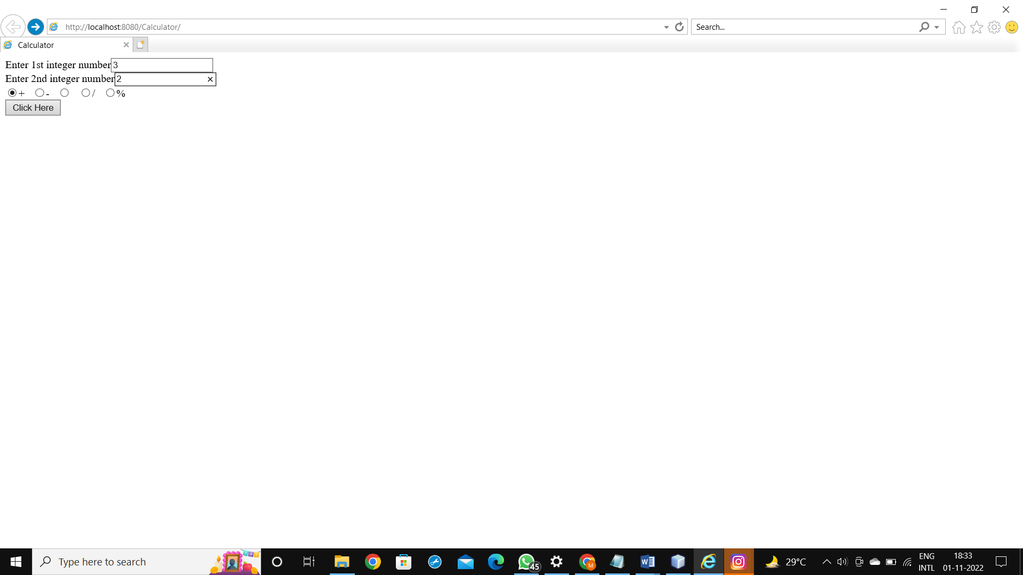

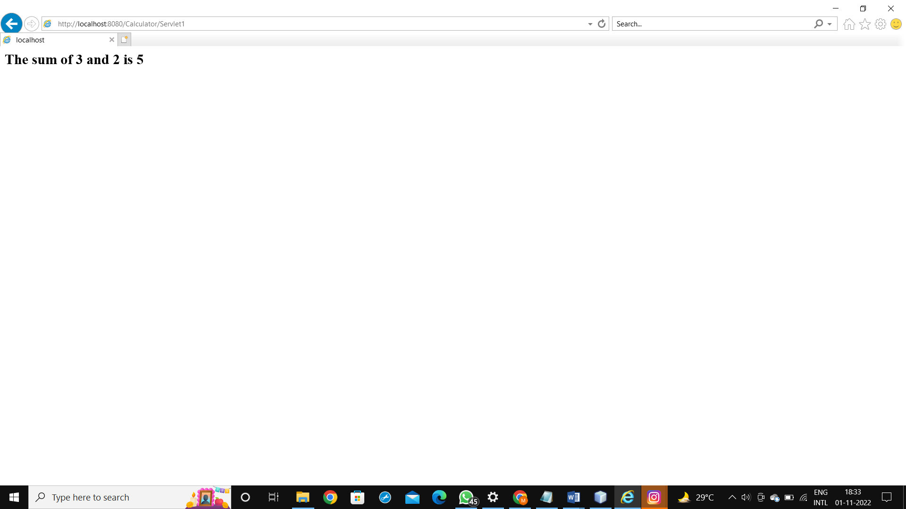

**b.Create a servlet for a login page. If the username and password are correct then it says message “Hello ” else a message “login failed”.**

**CODE:**

index.html

<html>

<head>

<title>TODO supply a title</title>

<meta charset="UTF-8">

<meta name="viewport" content="width=device-width, initial-scale=1.0">

</head>

<body>

<form method="post" action="LoginServlet" >

Enter User ID<input type="text" name="txtId"><br>

Enter Password<input type="password" name="txtPass"><br>

<input type="reset"><input type="submit" value=" Click to Login " >

</form>

</body>

</html>

LoginServlet.java

<html>

<head>

<title>TODO supply a title</title>

<meta charset="UTF-8">

<meta name="viewport" content="width=device-width, initial-scale=1.0">

</head>

<body>

<form method="post" action="LoginServlet" >

Enter User ID<input type="text" name="txtId"><br>

Enter Password<input type="password" name="txtPass"><br>

<input type="reset"><input type="submit" value=" Click to Login " >

</form>

</body>

</html>

**OUTPUT:**

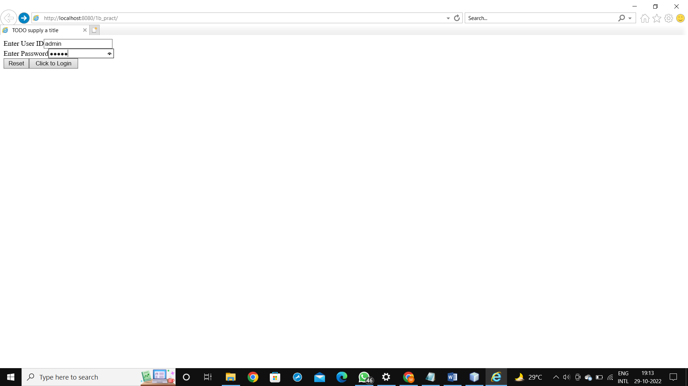

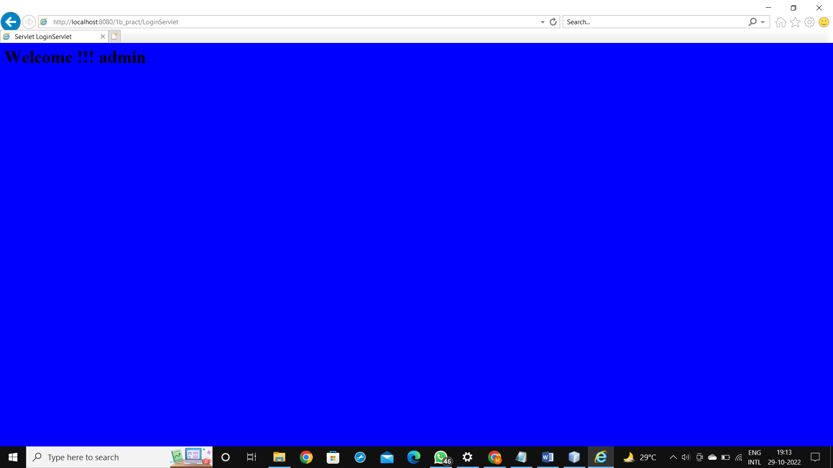

**c.write a servlet program that accept the integer number from html form. Calculate and display the factorial of no. if the number is -ve display the proper error message otherwise display the factorial of given number.**

**CODE:**

index.html

<html>

<head>

<title>Factorial</title>

<meta charset="UTF-8">

<meta name="viewport" content="width=device-width, initial-scale=1.0">

</head>

<body>

<form method="post" action ="Factorial">

<label> Enter integer number</label>

<input type ="text" name="txt1"/><br/>

<input type="submit" value="submit"/><br/>

</form>

</body>

Factorial.java

package pack3;

import java.io.*;

import javax.servlet.*;

import javax.servlet.http.*;

public class Factorial extends HttpServlet

{

@Override

protected void doPost(HttpServletRequest request, HttpServletResponse response)

throws ServletException, IOException

{

response.setContentType("text/html;charset=UTF-8");

PrintWriter out=response.getWriter();

int n,f=1;

String str;

str= request.getParameter("txt1");

n=Integer.parseInt(str);

if (n<0)

{

out.println("<h2>Entered number is-ve</h2>");

out.println("<h2>Please enter +ve number </h2>");

}

else

{

for(int i=1;i<=n;i++)

{

f=f*i;

}

out.println("<h2> The factorial of "+n+ " is "+f+"</h2>");

}

}

}

**OUTPUT:**

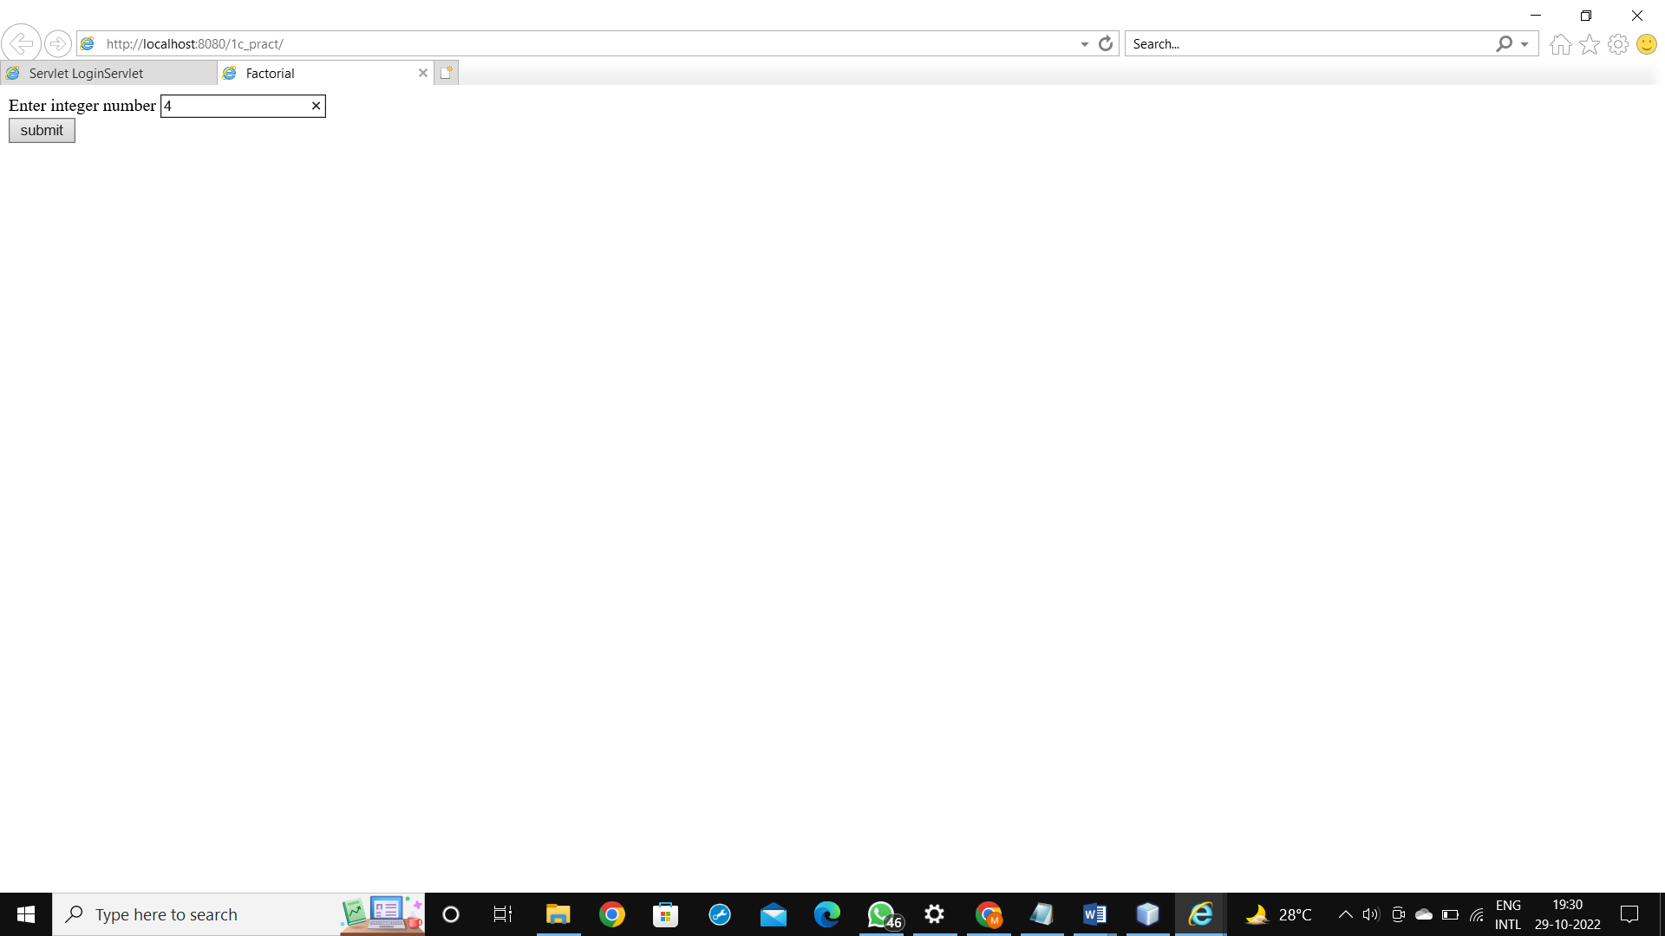

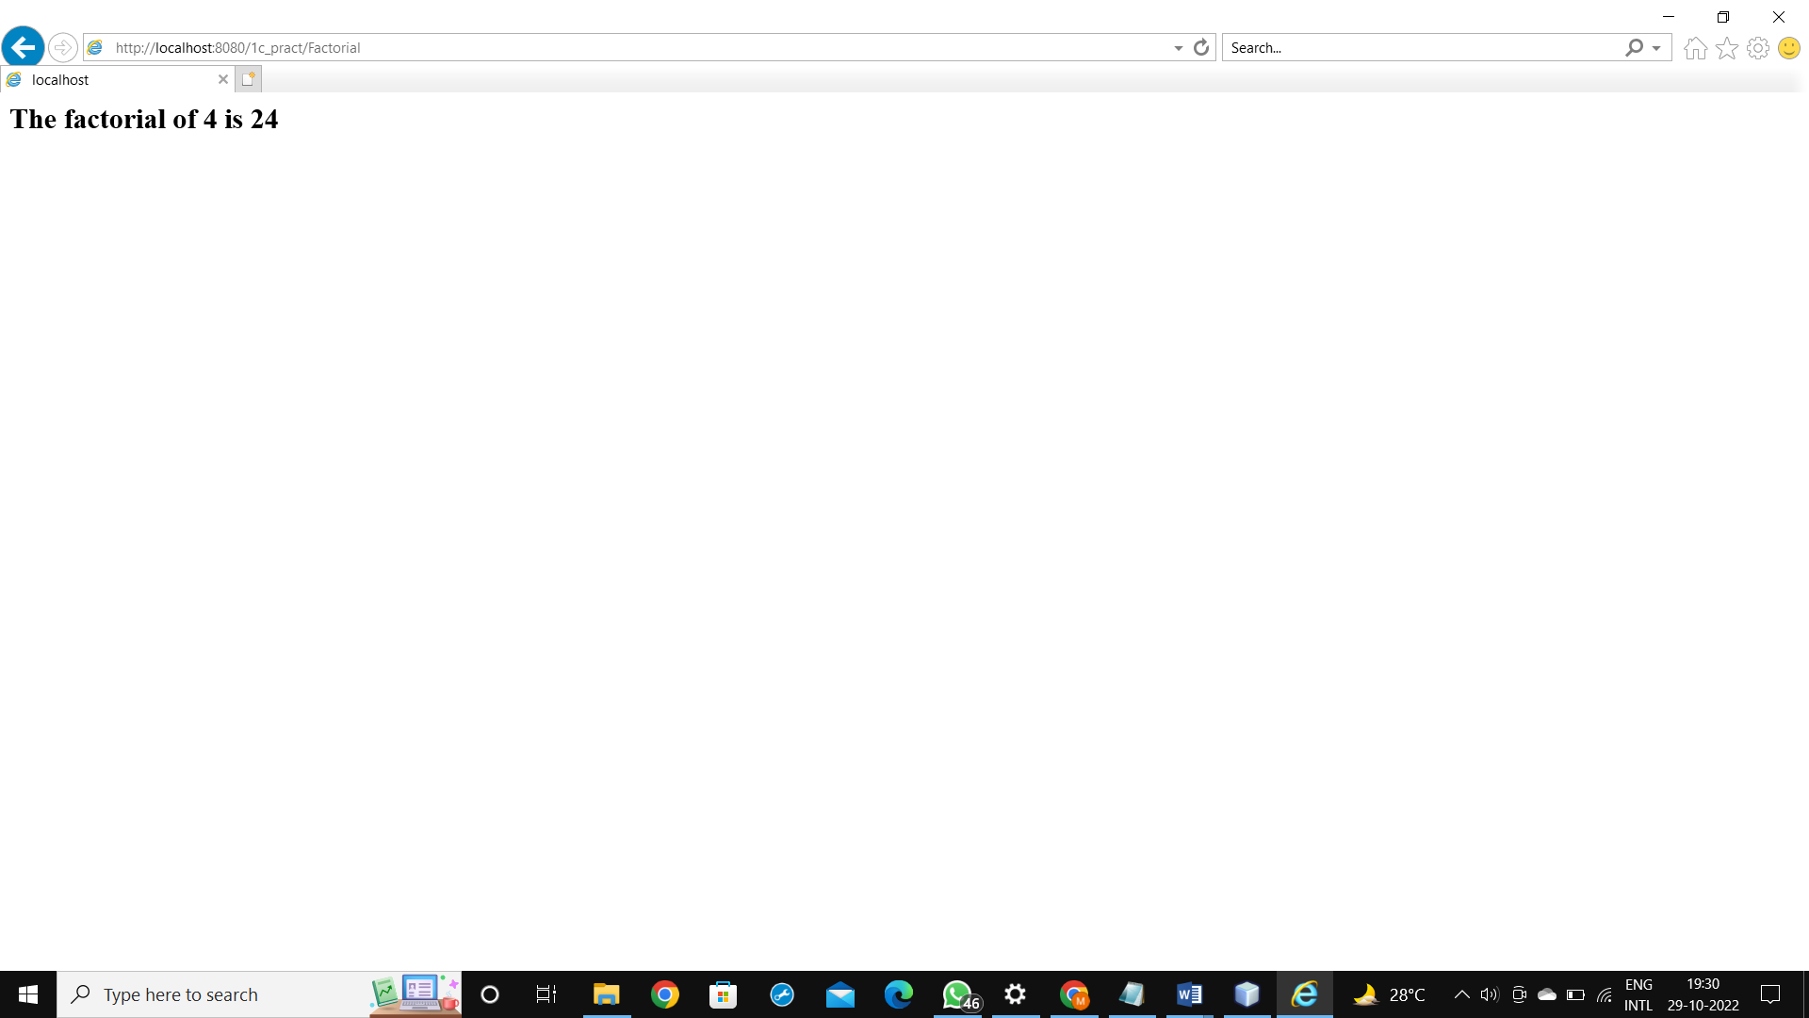

**d. Write servlet code that accept single value(name, mobile no.) as well as multivalued(language knows, hobbies) parameters like checkboxes and multiple language : Hindi , English. Hobbies: Reading, Singing, Travelling, Dancing, Swimming. Select list boxes from a html document and output them to the screen.**

**CODE:**

index.html

<html>

<head>

<title>TODO supply a title</title>

<meta charset="UTF-8">

<meta name="viewport" content="width=device-width, initial-scale=1.0">

</head>

<body>

<form name="frml" action="Servlet1" method="post" >

<center>

<table border="2">

<thead>

<tr>

<th colspan="2"><h1>Application Form</h1></th>

</tr>

</thead>

<tbody>

<tr>

<td><label>Enter your Name:</label></td>

<td><input type="text" name="txt1"/></td>

</tr>

<tr>

<td><label>Enter your Mobile No:</label></td>

<td><input type="text" name="txt2"/></td>

</tr>

<tr>

<td><label>Enter your Address:</label></td>

<td><textarea rows="8" cols="30" name="addr"></textarea></td>

</tr>

<tr>

<td><label>Language Known:</label></td>

<td><input type="checkbox" name="chk1" value="English"/>English &nbsp;&nbsp;

<input type="checkbox" name="chk1" value="Hindi"/>Hindi &nbsp;&nbsp;

<input type="checkbox" name="chk1" value="Marathi"/>Marathi &nbsp;&nbsp;

<input type="checkbox" name="chk1" value="Tamil"/>Tamil &nbsp;&nbsp;

</td>

</tr>

<tr>

<td><label>Hobbies:</label></td>

<td><select name="hob" multiple="multiple">

<option>Reading</option>

<option>Travelling</option>

<option>Swimming</option>

<option>Singing</option>

</select>

</td>

</tr>

<tr>

<td colspan="2">

<center> <input type="Submit" name="btnl" value="Submit"/></center>

</td>

</tr>

</tbody>

</table>

</center>

</form>

</body>

</html

Servlet1.java

package pack;

import java.io.*;

import javax.servlet.*;

import javax.servlet.http.*;

public class Servlet1 extends HttpServlet

{

@Override

protected void doPost(HttpServletRequest request, HttpServletResponse response)

throws ServletException, IOException

{

response.setContentType("text/html;charset=UTF-8");

PrintWriter out = response.getWriter();

String str1=request.getParameter("txt1");

String str2=request.getParameter("txt2");

String str3=request.getParameter("addr");

String st4[]=request.getParameterValues("chk1");

String st5[]=request.getParameterValues("hob");

out.println("<h2> Your Name is " +str1+"</h2>");

out.println("<h2> Your Mobile Number is " +str2+"</h2>");

out.println("<h2> Your Address is " +str3+"</h2>");

out.println("<h2> Languages Known</h2> ");

for (int i=0;i<st4.length;i++)

{

out.println(st4[i]);

}

out.println("<h2>Hobbies </h2>");

for (int i=0;i<st5.length;i++)

{

out.println(st5[i] );

}

}

}

**OUTPUT:**

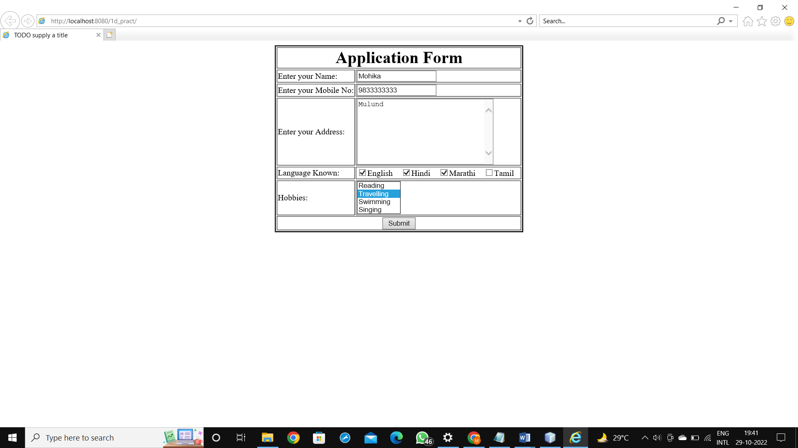

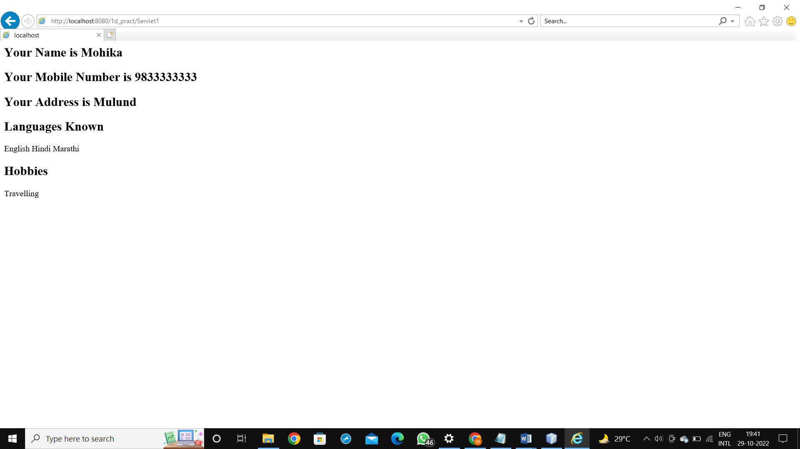

**e. Write servlet program to check given number is prime or not.**

**CODE:**

index.html

<html>

<head>

<title>Factorial</title>

<meta charset="UTF-8">

<meta name="viewport" content="width=device-width, initial-scale=1.0">

</head>

<body>

<form method="post" action ="Prime1">

<label> Enter integer number</label>

<input type ="text" name="txt1"/><br/>

<input type="submit" value="submit"/><br/>

</form>

</body>

</html>

Prime1.java

package pack1;

import java.io.*;

import javax.servlet.*;

import javax.servlet.http.*;

public class Prime1 extends HttpServlet

{

@Override

protected void doPost(HttpServletRequest request, HttpServletResponse response)

throws ServletException, IOException

{

response.setContentType("Text/html;charset=UTF-8");

PrintWriter out = response.getWriter();

int n, count,rem;

n= Integer.parseInt(request.getParameter("txt1"));

count=0;

for(int i=1;i<=n;i++)

{

rem=n%i;

if(rem==0)

count++;

}

if(count==2)

{

out.println("Number is prime number");

}

else

{

out.println("Number is not a prime number");

}

}

}

OUTPUT:

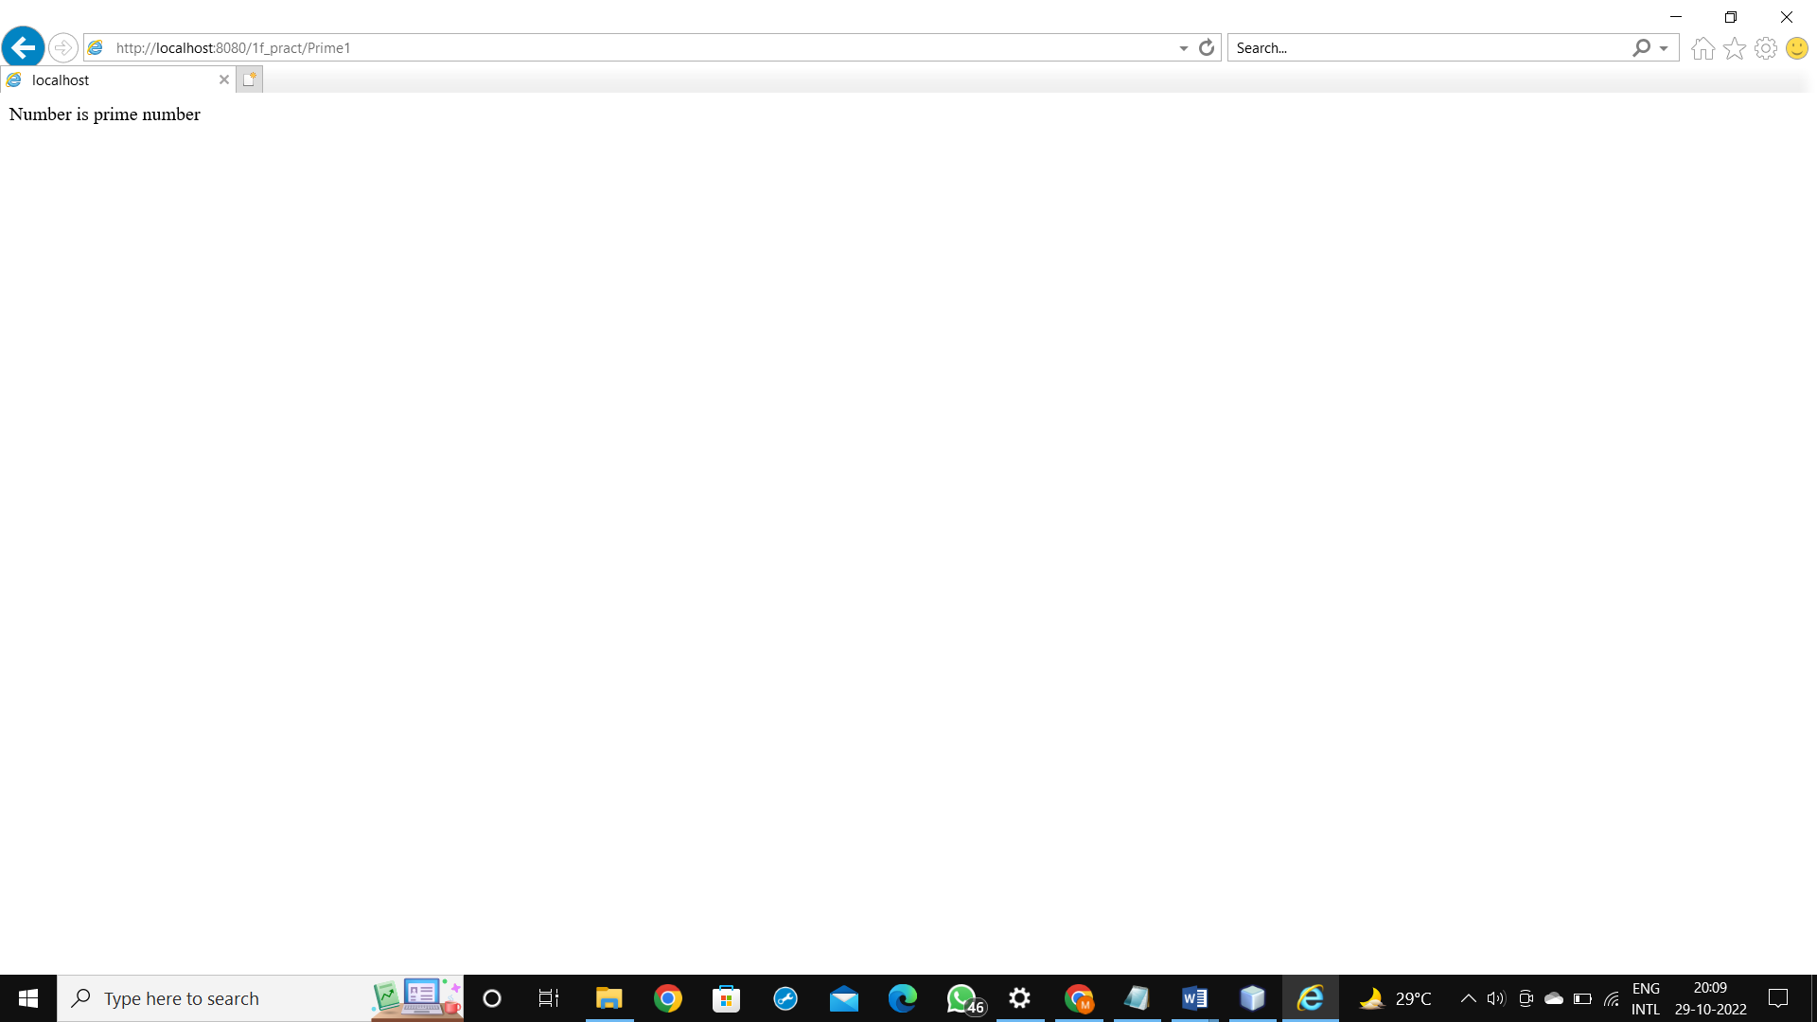

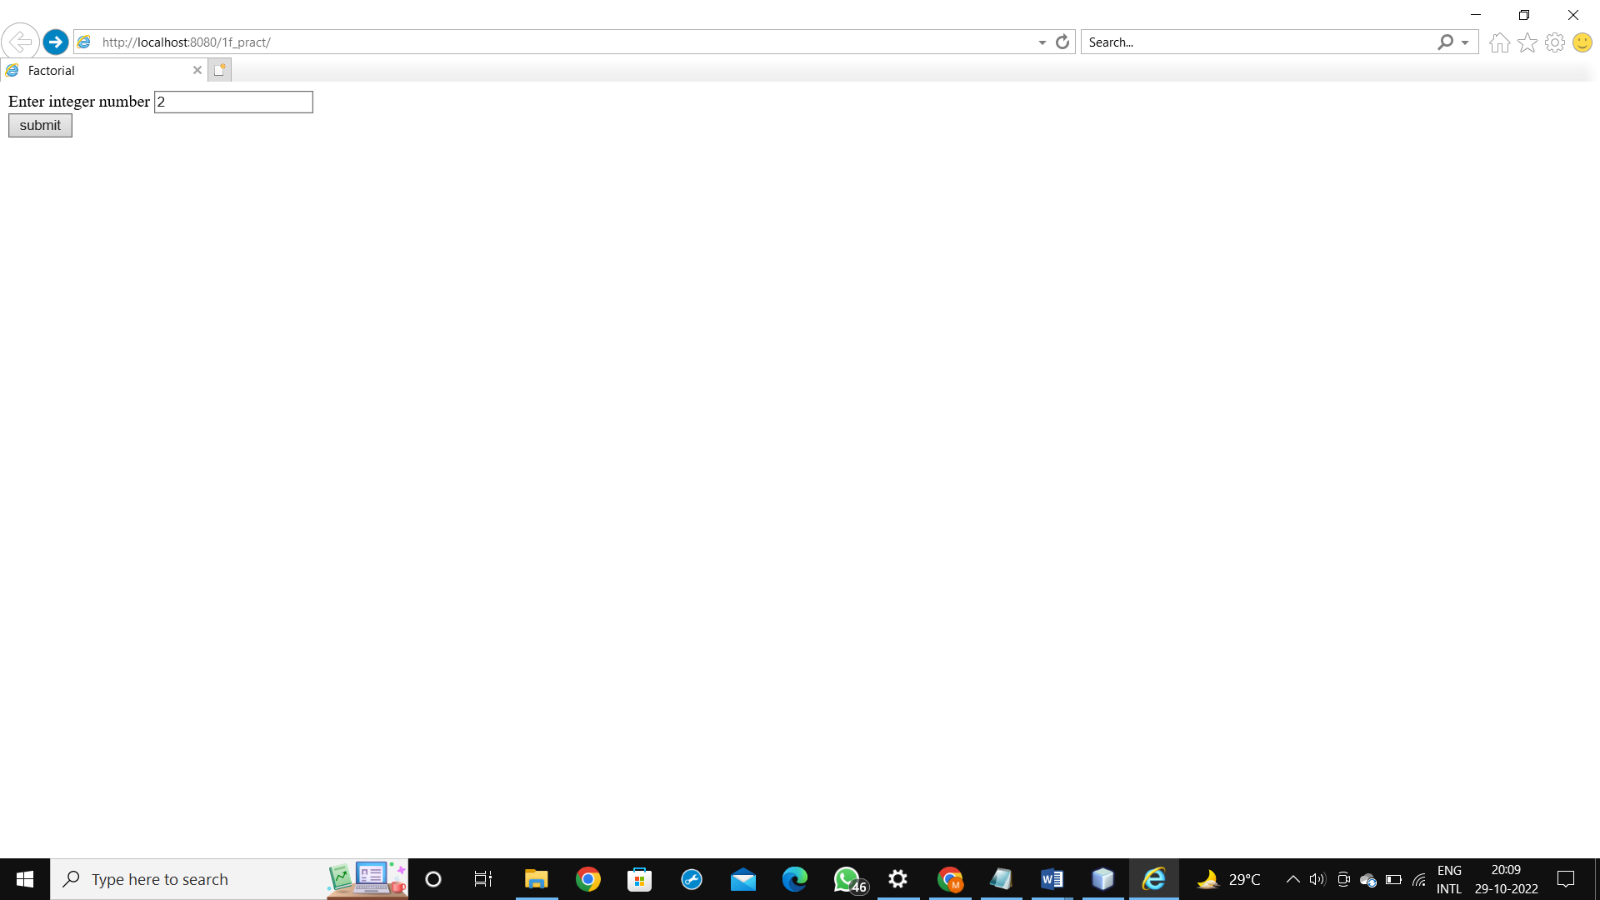

**f. Write servlet program to display the multiplication table of given number.**

**CODE:**

index.html

<html>

<head>

<title>TO DO supply a title</title>

<meta charset="UTF-8">

<meta name="viewport" content="width=device-width, initial-scale=1.0">

</head>

<body>

<form name="frml" method="post" action="Multiplication">

<label> Enter integer number</label><input type="text" name="m1"/><br/>

<input type="submit" value="Click Here"/>

</form>

</body>

</html>

Multiplication.java

package pack4;

import java.io.*;

import javax.servlet.*;

import javax.servlet.http.*;

public class Multiplication extends HttpServlet

{

@Override

protected void doPost(HttpServletRequest request, HttpServletResponse response)

throws ServletException, IOException

{

response.setContentType("text/html;charset=UTF-8");

PrintWriter out = response.getWriter();

String str1=request.getParameter("m1");

int n=Integer.parseInt(str1);

int ans;

for(int i=1;i<=10;i++)

{

ans=n*i;

out.println("<h3>" +n+"*"+i+"="+ans+"</h3>");

}

}

}

OUTPUT:

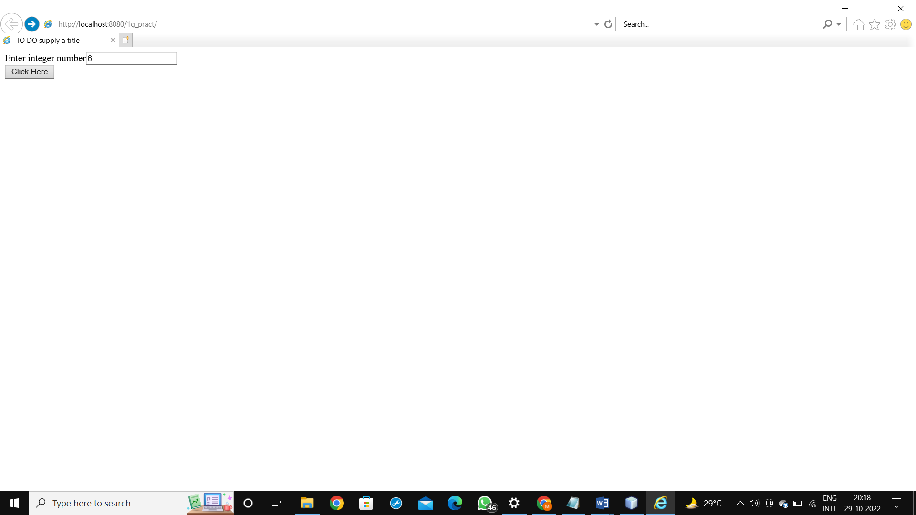

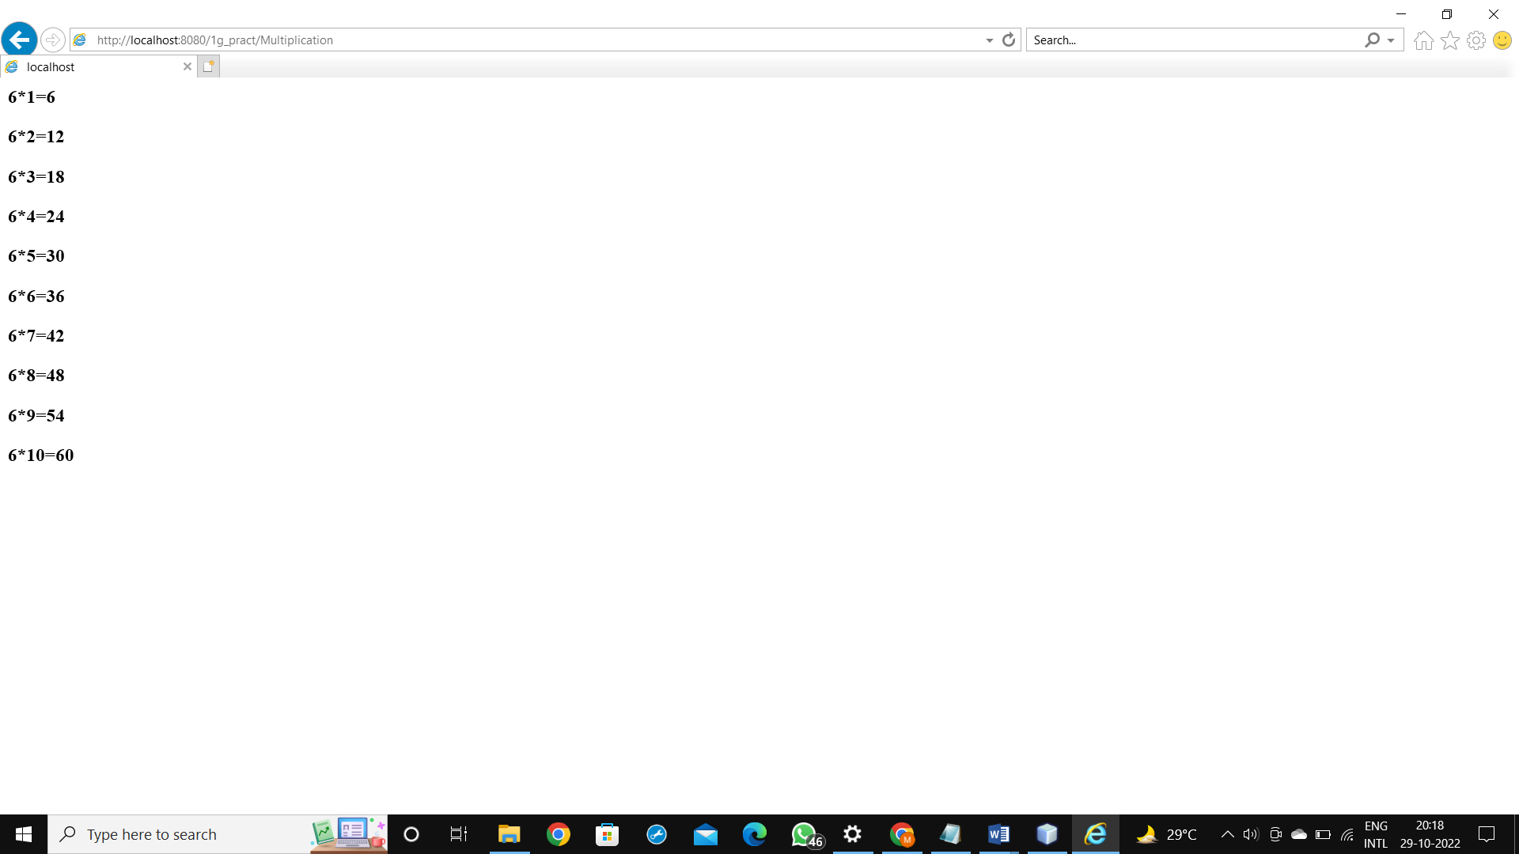

**PRACTICAL 8 Implement the following JPA applications**.

**a.Develop a simple Inventory Application Using JPA.**

**CODE:**

index.html

<!DOCTYPE html>

<!--

To change this license header, choose License Headers in Project Properties.

To change this template file, choose Tools | Templates

and open the template in the editor.

-->

<html>

<head>

<title>TODO supply a title</title>

<meta charset="UTF-8">

<meta name="viewport" content="width=device-width, initial-scale=1.0">

</head>

<body>

<form method="post" action="checkinventory.jsp">

<table border="1">

<thead>

<tr>

<th colspan="2">Add Items To Inventory Table</th>

<th></th>

</tr>

</thead>

<tbody>

<tr>

<td>Enter Item ID</td>

<td><input type="text" name="txtID"></td>

</tr>

<tr>

<td>Enter Item Name</td>

<td><input type="text" name="txtName"></td>

</tr>

<tr>

<td>Enter Item Price</td>

<td><input type="text" name="txtPrice"></td>

</tr>

<tr>

<td>Enter Item Qty</td>

<td><input type="text" name="txtQty"></td>

</tr>

<tr>

<td colspan="2"><input type="submit" value="submit"/></td>

</tr>

</tbody>

</table>

</form>

</body>

</html>

Inventory.java

/*

* To change this license header, choose License Headers in Project Properties.

* To change this template file, choose Tools | Templates

* and open the template in the editor.

*/

package com.test;

import java.io.Serializable;

import javax.persistence.Basic;

import javax.persistence.Column;

import javax.persistence.Entity;

import javax.persistence.Id;

import javax.persistence.NamedQueries;

import javax.persistence.NamedQuery;

import javax.persistence.Table;

import javax.validation.constraints.NotNull;

import javax.validation.constraints.Size;

import javax.xml.bind.annotation.XmlRootElement;

/**

*

* @author mohik

*/

@Entity

@Table(name = "INVENTORY")

@XmlRootElement

@NamedQueries({

@NamedQuery(name = "Inventory.findAll", query = "SELECT i FROM Inventory i")

, @NamedQuery(name = "Inventory.findByItemNo", query = "SELECT i FROM Inventory i WHERE i.itemNo = :itemNo")

, @NamedQuery(name = "Inventory.findByItemName", query = "SELECT i FROM Inventory i WHERE i.itemName = :itemName")

, @NamedQuery(name = "Inventory.findByItemPrice", query = "SELECT i FROM Inventory i WHERE i.itemPrice = :itemPrice")

, @NamedQuery(name = "Inventory.findByQty", query = "SELECT i FROM Inventory i WHERE i.qty = :qty")})

public class Inventory implements Serializable {

private static final long serialVersionUID = 1L;

@Id

@Basic(optional = false)

@NotNull

@Column(name = "ITEM_NO")

private Integer itemNo;

@Size(max = 50)

@Column(name = "ITEM_NAME")

private String itemName;

@Column(name = "ITEM_PRICE")

private Integer itemPrice;

@Column(name = "QTY")

private Integer qty;

public Inventory() {

}

public Inventory(Integer itemNo) {

this.itemNo = itemNo;

}

public Integer getItemNo() {

return itemNo;

}

public void setItemNo(Integer itemNo) {

this.itemNo = itemNo;

}

public String getItemName() {

return itemName;

}

public void setItemName(String itemName) {

this.itemName = itemName;

}

public Integer getItemPrice() {

return itemPrice;

}

public void setItemPrice(Integer itemPrice) {

this.itemPrice = itemPrice;

}

public Integer getQty() {

return qty;

}

public void setQty(Integer qty) {

this.qty = qty;

}

@Override

public int hashCode() {

int hash = 0;

hash += (itemNo != null ? itemNo.hashCode() : 0);

return hash;

}

@Override

public boolean equals(Object object) {

// TODO: Warning - this method won't work in the case the id fields are not set

if (!(object instanceof Inventory)) {

return false;

}

Inventory other = (Inventory) object;

if ((this.itemNo == null && other.itemNo != null) || (this.itemNo != null && !this.itemNo.equals(other.itemNo))) {

return false;

}

return true;

}

@Override

public String toString() {

return "com.test.Inventory[ itemNo=" + itemNo + " ]";

}

}

persistence.xml

<?xml version="1.0" encoding="UTF-8"?>

<persistence version="2.1" xmlns="http://xmlns.jcp.org/xml/ns/persistence" xmlns:xsi="http://www.w3.org/2001/XMLSchema-instance" xsi:schemaLocation="http://xmlns.jcp.org/xml/ns/persistence http://xmlns.jcp.org/xml/ns/persistence/persistence_2_1.xsd">

<persistence-unit name="pract_8aPU" transaction-type="JTA">

<exclude-unlisted-classes>false</exclude-unlisted-classes>

<properties/>

</persistence-unit>

</persistence>

AddInverntory.java

package com.test;

import java.io.*;

import javax.persistence.EntityManager;

import javax.persistence.EntityManagerFactory;

import javax.persistence.EntityTransaction;

import javax.persistence.Persistence;

import javax.servlet.ServletException;

import javax.servlet.http.*;

public class AddInventory extends HttpServlet

{

protected void processRequest(HttpServletRequest request, HttpServletResponse response)

throws ServletException, IOException {

response.setContentType("text/html;charset=UTF-8");

try (PrintWriter out = response.getWriter()) {

/* TODO output your page here. You may use following sample code. */

out.println("<!DOCTYPE html>");

out.println("<html>");

out.println("<head>");

out.println("<title>Servlet AddInventory</title>");

out.println("</head>");

out.println("<body>");

EntityManagerFactory entityManagerFactory=Persistence.createEntityManagerFactory("Practical_8APU");

EntityManager entityManager=entityManagerFactory.createEntityManager();

EntityTransaction entityTransaction=entityManager.getTransaction();

Inventory i=new Inventory();

i.setItemNo(Integer.parseInt(request.getParameter("txtId")));

i.setItemName(request.getParameter("txtName"));

i.setItemPrice(Integer.parseInt(request.getParameter("txtPrice")));

i.setQty(Integer.parseInt(request.getParameter("txtQty")));

entityTransaction.begin();

entityManager.persist(i);

entityTransaction.commit();

out.println("<h1>Record Added Auccessfully</h1>");

out.println("</body>");

out.println("</html>");

}

}

// <editor-fold defaultstate="collapsed" desc="HttpServlet methods. Click on the + sign on the left to edit the code.">

/**

* Handles the HTTP <code>GET</code> method.

*

* @param request servlet request

* @param response servlet response

* @throws ServletException if a servlet-specific error occurs

* @throws IOException if an I/O error occurs

*/

@Override

protected void doGet(HttpServletRequest request, HttpServletResponse response)

throws ServletException, IOException {

processRequest(request, response);

}

/**

* Handles the HTTP <code>POST</code> method.

*

* @param request servlet request

* @param response servlet response

* @throws ServletException if a servlet-specific error occurs

* @throws IOException if an I/O error occurs

*/

@Override

protected void doPost(HttpServletRequest request, HttpServletResponse response)

throws ServletException, IOException {

processRequest(request, response);

}

/**

* Returns a short description of the servlet.

*

* @return a String containing servlet description

*/

@Override

public String getServletInfo() {

return "Short description";

}// </editor-fold>

}

**OUTPUT:**

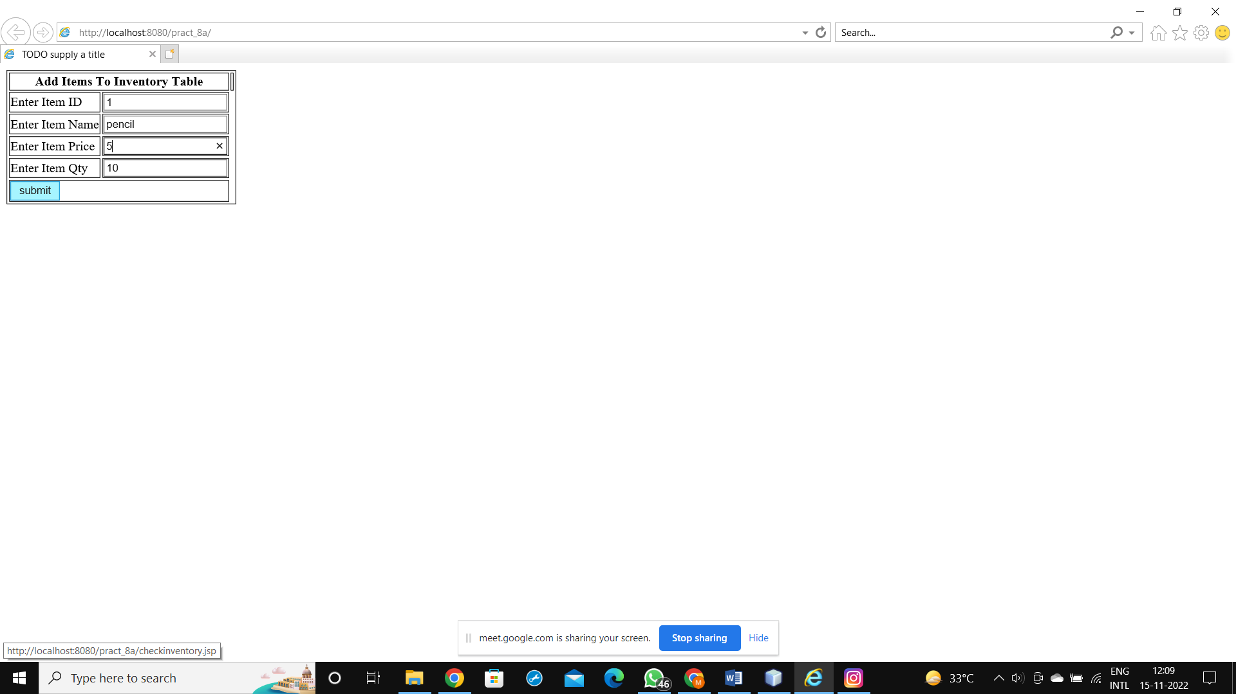

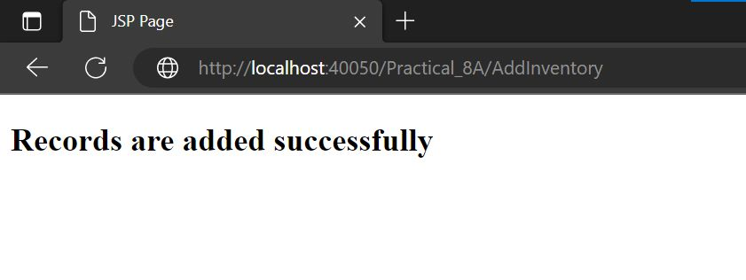

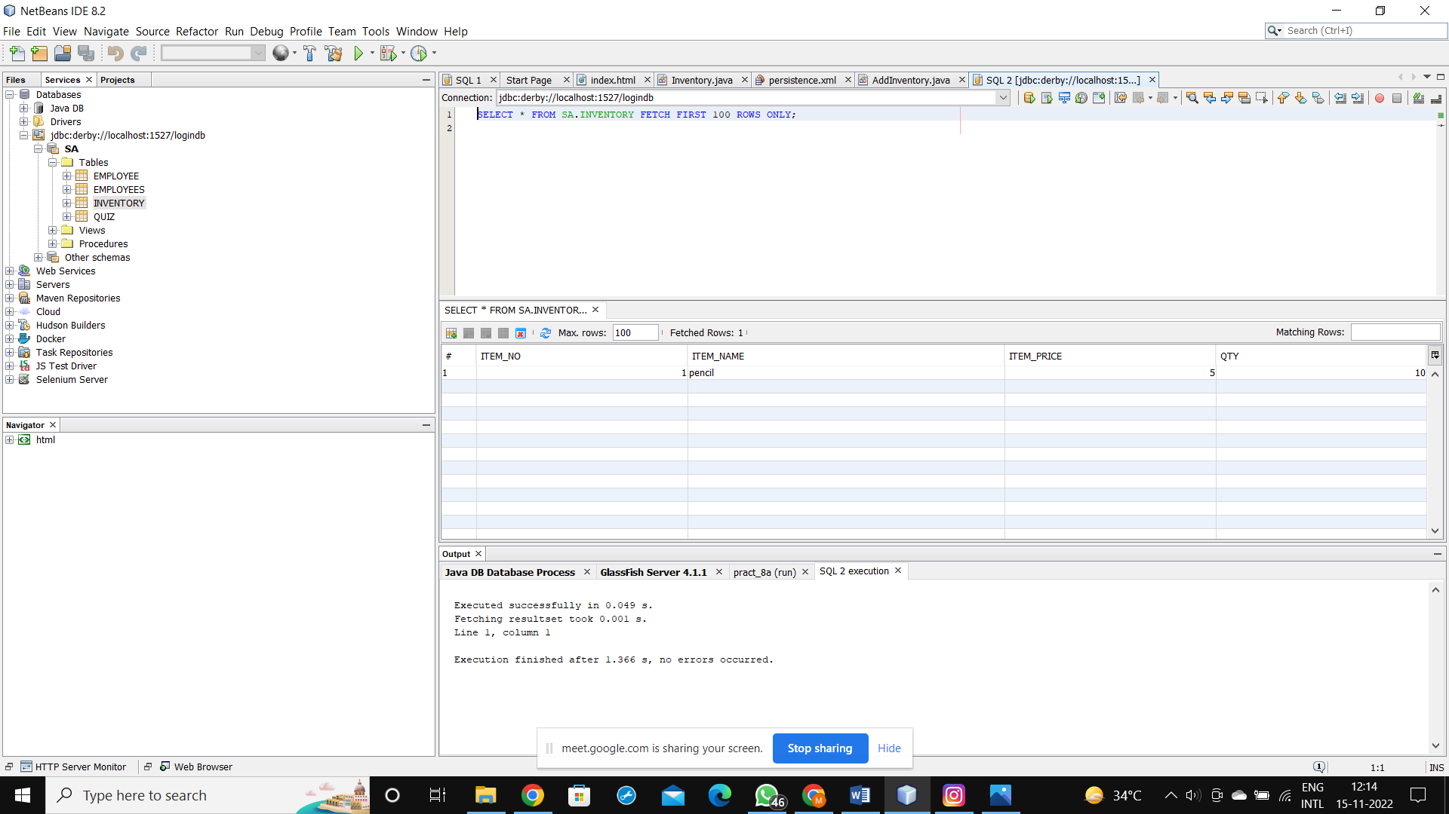

**PRACTICAL 2**

**a.Using Request Dispatcher Interface create a Servlet which will validate the password entered by the user, if the user has entered "Servlet" as password, then he will be forwarded to Welcome Servlet else the user will stay on the index.html page and an error message will be displayed.**

**CODE:**

index.html

<html>

<head>

<title>TODO supply a title</title>

<meta charset="UTF-8">

<meta name="viewport" content="width=device-width, initial-scale=1.0">

</head>

<body>

<form method="post" action="Validate">

User Name: <input type="text" name ="un"><br>

Password: <input type="password" name ="pw"><br>

<input type="submit" value="Login">

</form>

</body> </html>

Welcome.java

package pack;

import java.io.*;

import javax.servlet.*;

import javax.servlet.http.*;

public class Welcome extends HttpServlet

{

@Override

protected void doPost(HttpServletRequest request, HttpServletResponse

response)

throws ServletException, IOException

{

response.setContentType("text/html;charset=UTF-8");

PrintWriter out = response.getWriter();

String s2username = (String)request.getAttribute("s1username");

String s2password =(String)request.getAttribute("s2password");

out.println("Welcome "+s2username);

}

}

Validate.java

package pack;

import java.io.*;

import javax.servlet.*;

import javax.servlet.http.*;

public class Validate extends HttpServlet

{

@Override

protected void doPost(HttpServletRequest request, HttpServletResponse

response)

throws ServletException, IOException

{

response.setContentType("text/html;charset=UTF-8");

PrintWriter out = response.getWriter();

String username=request.getParameter("un");

String password=request.getParameter("pw");

if(password.equals("Servlet"))

{

request.setAttribute("s1username",username);

request.setAttribute("s1password",password);

RequestDispatcher rd= request.getRequestDispatcher("/Welcome");

rd.forward(request, response);

}

else

{

out.print("Incorrect password");

RequestDispatcher rd= request.getRequestDispatcher("/index.html");

rd.include(request, response);

}

}

}

OUTPUT:

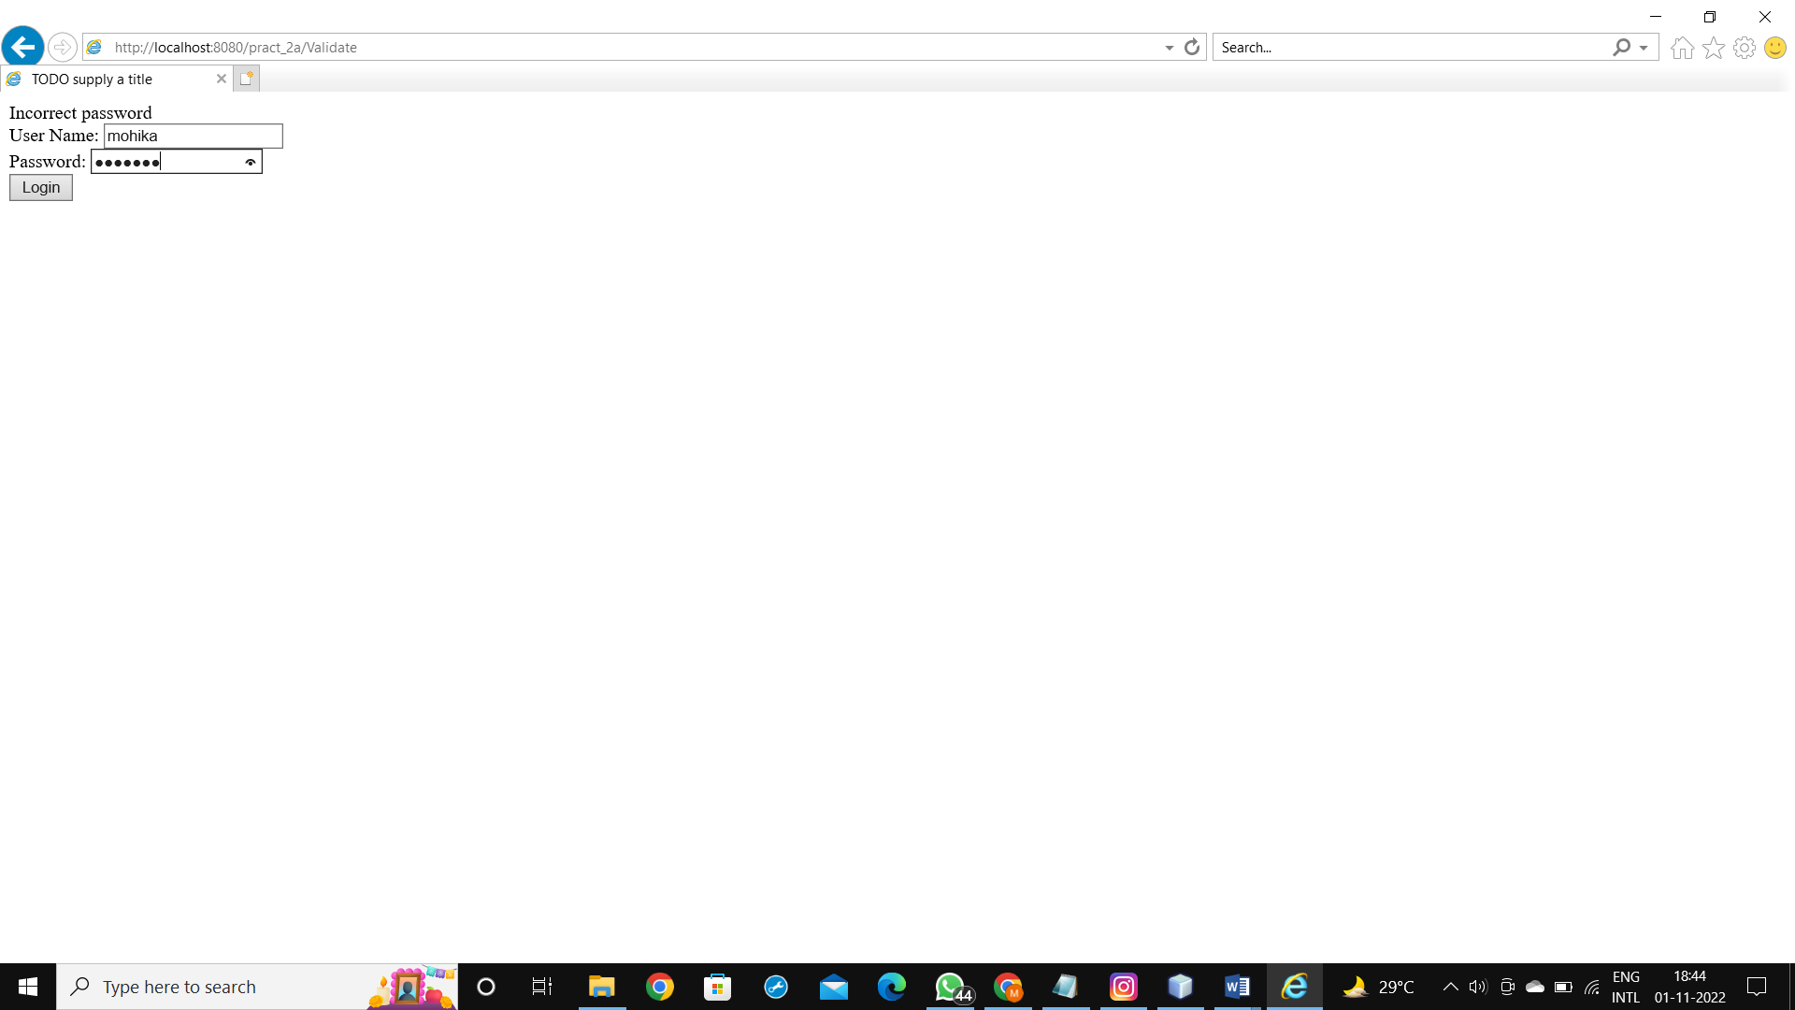

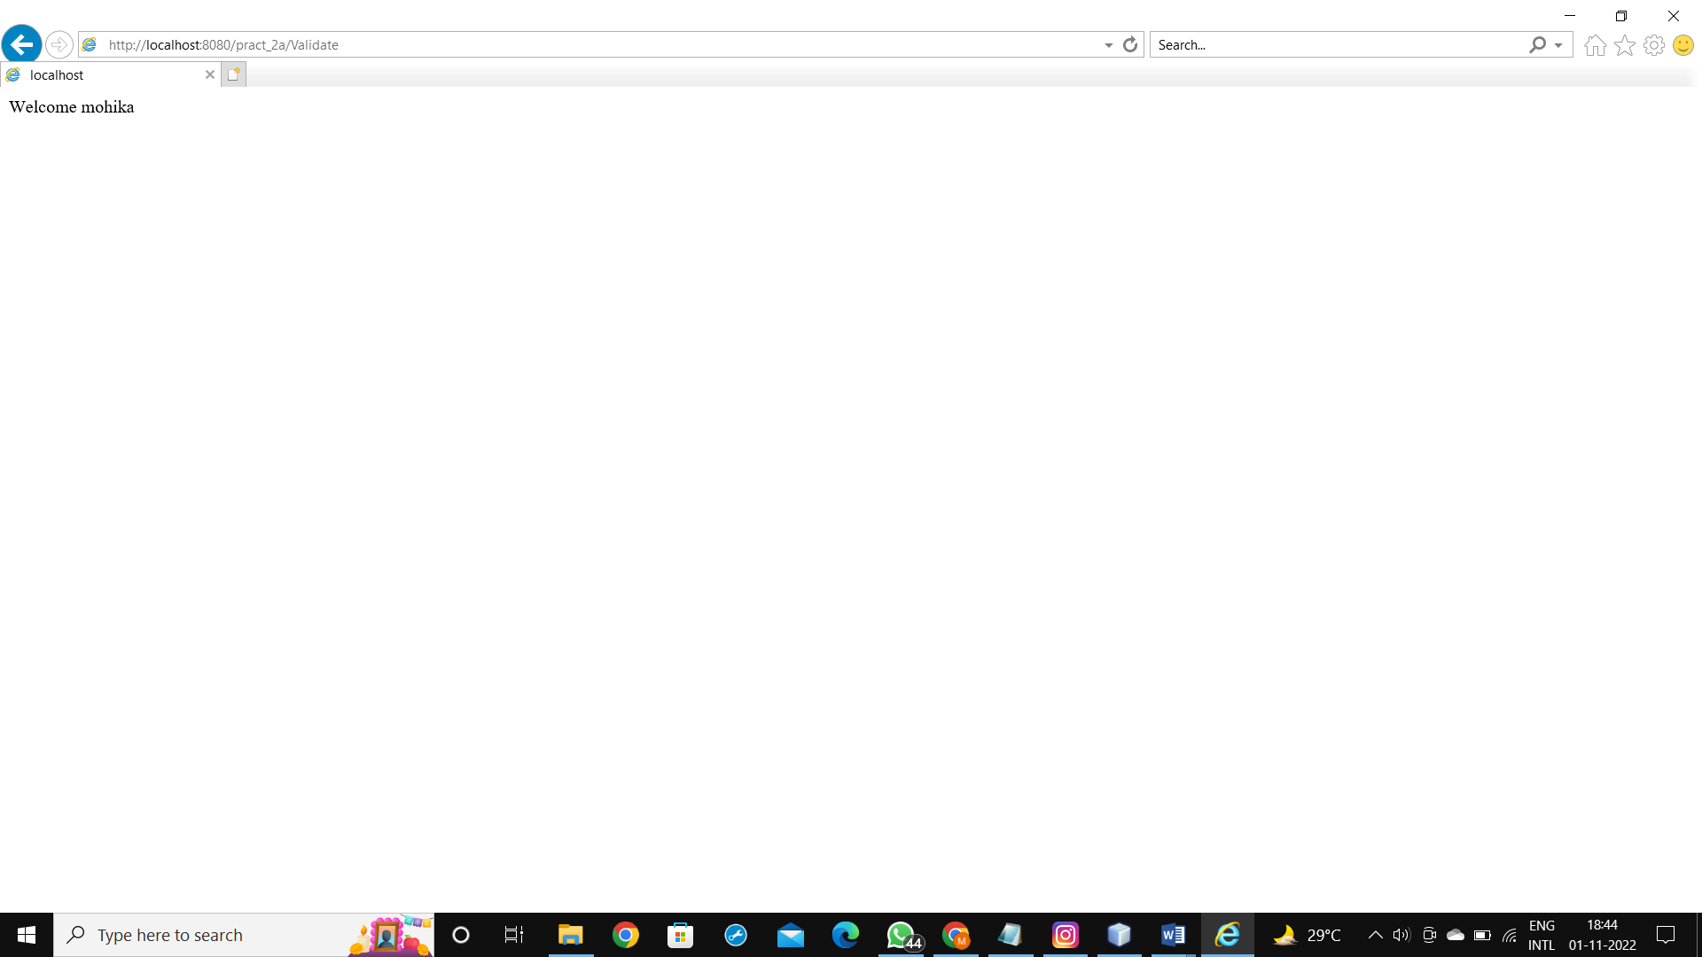

**b.Create a servlet that uses Cookies to store the number of times a user has visited servlet.**

**CODE:**

CookieServlet.java

package pack;

import java.io.*;

import javax.servlet.*;

import javax.servlet.http.*;

public class CookieServlet extends HttpServlet

{

private int i=1;

public void doGet(HttpServletRequest request, HttpServletResponse response)

throws IOException, ServletException

{

response.setContentType("text/html");

PrintWriter out = response.getWriter();

String k=String.valueOf(i);

Cookie c = new Cookie("visit",k);

response.addCookie(c);

int j=Integer.parseInt(c.getValue()); if(j==1)

{

out.println("This is the first time you are visiting this page");

}

else

{

synchronized(CookieServlet.this)

{

out.println("You visited this page "+i+" times");

}

}

i++;

}

}

**OUTPUT:**

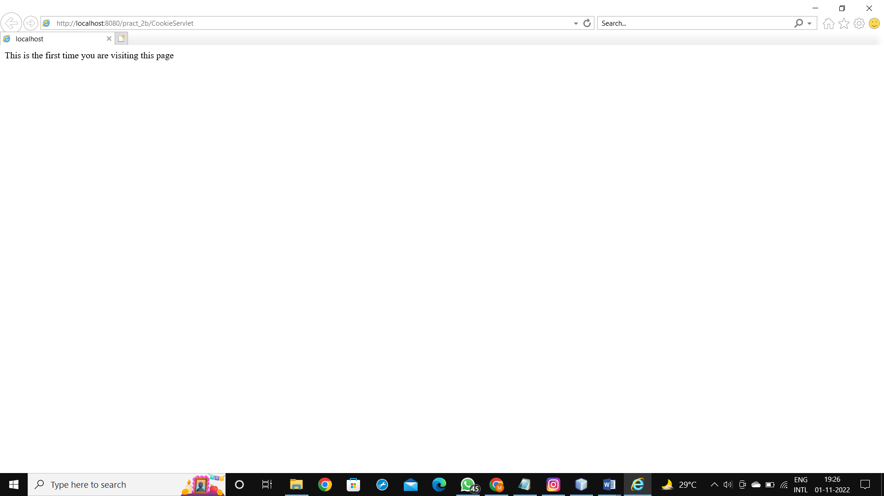

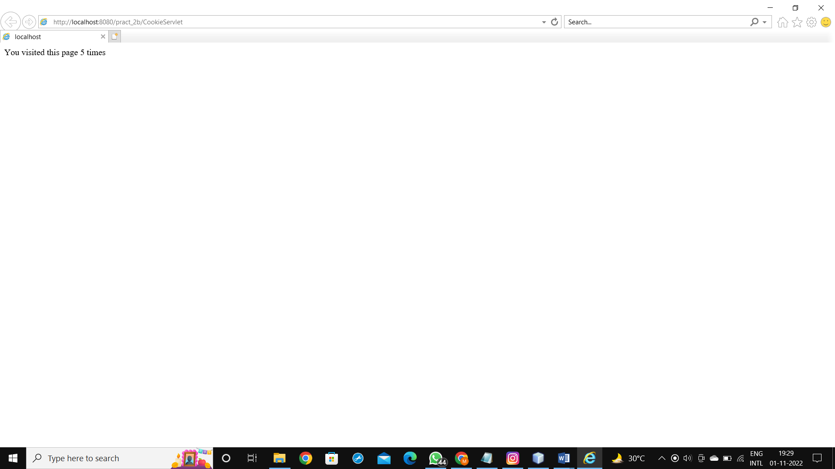

**c.Create a servlet demonstrating the use of session creation and destruction. Also check whether the user has visited this page first time or has visited earlier also using sessions.**

**CODE:**

index.html

<html>

<head>

<title>TO DO supply a title</title>

<meta charset="UTF-8">

<meta name="viewport" content="width=device-width, initial-scale=1.0">

</head>

<body>

<form action ="Page1" method ="get">

Enter User ID <input type ="text" name ="txtname"/> <br/>

<input type ="reset"/> <input type ="submit"/>

</form>

</body>

</html>

Page1.html

package pack1;

import java.io.*;

import javax.servlet.*;

import javax.servlet.http.*;

public class Page1 extends HttpServlet

{

protected void doGet(HttpServletRequest request, HttpServletResponse response)

throws ServletException, IOException

{

response.setContentType("text/html;charset=UTF-8");

PrintWriter out = response.getWriter();

try

{

HttpSession hs=request.getSession(true);

if(hs.isNew())

{

out.println("<body bgcolor='yellow'>");

String name=request.getParameter("txtName");

hs.setAttribute("uname", name);

hs.setAttribute("visit","1");

out.print("<h1> Welcome First Time</h1>");

}

else

{

out.println("Welcome once again");

int visit=Integer.parseInt((String)hs.getAttribute("visit"))+1;

out.println("<h1>You Visited"+visit+"times</h1>");

hs.setAttribute("visit",""+visit);

}

out.println("<h1>Your session ID"+hs.getId()+"</h1>");

out.println("<h1>You logged in at"+new java.util.Date(hs.getCreationTime())+"</h1>");

out.println("<h1><a href=Page2>Click for Page2</a></h1>");

out.println("<h1><a href=Page3>Click for Page3</a></h1>")

out.println("<h1><a href=LogServlet2>Click to terminate session</a></h1>");

out.println("</body></html>");

}

catch(Exception e)

{

}

}

}

Page2.html

package pack1;

import java.io.*;

import javax.servlet.*;

import javax.servlet.http.*;

public class Page2 extends HttpServlet

{

protected void doGet(HttpServletRequest request, HttpServletResponse response)

throws ServletException, IOException {

response.setContentType("text/html;charset=UTF-8");

PrintWriter out = response.getWriter();

try

{

HttpSession hs=request.getSession(false);

out.print("<h1> Welcome again on Page2</h1>");

int visit=Integer.parseInt((String)hs.getAttribute("visit"))+1;

out.println("<h1>You Visited"+visit+"times</h1>");

hs.setAttribute("visit",""+visit);

out.println("<h1>Your session ID"+hs.getId()+"</h1>");

out.println("<h1>You logged in at"+new java.util.Date(hs.getCreationTime())+"</h1>");

out.println("<h1><a href=Page2>Click for Page2</a></h1>");

out.println("<h1><a href=Page3>Click for Page3</a></h1>");

out.println("<h1><a href=LogServlet2>Click to terminate session</a></h1>");

out.println("</body></html>");

}

catch(Exception e)

{

}

}

}

Page3.html

package pack1;

import java.io.*;

import javax.servlet.*;

import javax.servlet.http.*;

public class Page3 extends HttpServlet

{

protected void doGet(HttpServletRequest request, HttpServletResponse response)

throws ServletException, IOException {

response.setContentType("text/html;charset=UTF-8");

PrintWriter out = response.getWriter();

try

{

HttpSession hs=request.getSession(false);

out.print("<h1> Welcome again on Page3</h1>");

int visit=Integer.parseInt((String)hs.getAttribute("visit"))+1;

out.println("<h1>You Visited"+visit+"times</h1>");

hs.setAttribute("visit",""+visit);

out.println("<h1>Your session ID"+hs.getId()+"</h1>");

out.println("<h1>You logged in at"+new java.util.Date(hs.getCreationTime())+"</h1>");

out.println("<h1><a href=Page2>Click for Page2</a></h1>");

out.println("<h1><a href=Page3>Click for Page3</a></h1>");

out.println("<h1><a href=LogServlet2>Click to terminate session</a></h1>");

out.println("</body></html>");

}

catch(Exception e)

{

}

}

}

LogServlet2.java

package pack1;

import java.io.*;

import javax.servlet.*;

import javax.servlet.http.*;

public class LogServlet2 extends HttpServlet

{

protected void doGet(HttpServletRequest request, HttpServletResponse response)

throws ServletException, IOException {

response.setContentType("text/html;charset=UTF-8");

PrintWriter out = response.getWriter();

HttpSession hs=request.getSession();

if(hs!=null)

hs.invalidate();

out.println("<h1>You are Logged out now</h1>");

out.println("</body>");

out.println("</html>");

}

}

**OUTPUT:**

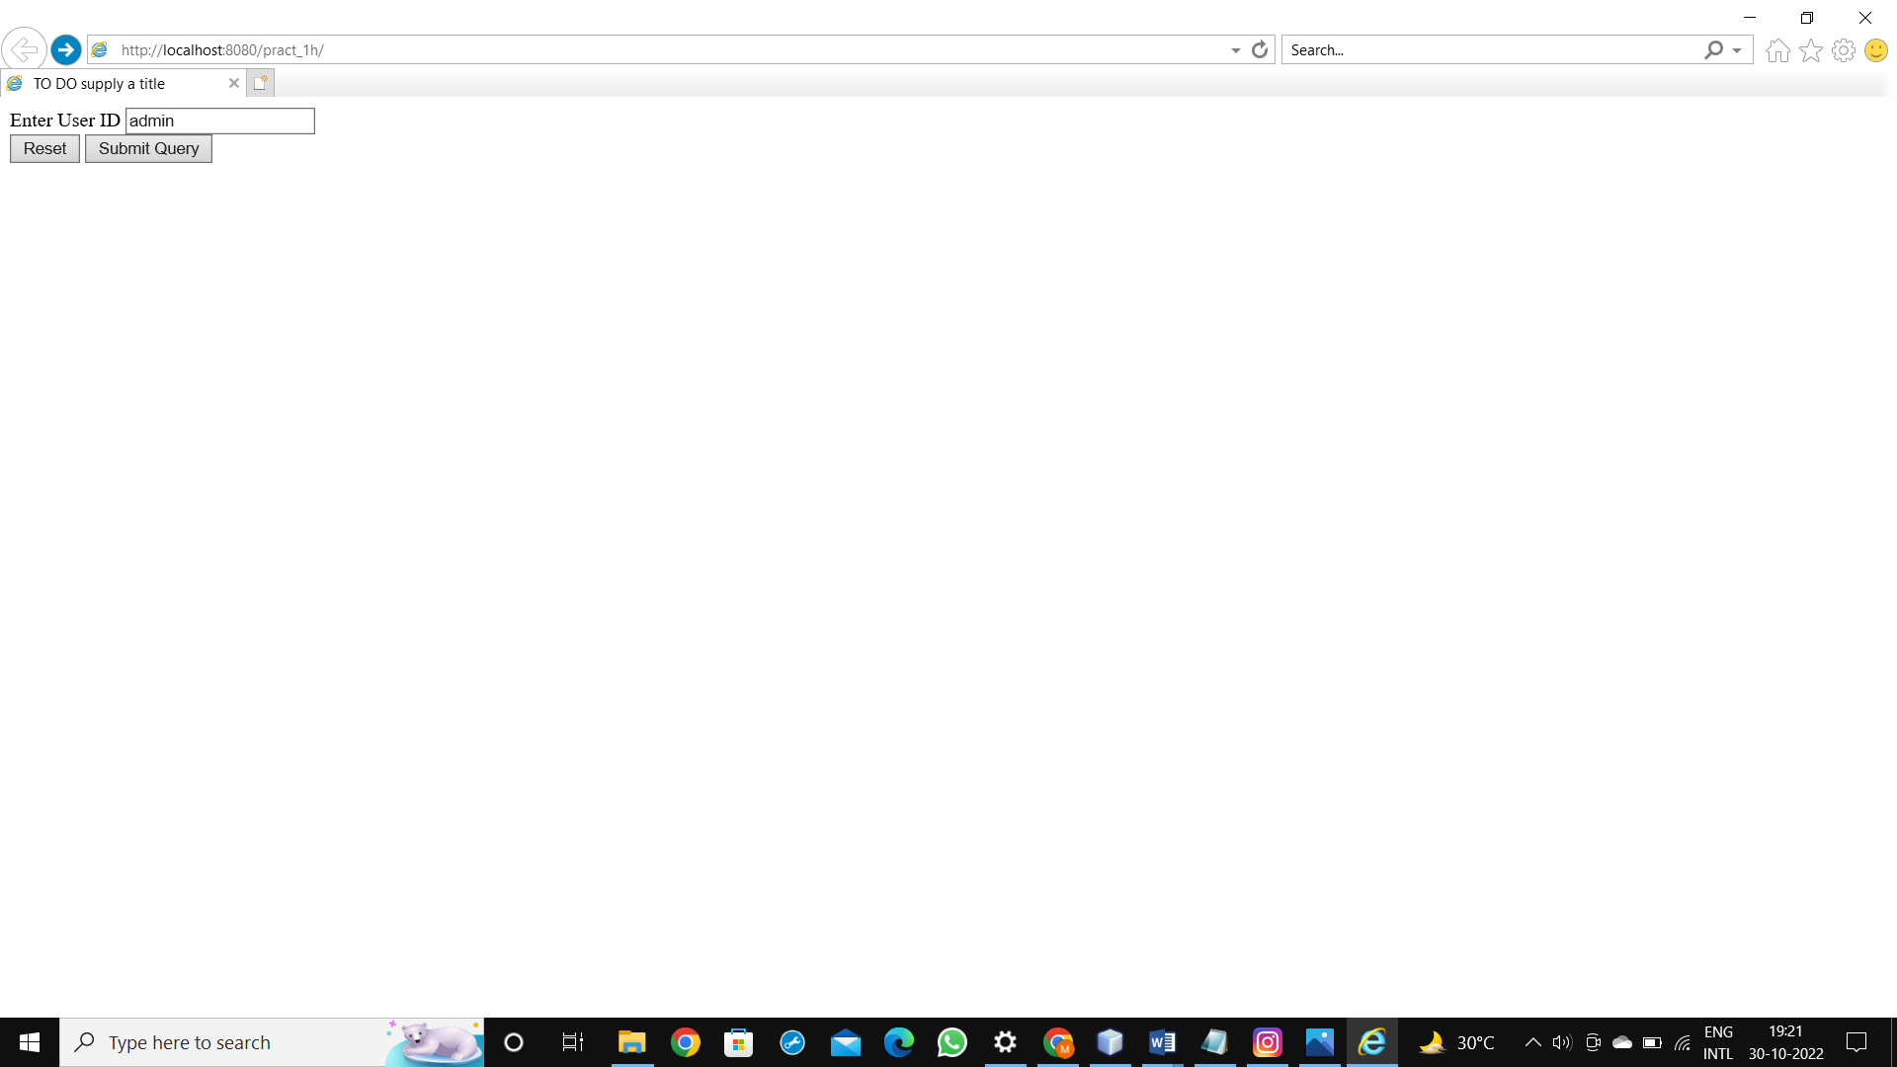

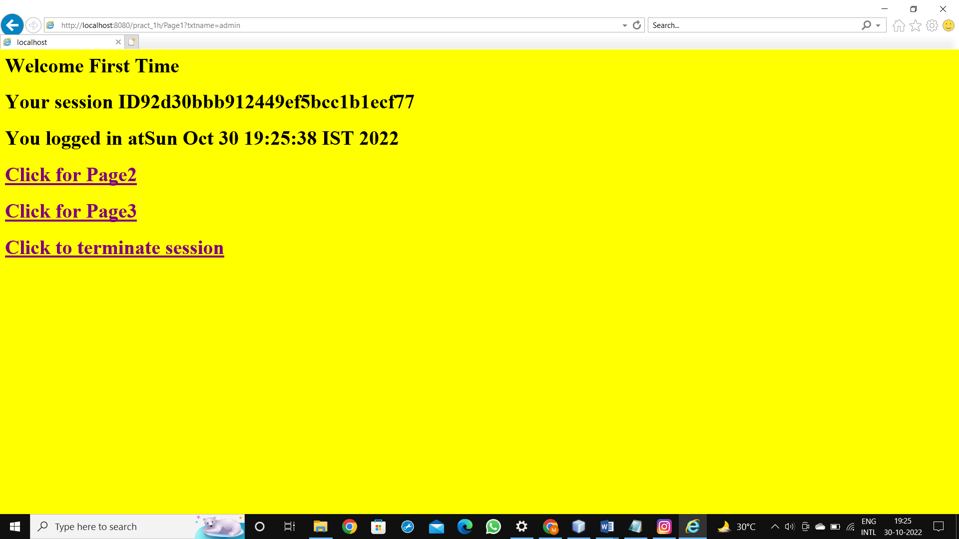

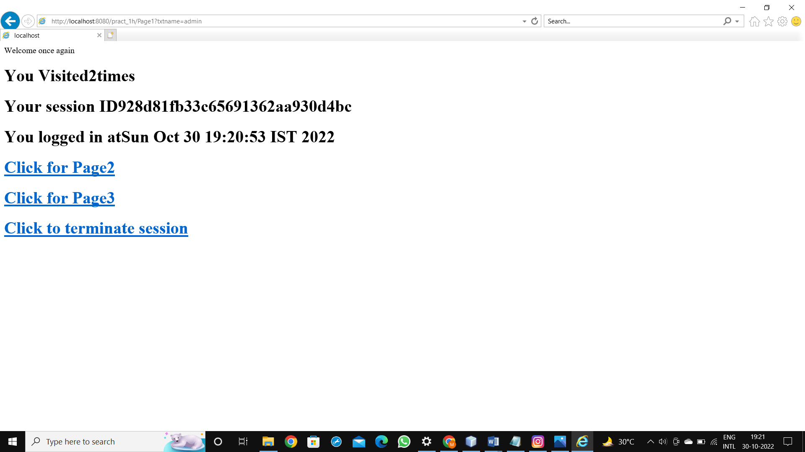

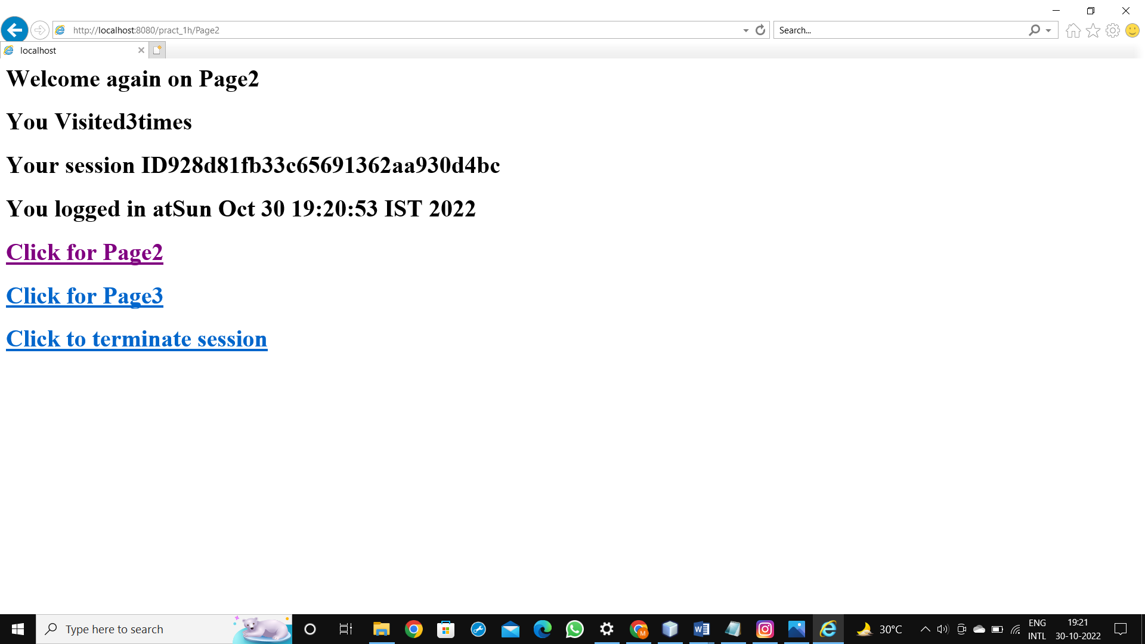

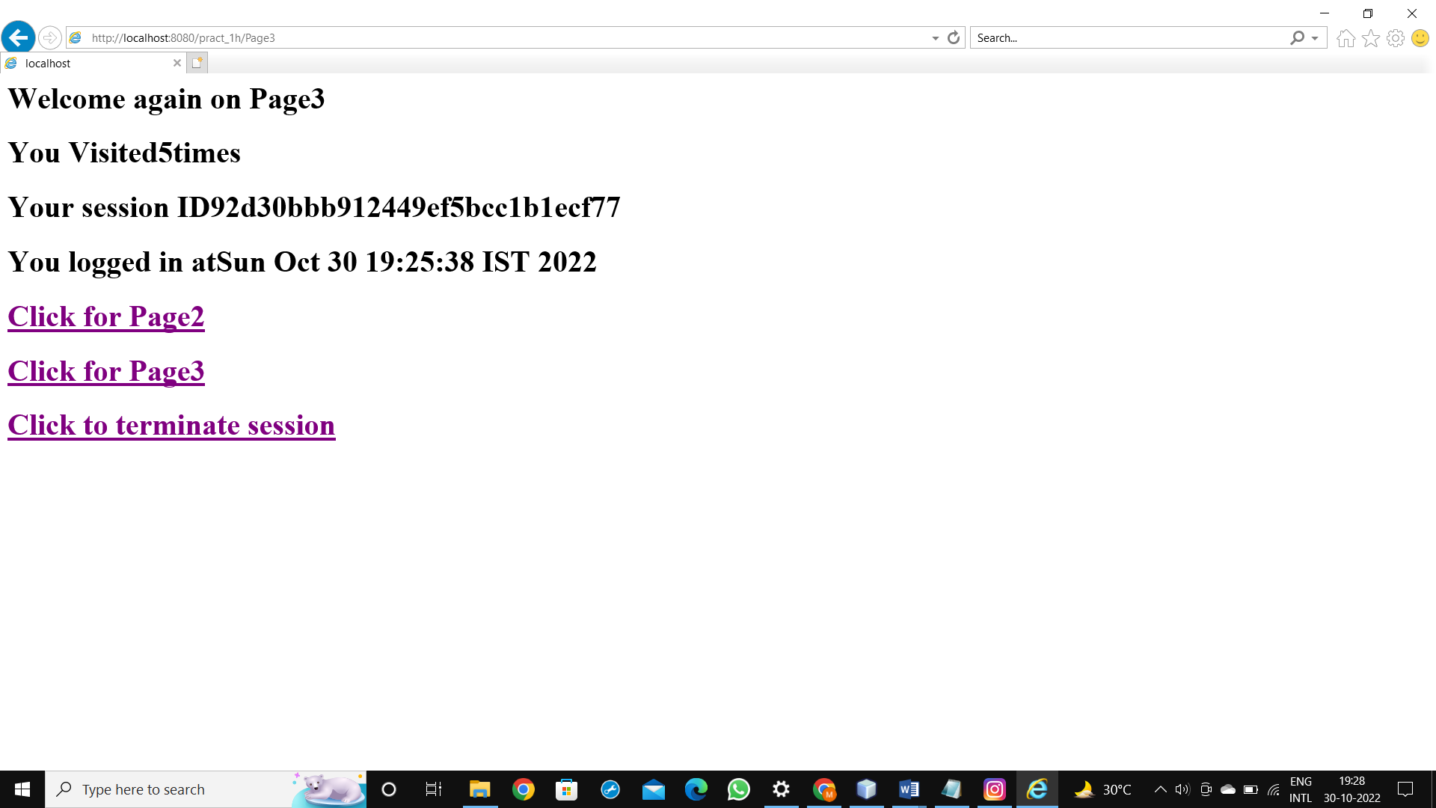

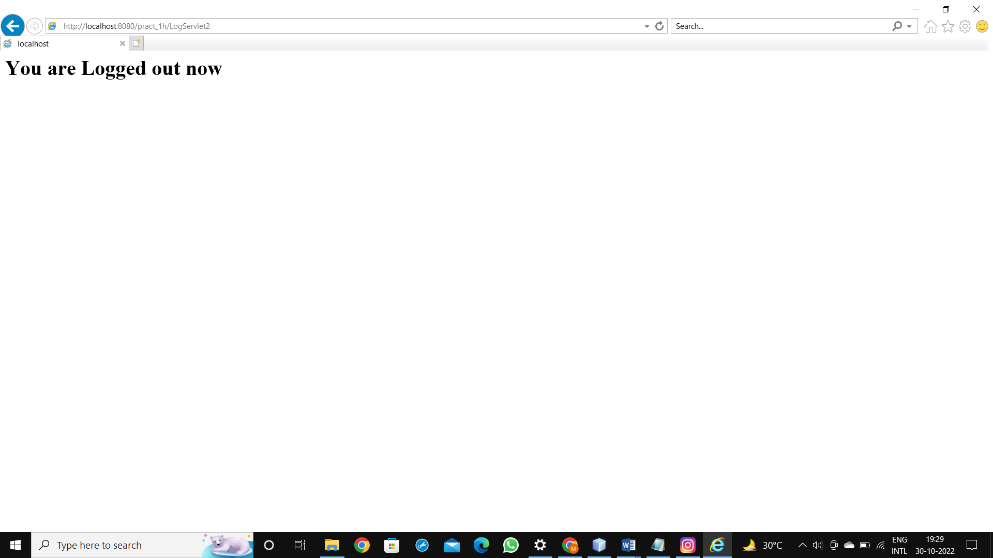

**PRACTICAL 3**

**a.Create a Servlet application to upload and download a file.**

**CODE:**

index.html

<html>

<head>

<title>TODO supply a title</title>

<meta charset="UTF-8">

<meta name="viewport" content="width=device-width, initial-scale=1.0">

</head>

<body>

<form action="FileUploadServlet" method="post" enctype="multipart/form-data">

Select File to Upload:<input type="file" name="file" id="file">

Destination <input type="text" value="E:\java" name="destination"><br>

<input type="submit" value="Upload file" name="upload" id="upload">

</form>

</body>

</html>

FileUploadServlet

package pack;

import java.io.*;

import javax.servlet.*;

import javax.servlet.annotation.MultipartConfig;

import javax.servlet.http.*;

@MultipartConfig

public class FileUploadServlet extends HttpServlet

{

@Override

public void doPost(HttpServletRequest req,HttpServletResponse res)

throws ServletException, IOException

{

res.setContentType("text/html");

PrintWriter out = res.getWriter();

String path=req.getParameter("destination"); Part filePart=req.getPart("file");

String sfilePart=req.getPart("file").toString();

out.print("<br> filePart: "+sfilePart);

String filename=filePart.getSubmittedFileName().toString();

out.print("<br><br><hr> file name: "+filename);

OutputStream os=null;

InputStream is=null;

try

{

os=new FileOutputStream(new File(path+File.separator+filename));

is=filePart.getInputStream();

int read=0;

byte[] b=new byte[1024];

while ((read = is.read(b)) != -1)

{

os.write(b, 0, read);

}

out.println("<br>file uploaded sucessfully...!!!");

}

catch(FileNotFoundException e)

{

out.print(e);

}

}

}

Download file

index.html

<!DOCTYPE html>

<html>

<head>

<title>TODO supply a title</title>

<meta charset="UTF-8">

<meta name="viewport" content="width=device-width, initial-scale=1.0">

</head>

<body>

<form method="post" action="downloadServlet" enctype="multipart/form-data">

Enter Filename to Download<input type="file" name="filename"/><br/>

<input type="submit" value="DownloadFile"/>

</form>

</body>

</html>

downloadServlet.java

package pack;

import java.io.*;

import javax.servlet.*;

import javax.servlet.http.*;

public class downloadServlet extends HttpServlet

{

ServletOutputStream os;

@Override

protected void doPost(HttpServletRequest request, HttpServletResponse response)

throws ServletException, IOException

{

response.setContentType("APPLICATION/OCTET-STREAM");

String filename=request.getParameter("txt1");

String filepath="D:\\"+filename;

try

{

ServletContext context= getServletConfig().getServletContext();

InputStream is=context.getResourceAsStream("/"+filepath);

os=response.getOutputStream();

response.setHeader("Content-Disposition","attachment; filename=\"" + filename + "\"");

int i;

byte b[]=new byte[1024];

while (is!=null && (i=is.read(b)) !=1)

{

os.write(b,0,i);

}

//is.close();

os.flush();

}

catch(Exception e){

}

finally

{

os.close();

}

}

}

context.xml

<?xml version="1.0" encoding="UTF-8"?>

<Context path="/DownloadFile"/>

**OUTPUT:**

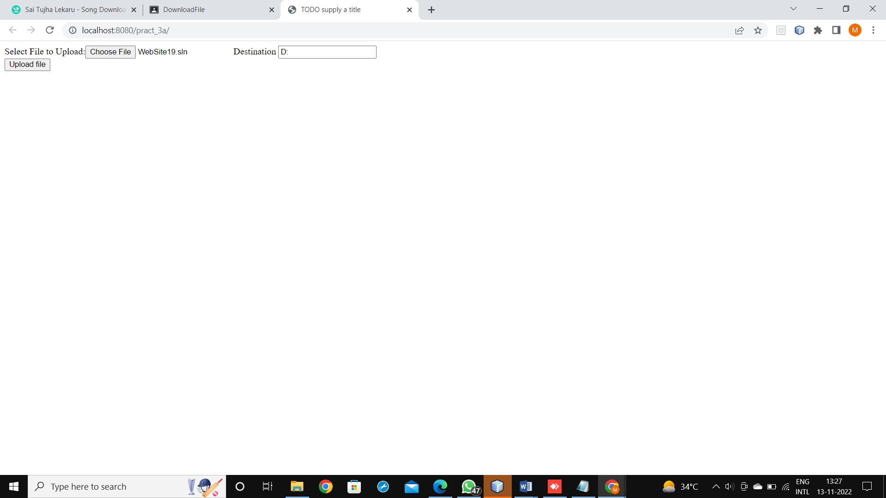

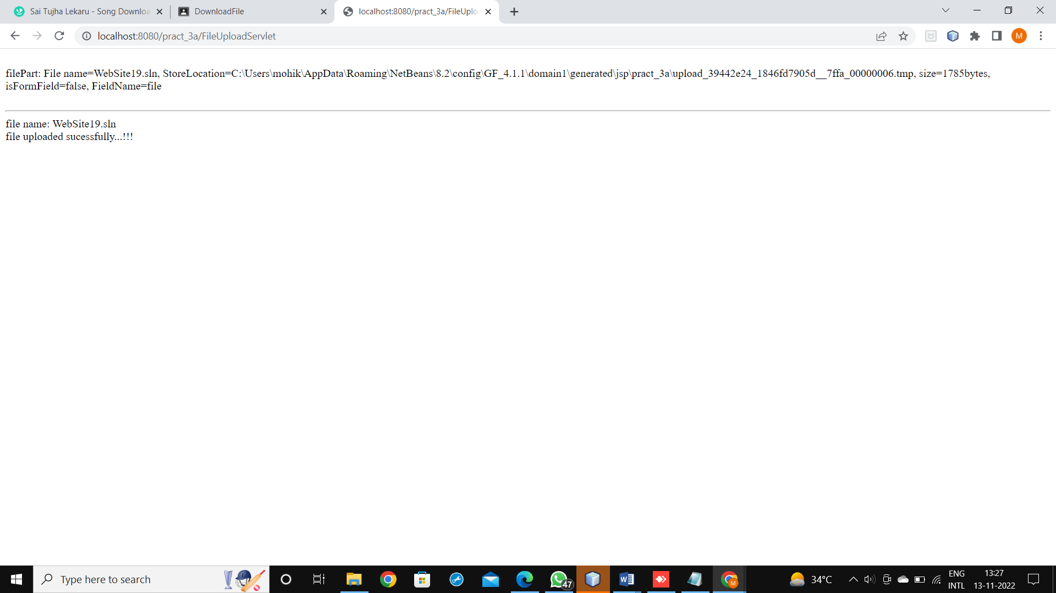

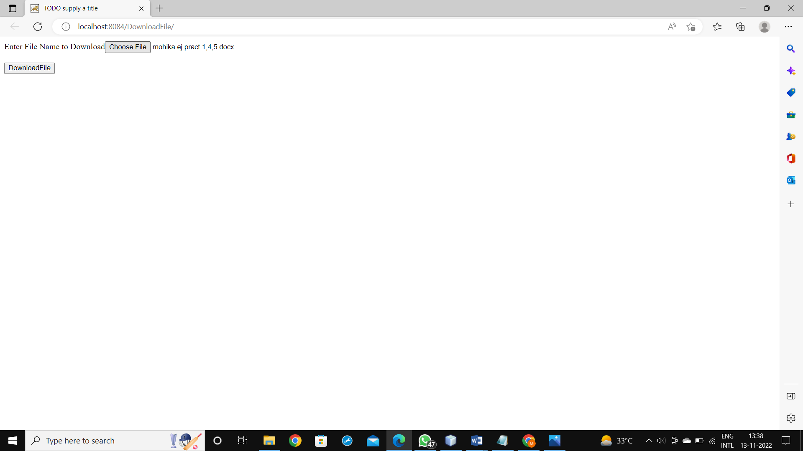

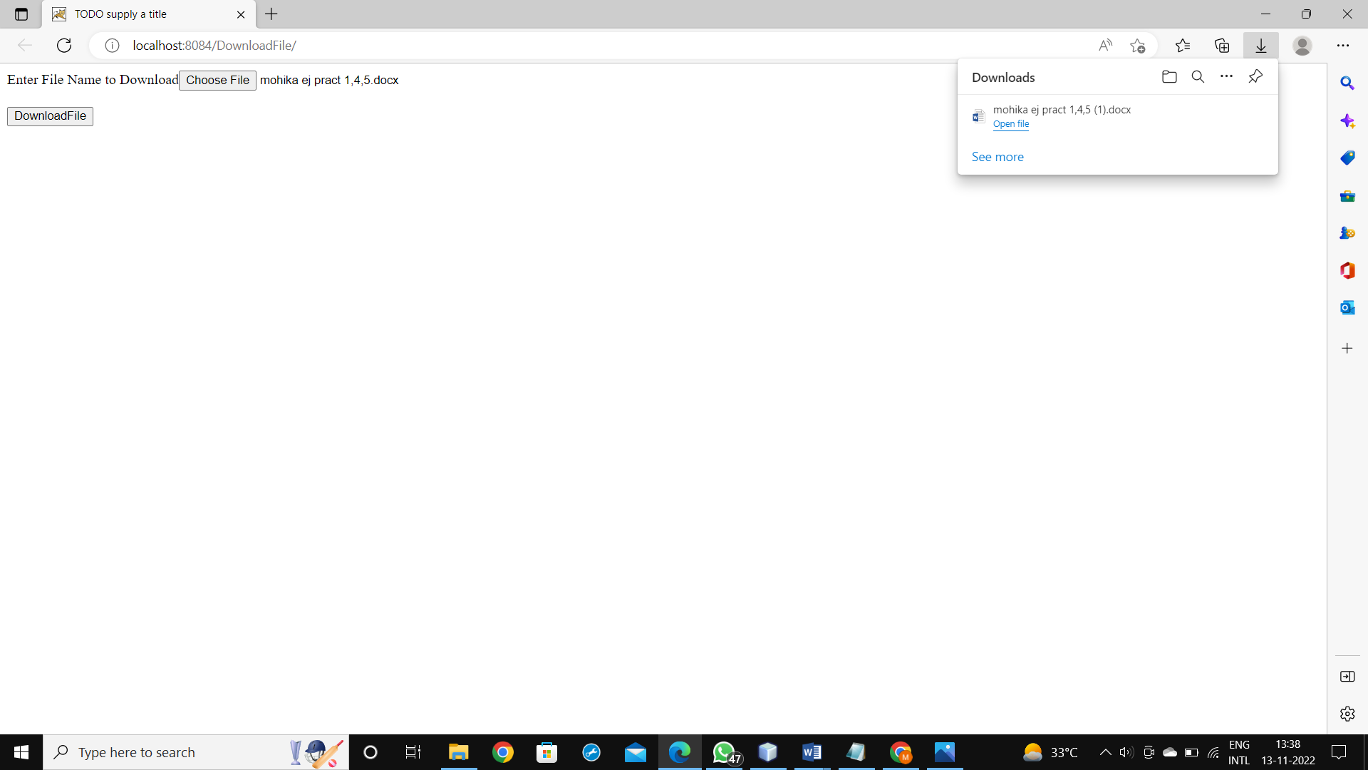

**b.Develop Simple Servlet Question Answer Application using Database.**

**CODE:**

QuizServlet.java

package pack;

import java.io.*;

import javax.servlet.*;

import javax.servlet.http.*;

import java.sql.*;

public class QuizServlet extends HttpServlet

{

@Override

protected void doGet(HttpServletRequest request,

HttpServletResponse response)

throws ServletException, IOException

{

response.setContentType("text/html;charset=UTF-8");

PrintWriter out = response.getWriter();

try

{

out.print("<html><body><br>");

out.println("<form method='post' action='MarksServlet'>");

Class.forName("org.apache.derby.jdbc.ClientDriver");

Connection con=DriverManager.getConnection("jdbc:derby://localhost:1527/logindb","sa","1234567");

Statement st = con.createStatement();

String sql="select * from Quiz";

ResultSet rs = st.executeQuery(sql);

int i=0;

out.print("<center>Online Exam</center>");

while(rs.next())

{

i++;

out.print("<br><br><hr>"+rs.getInt(1)+" ");

out.print(rs.getString(2));

out.print("<br><input type=radio name="+i+" value="+rs.getString(3)+">"+rs.getString(3));

out.print("<br><input type=radio name="+i+" value="+rs.getString(4)+">"+rs.getString(4));

out.print("<br><input type=radio name="+i+" value="+rs.getString(5)+">"+rs.getString(5));

out.print("<br><input type=radio name="+i+" value="+rs.getString(6)+">"+rs.getString(6));

String ans="ans"+i;

out.println("<br><input type=hidden name="+ans+" value="+rs.getString(7)+">");

//out.println("<h2>"+ans+"</h2>");

}

out.println("<br><input type=hidden name=total value="+i+">");

out.println("<input type=submit value=submit>");

out.println("</form>");

out.print("</body></html>");

}

catch(Exception e)

{

out.println("ERROR "+e.getMessage());

}

}

}

MarksServlet.java

package pack;

import java.io.*;

import javax.servlet.*;

import javax.servlet.http.*;

public class MarksServlet extends HttpServlet

{

@Override

protected void doPost(HttpServletRequest request, HttpServletResponse response)

throws ServletException, IOException

{

response.setContentType("text/html");

PrintWriter out = response.getWriter();

try

{

out.print("<html><body>");

int total=Integer.parseInt(request.getParameter("total"));

int marks=0;

for(int i=1; i<=total; i++)

{

String sel=request.getParameter(new Integer(i).toString());

String ans="ans"+i;

String a=request.getParameter(ans);

if (sel.equals(a))

marks++;

}

out.println("Total Marks : "+marks);

out.print("</body></html>");

}

catch(Exception e)

{

out.println("ERROR "+e.getMessage());

}

}

}

Create database table

create table quiz (qno varchar(5) PRIMARY KEY,question varchar(100), op1 varchar(50), op2 varchar(50), op3 varchar(50), op4 varchar(50), ans varchar(50))

insert into quiz values('001','What is the capital of India??', 'New Delhi','Kolkata','Chennai','Mumbai','New Delhi');

insert into quiz values('002', 'Who was the First President of India??','Dr. Rajendra Prasad','Dr. S.Radhakrishnan',' Ram Nath Kovind', 'V. V. Giri','Dr. Rajendra Prasad');

insert into quiz values('003', 'What is ORM','Object Ratio Mean', 'Object Rotation Measure','Object Relation Mapping','Oracle Request Management','Object Relation Mapping');

insert into quiz values('004','Unit of Energy is Dozon','Kilo Meter','Joul','Hertz','Dozon','Joul');

insert into quiz values('005', 'is the smallest memory unit.','bit', 'byte','Kilo Byte','Giga Byte','bit');

select * from quiz

**OUTPUT:**

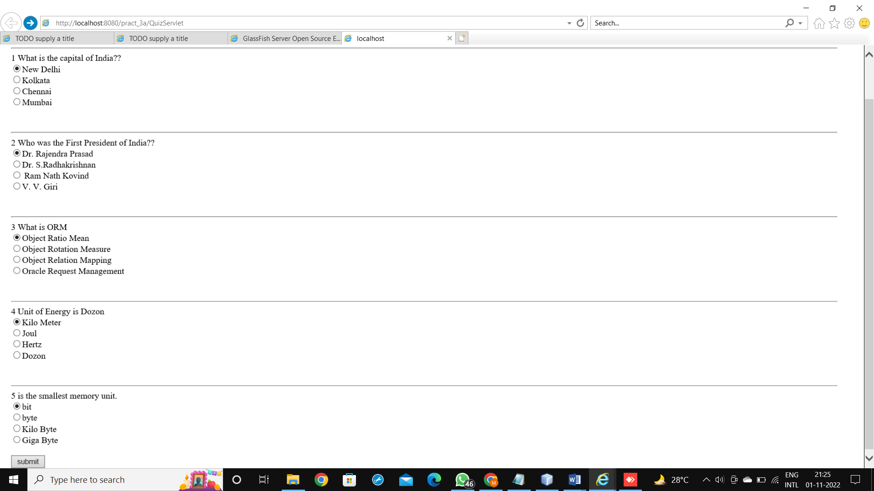

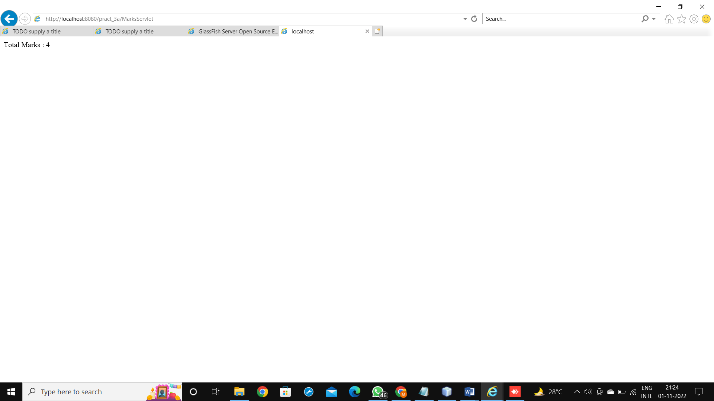

**c.Create simple Servlet application to demonstrate Non-Blocking Read Operation.**

**CODE:**

index.html

<html>

<head>

<title>TODO supply a title</title>

<meta charset="UTF-8">

<meta name="viewport" content="width=device-width, initial-scale=1.0">

</head>

<body>

<a href="NonBlockingServlet">Non Blocking Servlet</a>

</body>

</html>

ReadingListner.java

package nonblkapp;

import javax.servlet.*;

public class ReadingListner implements ReadListener

{

ServletInputStream input = null;

AsyncContext ac = null;

ReadingListner(ServletInputStream in, AsyncContext c)

{

input = in;

ac = c;

}

@Override

public void onDataAvailable()

{

}

@Override

public void onAllDataRead()

{

ac.complete();

}

@Override

public void onError(Throwable t)

{

ac.complete();

}

}

NonBlockingServlet.java

package nonblkapp;

import java.io.*;

import java.net.HttpURLConnection;

import java.net.URL;

import java.util.logging.Level;

import java.util.logging.Logger;

import javax.servlet.*;

import javax.servlet.annotation.WebServlet;

import javax.servlet.http.*;

@WebServlet(name = "NonBlockingServlet", urlPatterns = {"/NonBlockingServlet"})

public class NonBlockingServlet

extends HttpServlet

{

@Override

protected void service(HttpServletRequest request, HttpServletResponse response)

throws ServletException, IOException

{

response.setContentType("text/html");

PrintWriter out = response.getWriter();

String filename = "/WEB-INF/booklist.txt";

ServletContext c = getServletContext();

InputStream is = c.getResourceAsStream("/"+filename);

InputStreamReader isr = new InputStreamReader(is);

BufferedReader br = new BufferedReader(isr);

String path = "http://" + request.getServerName() + ":" + request.getServerPort() + request.getContextPath() + "/ReadingNonBlockingServlet";

out.println("<h1>File Reader</h1>");

URL url = new URL(path);

HttpURLConnection hc = (HttpURLConnection) url.openConnection();

hc.setChunkedStreamingMode(2);

hc.setDoOutput(true);

hc.connect();

String text = "";

System.out.println("Reading started...");

BufferedWriter bw = new BufferedWriter(new OutputStreamWriter(hc.getOutputStream()));

while ((text = br.readLine()) != null)

{

bw.write(text);

bw.flush();

out.println(text+"<br>");

out.flush();

try

{Thread.sleep(1000);

}

catch (Exception ex)

{

out.print(ex);

}

}

bw.write("Reading completed...");

bw.flush();

bw.close();

}

}

ReadingNonBlockingServlet.java

package nonblkapp;

import java.io.*;

import javax.servlet.*;

import javax.servlet.annotation.WebServlet;

import javax.servlet.http.*;

@WebServlet (name = "ReadingNonBlockingServlet", urlPatterns ={"/ReadingNonBlockingServlet"},asyncSupported = true )

public class ReadingNonBlockingServlet

extends HttpServlet

{

@Override

protected void service(HttpServletRequest request, HttpServletResponse response)

throws ServletException, IOException

{

response.setContentType("text/html");

AsyncContext ac = request.startAsync();

ServletInputStream in=request.getInputStream();

in.setReadListener(new ReadingListner(in,ac));

}

}

booklist.txt

HI!I M MOHIKA

ENTERPRISE JAVA PRACTICALS

**OUTPUT:**

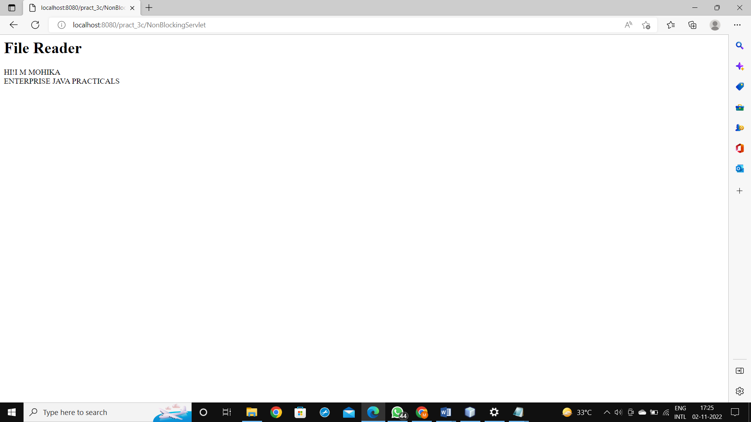

**PRACTICAL 4 Implement the following JSP applications**

**a.Develop a simple JSP application to display values obtained from the use of intrinsic objects of various types.**

**CODE:**

index.html

<html>

<head>

<title>TODO supply a title</title>

<meta charset="UTF-8">

<meta name="viewport" content="width=device-width, initial-scale=1.0">

</head>

<body>

<form name="frm1" method="post" action="Implicit.jsp">

<label>Enter your name:</label><input type="text" name=txt1/>

<br/>

<input type="submit" value="submit"/>

</form>

</body>

</html>

Implicit.jsp

<%@page contentType="text/html" pageEncoding="UTF-8"%>

<html>

<head>

<meta http-equiv="Content-Type" content="text/html; charset=UTF-8">

<title>JSP Page</title>

</head>

<body>

<h1>request Implicit Object</h1>

<%

String str1=request.getParameter("txt1");

out.println("<h3>Hi"+str1+"Welcome to thw world of JSP</h3>");

String str2=request.getContextPath();

out.println("<h3>Context path is:"+str2+"</h3>");

String str3=request.getMethod();

out.println("<h3>Method name is:"+str3+"</h3>");

%>

<h1>Methods of out implicit objects</h1>

<%

out.println("JSP stands for Java Server Page<br/>");

out.newLine();

out.println("Printing boolean value<br/>");

out.println(true+"<br/>");

char ch[]={'H','e','l','l','o'};

out.println("Printing Array of Characters<br/>");

out.println(ch);

%>

<%

session.setAttribute("user",str1);

%>

<a href="Welcome.jsp">Next Page</a>

</body>

</html>

Welcome.jsp

<%@page contentType="text/html" pageEncoding="UTF-8"%>

<%@page import="java.io.PrintWriter,java.util.Date"%>

<html>

<head>

<meta http-equiv="Content-Type" content="text/html; charset=UTF-8">

<title>JSP Page</title>

</head>

<body>

<body>

<h1>Methods of session implicit object</h1>

<%

String name=(String)session.getAttribute("user");

out.print("Welcome "+name+"<br/>");

out.println("Seesion ID is: "+session.getId()+"<br/>");

out.println("Session Creation time is: "+new Date(session.getCreationTime())+"<br/>");

out.println("Session Last Accessed time is: "+new Date(session.getLastAccessedTime())+"<br/>");

out.println("Session is New? "+session.isNew()+"<br/>");

%>

<h3>Methods of response implicit object</h3>

<%

out.println("current status code of this response "+response.getStatus()+"<br/>");

PrintWriter ul=response.getWriter();

ul.println("PrintWriter object is created<br/>");

%>

<a href="go.jsp">Next Page</a>

</body>

</html>

go.jsp

<%@page contentType="text/html" pageEncoding="UTF-8"%>

<html>

<head>

<meta http-equiv="Content-Type" content="text/html; charset=UTF-8">

<title>JSP Page</title>

</head>

<body>

<h3>Methods of response implicit object</h3>

<%

response.sendRedirect("https://vpmrzshahcollege.edu.in/");

%>

</body>

</html>

**OUTPUT:**

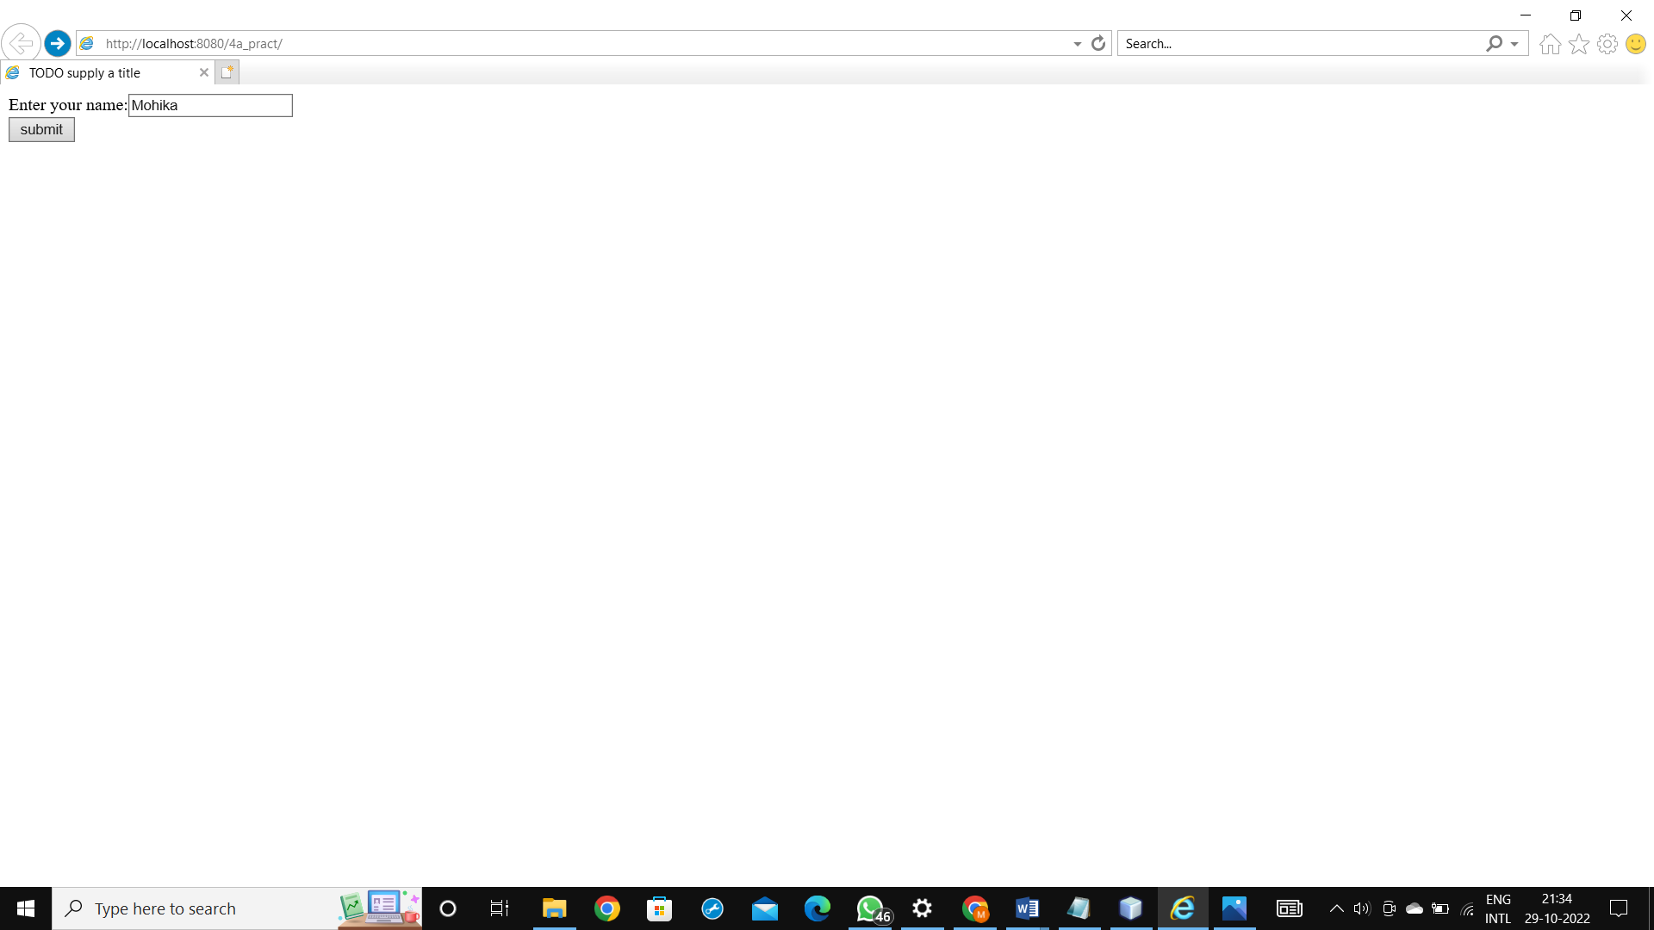

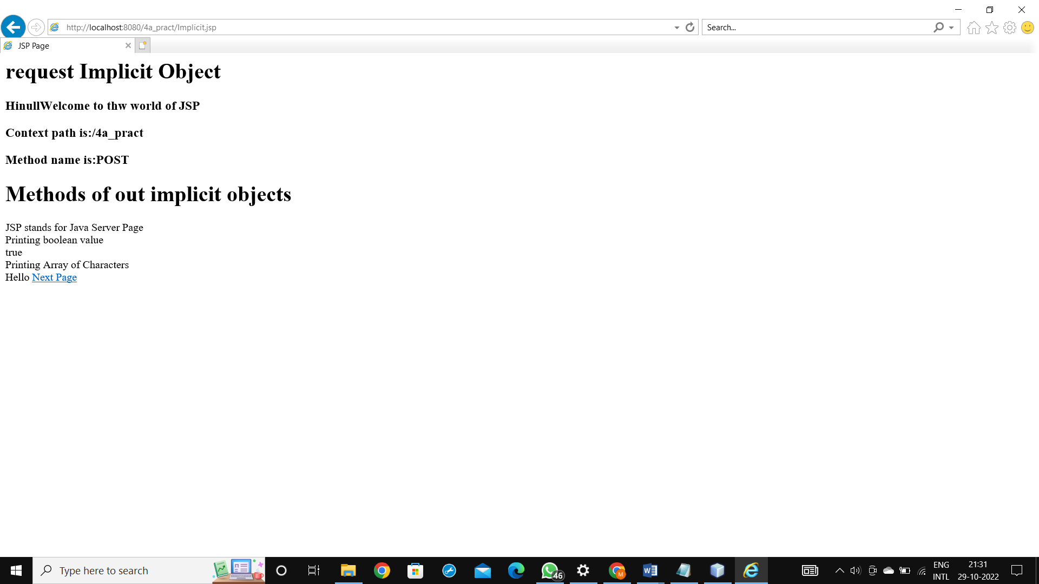

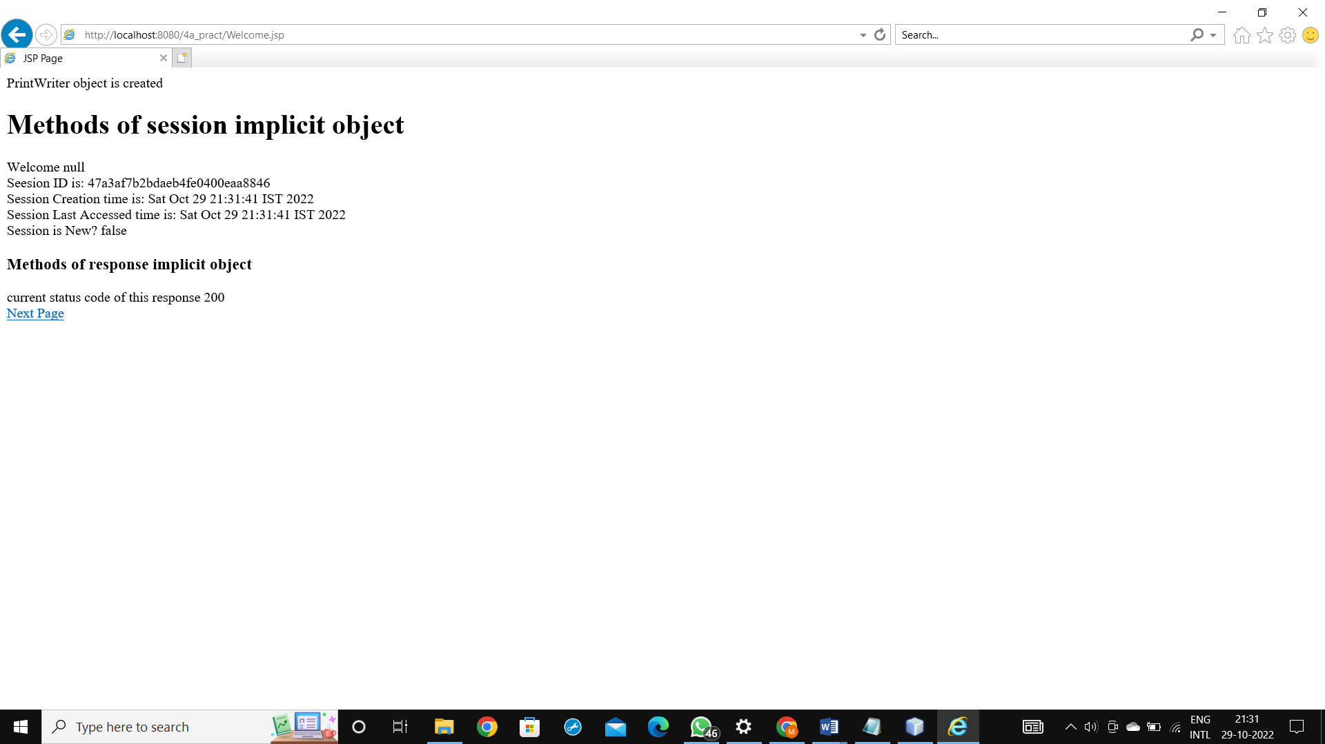



**b.Develop a simple JSP application to pass values from one page to another (Name-txt, age-txt, hobbies-checkbox, email-txt, gender-radio button).**

**CODE:**

index.html

<html>

<head>

<title>TODO supply a title</title>

<meta charset="UTF-8">

<meta name="viewport" content="width=device-width, initial-scale=1.0">

</head>

<body>

<form action="validate.jsp">

Enter Your Name<input type="text" name="name" ><br>

Enter Your Age<input type="text" name="age" ><br>

Select Hobbies

<input type="checkbox" name="hob" value="Singing">Singing

<input type="checkbox" name="hob" value="Reading Books">Reading Books

<input type="checkbox" name="hob" value="Playing Football">Playing Football<br>

Enter E-mail<input type="text" name="email" ><br>

Select Gender

<input type="radio" name="gender" value="male">Male

<input type="radio" name="gender" value="female">Female

<input type="radio" name="gender" value="other">Other<br>

<input type="hidden" name="error" value=" ">

<input type="submit" value="Submit Form">

</form>

</body>

</html>

validate.jsp

<%@page contentType="text/html" pageEncoding="UTF-8"%>

<html>

<head>

<meta http-equiv="Content-Type" content="text/html; charset=UTF-8">

<title>JSP Page</title>

</head>

<body>

<h1>Validation Page</h1>

<jsp:useBean id="obj1" class="pack.CheckerBean"></jsp:useBean>

<jsp:setProperty property="*" name="obj1"/>

Your Name:<jsp:getProperty name="obj1" property="name" /><br/>

Age:<jsp:getProperty name="obj1" property="age"/><br/>

<%

if(obj1.validate())

{

%>

<jsp:forward page="Successful.jsp"/>

<%}

else

{

out.println("<h2>"+obj1.getError()+"</h2>");

}

%>

</body>

</html>

CheckerBean.java

package pack;

public class CheckerBean

{

String name,hob,email,gender,error;

int age;

public CheckerBean()

{

name="";

hob="";

email="";

gender="";

error="";

age=0;

}

public void setName(String n)

{

name=n;

}

public String getName()

{

return name;

}

public void setAge(int a)

{

age=a;

}

public int getAge()

{

return age;

}

public void setHob(String h)

{

name=h;

}

public String getHob()

{

return hob;

}

public void setEmail(String e)

{

email=e;

}

public String getEmail()

{

return email;

}

public void setGender(String g)

{

gender=g;

}

public String getGender()

{

return gender;

}

public String getError()

{

return error;

}

public boolean validate()

{

boolean res=true;

if(name.trim().equals(""))

{

error+="<br>Enter First Name";

res=false;

}

if(age<0||age>99)

{

error+="<br> Age Invalid";

res=false;

}

String emailregex="^[A-Za-z0-9+_.]+@(.+)$";

Boolean b=email.matches(emailregex);

if(!b)

{

error+="<br>email invalid";

res=false;

}

return res;

}

}

Successful.jsp

<%@page contentType="text/html" pageEncoding="UTF-8"%>

<html>

<head>

<meta http-equiv="Content-Type" content="text/html; charset=UTF-8">

<title>JSP Page</title>

</head>

<body>

<h1>Data Submitted successfully</h1>

</body>

</html>

**OUTPUT:**

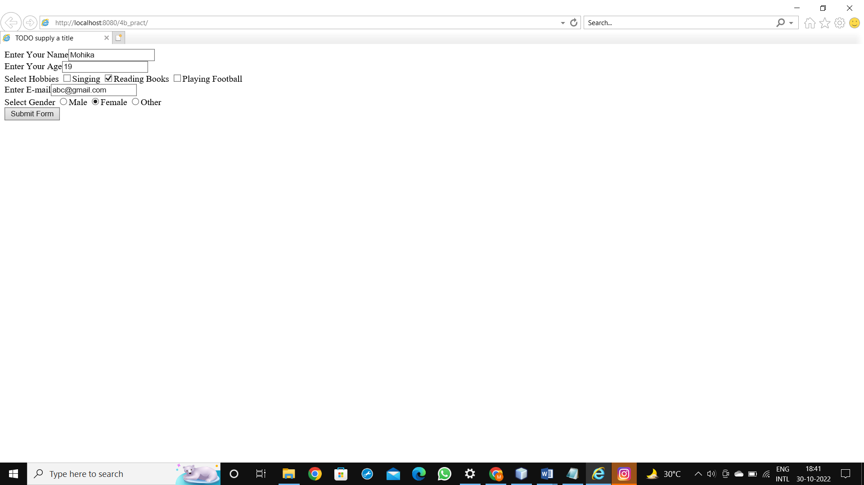

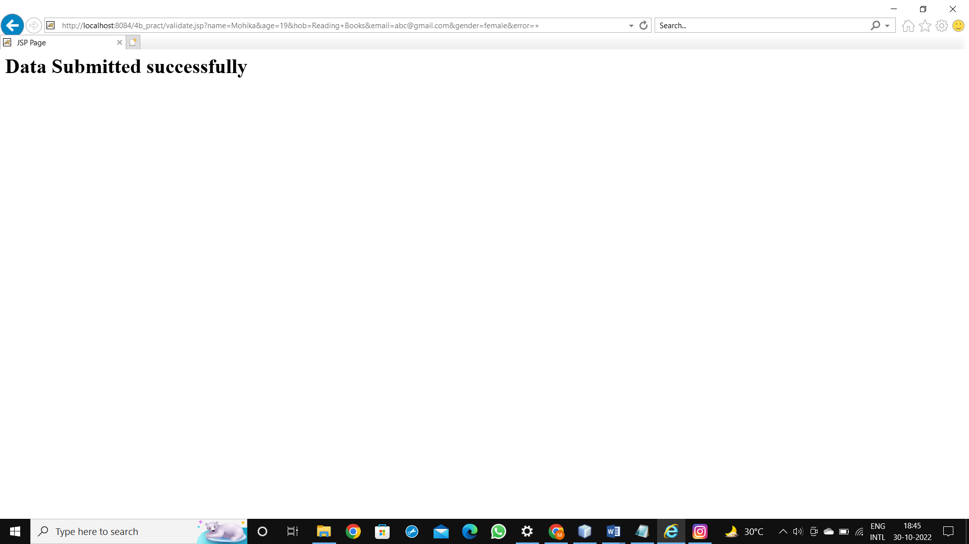

**c.** **Create a registration and login JSP application to register and authenticate the user based on username and password using JDBC.**

**CODE:**

index.html

<html>

<head>

<title>TODO supply a title</title>

<meta charset="UTF-8">

<meta name="viewport" content="width=device-width, initial-scale=1.0">

</head>

<body>

<a href="Register.html"><h1>New User Register Here</h1></a><br/>

<a href="Login.html"><h1>Click here to Login</h1></a>

</body>

</html>

Register.jsp

<%@page contentType="text/html" pageEncoding="UTF-8"%>

<%@page import="java.sql.*" %>

<!DOCTYPE html>

<html>

<head>

<meta http-equiv="Content-Type" content="text/html; charset=UTF-8">

<title>JSP Page</title>

</head>

<body>

<%

Connection con;

Statement stmt;

PreparedStatement pst;

ResultSet rs;

ResultSetMetaData rsmd;

String uname=request.getParameter("txtName");

String pass = request.getParameter("txtPass");

try

{

Class.forName("com.microsoft.sqlserver.jdbc.SQLServerDriver");

}

catch(ClassNotFoundException e)

{

}

try

{

String url="jdbc:derby://localhost:1527/sample";

con=DriverManager.getConnection(url,"app","app");

pst = con.prepareStatement("insert into Login values (?,?)");

pst.setString(1, uname);

pst.setString(2, pass);

int r=pst.executeUpdate();

if(r==1)

{

out.println("<b>Record is updated successfully</b>");

out.println("<h1><a href='Login.html'>Click here to go back</a></h1>");

}

else

{

out.println("Registration Failed !!!!");

out.println("<h1><a href='Register.html'>Click here to go back</a></h1>");

}

}

catch(SQLException e)

{

}

%>

</body>

</html>

Register.html

<html>

<head>

<title>TODO supply a title</title>

<meta charset="UTF-8">

<meta name="viewport" content="width=device-width, initial-scale=1.0">

</head>

<body>

<form method="post" action="Register.jsp" >

<h1> New User Registration Page</h1>

Enter User Name <input type="text" name="txtName" ><br>

Enter Password <input type="password" name="txtPass" ><br>

<input type="reset" ><input type="submit" value="REGISTER" >

</form>

</body>

</html>

Login.jsp

<%@page contentType="text/html" pageEncoding="UTF-8"%>

<%@page import="java.sql.*" %>

<!DOCTYPE html>

<html>

<head>

<meta http-equiv="Content-Type" content="text/html; charset=UTF-8">

<title>JSP Page</title>

</head>

<body>

<%

Connection con;

Statement stmt;

PreparedStatement pst;

ResultSet rs;

ResultSetMetaData rsmd;

String uname=request.getParameter("txtName");

String pass = request.getParameter("txtPass");

try

{

Class.forName("org.apache.derby.jdbc.ClientDriver");

}

catch(ClassNotFoundException e)

{

}

try

{

String url="jdbc:derby://localhost:1527/sample";

con=DriverManager.getConnection(url,"app","app");

pst=con.prepareStatement("select User_Password from Login where User_Name=?");

pst.setString(1, uname);

rs=pst.executeQuery();

if(rs.next())

{

if(pass.equals(rs.getString(1)))

{

out.println("<h1>~~~ LOGIN SUCCESSFULLL ~~~ </h1>");

}

else

{

out.println("<h1>User Name not exist !!!!!</h1>");

%>

<jsp:include page="Register.html" ></jsp:include>

<%

}

}

else

{

out.println("<h1>User Name not exist !!!!!</h1>");

}

%>

<jsp:include page="index.html" ></jsp:include>

<%

}

catch(SQLException e)

{

}

%>

</body>

</html>

Login.html

<html>

<head>

<title>TODO supply a title</title>

<meta charset="UTF-8">

<meta name="viewport" content="width=device-width, initial-scale=1.0">

</head>

<body>

<form method="post" action="Login.jsp" >

Enter User Name <input type="text" name="txtName" ><br>

Enter Password <input type="password" name="txtPass" ><br>

<input type="reset" ><input type="submit" value="LOGIN" >

</form>

</body>

</html>

**OUTPUT:**

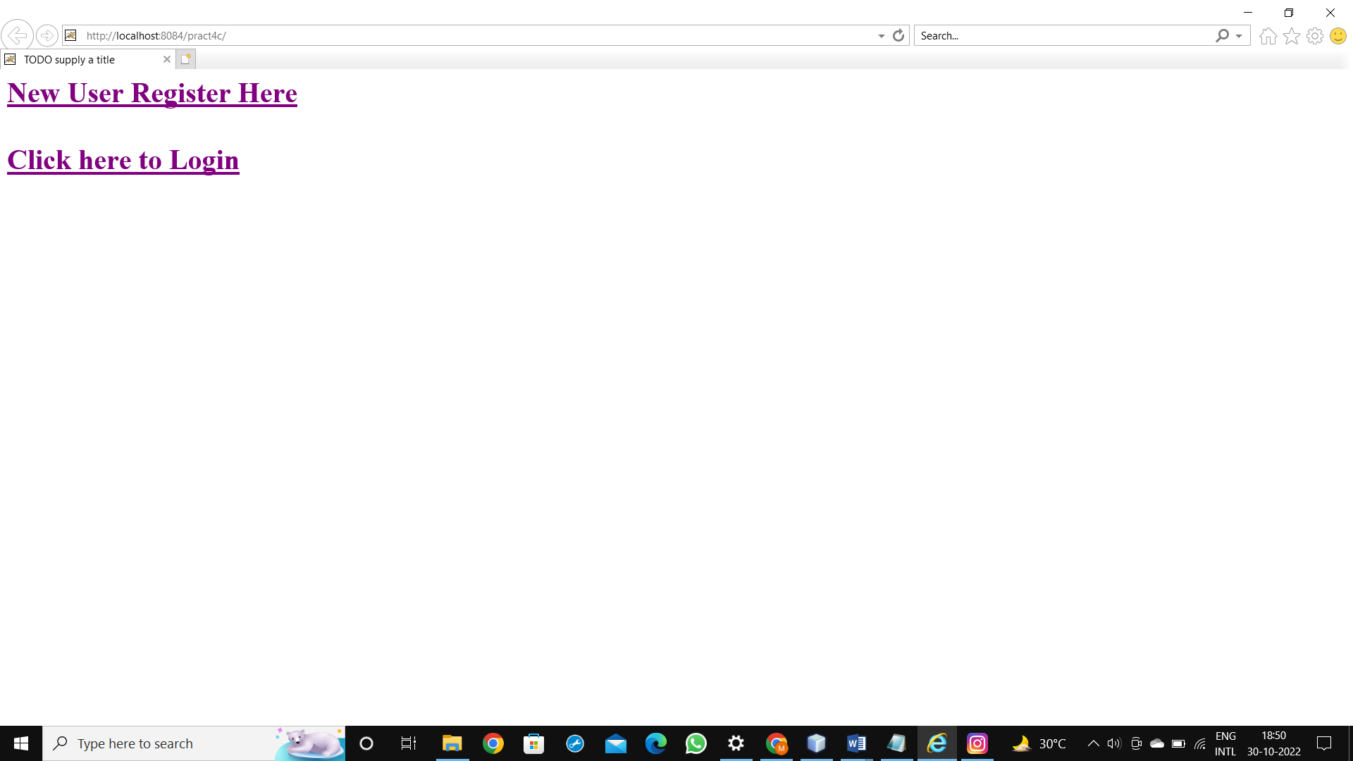

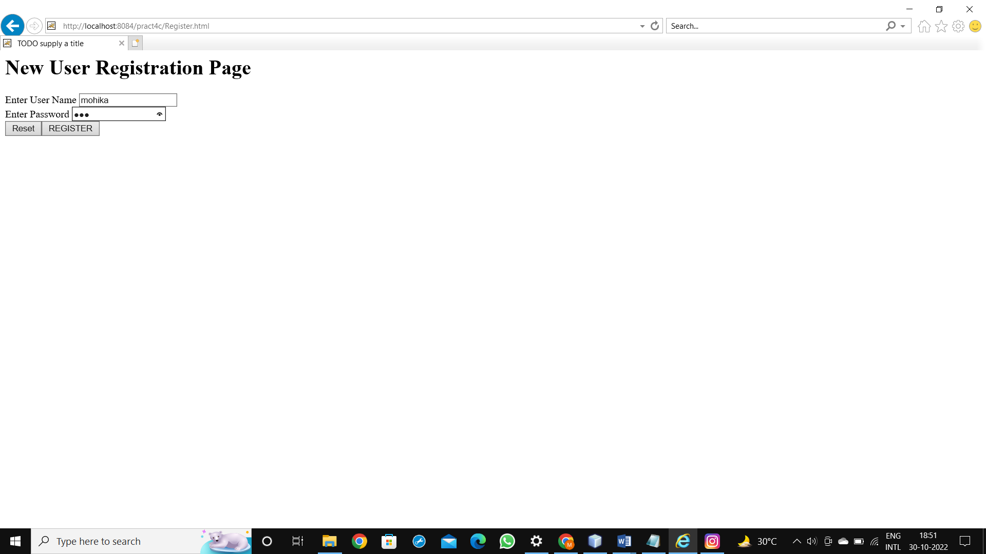

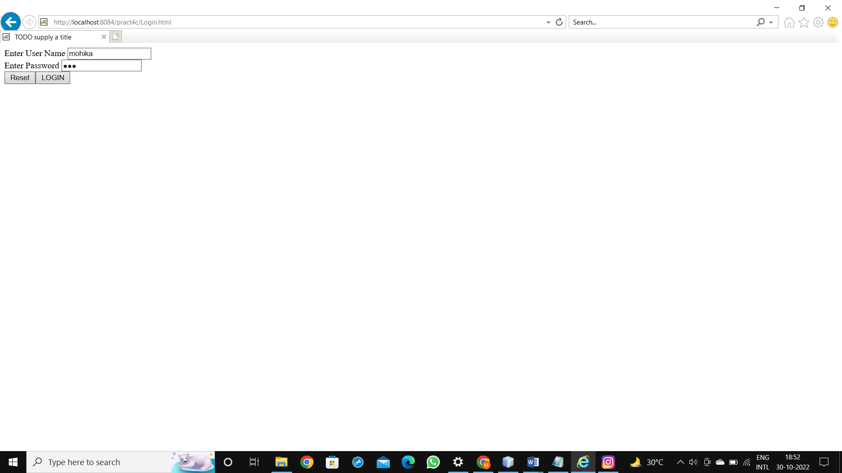

**PRACTICAL 5 Implement the following JSP JSTL and EL Applications**

**a.Create an html page with fields, eno, name, age, desg, salary. Now on submit this data to a JSP page which will update the employee table of database with matching eno.**

**CODE:**

Index.html:

<html>

<head>

<title>TODO supply a title</title>

<meta charset="UTF-8">

<meta name="viewport" content="width=device-width, initial-scale=1.0">

</head>

<body>

<form name="frm1" method="post" action="Update.jsp">

<center>

<table border="1">

<thead>

<tr>

<th colspan="2">Employee Details</th>

</tr>

</thead>

<tbody>

<tr>

<td><label>Enter EMP ID: </label></td>

<td><input type="text" name="txt1"/></td>

</tr>

<tr>

<td><label>Enter Employee Name: </label></td>

<td><input type="text" name="txt2"/></td>

</tr>

<tr>

<td><label>Enter Employee Age: </label></td>

<td><input type="text" name="txt3"/></td>

</tr>

<tr>

<td><label>Enter Employee Designation </label></td>

<td><input type="text" name="txt4"/></td>

</tr>

<tr>

<td><label>Enter Employee Salary </label></td>

<td><input type="text" name="txt5"/></td>

</tr>

<tr>

<td colspan="2"><center><input type="submit" value="Submit"/></center></td>

</tr>

</tbody>

</table>

</center>

</form>

</body>

</html>

Update.jsp:

<%@page contentType="text/html" pageEncoding="UTF-8"%>

<%@page import="java.sql.*" %>

<!DOCTYPE html>

<html>

<head>

<meta http-equiv="Content-Type" content="text/html; charset=UTF-8">

<title>JSP Page</title>

</head>

<body>

<%

Connection con;

ResultSet rs;

ResultSetMetaData rsmd;

Statement st;

PreparedStatement ps;

//Loading Driver

try

{

Class.forName("org.apache.derby.jdbc.ClientDriver");

}

catch(ClassNotFoundException e)

{

}

try

{

String url="jdbc:derby://localhost:1527/logindb";

con=DriverManager.getConnection(url,"sa","1234567");

int eno=Integer.parseInt(request.getParameter("txt1"));

String n=request.getParameter("txt2");

int age=Integer.parseInt(request.getParameter("txt3"));

String desig=request.getParameter("txt4");

int salary=Integer.parseInt(request.getParameter("txt5"));

ps=con.prepareStatement("update EMPLOYEE set EName=?, Age=?, Designation=?, Salary=? where Emp_ID=?");

ps.setString(1, n);

ps.setInt(2, age);

ps.setString(3, desig);

ps.setInt(4, salary);

ps.setInt(5,eno);

ps.executeUpdate();

st=con.createStatement();

rs=st.executeQuery("select * from EMPLOYEE");

rsmd=rs.getMetaData();

int col=rsmd.getColumnCount();

out.println("<center><table border='1'>");

out.println("<tr>");

for(int i=1;i<=col;i++)

{

out.println("<th>"+rsmd.getColumnName(i)+"</th>");

}

out.println("</tr>");

while(rs.next())

{

out.println("<tr><td>"+rs.getInt(1)+"</td><td>"+rs.getString(2)+"</td><td>"+rs.getInt(3)+"</td><td>"+rs.getString(4)+"</td><td>"+rs.getInt(5)+"</td></tr>");

}

out.println("</table></center>");

}

catch(SQLException e)

{

}

%>

</body>

</html>

**OUTPUT:**

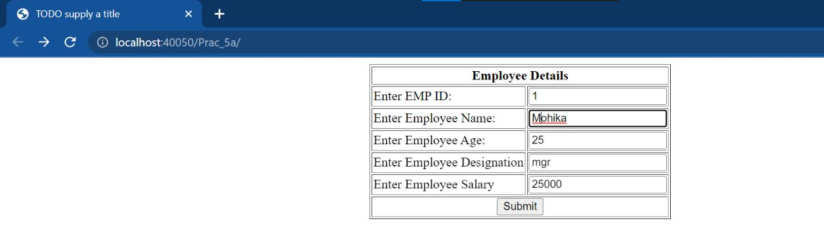

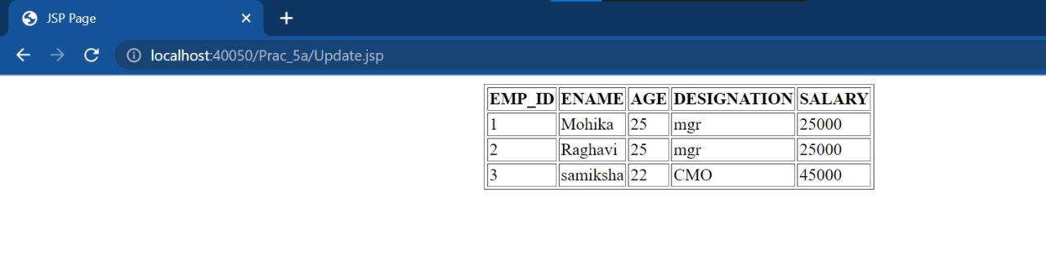

**b.Create a JSP page to demonstrate the use of Expression language.**

**CODE:**

Index.html

<html>

<head>

<title>TODO supply a title</title>

<meta charset="UTF-8">

<meta name="viewport" content="width=device-width, initial-scale=1.0">

</head>

<body>

<form action="Show.jsp">

Enter an integer number:<input type="text" name="txt1"/><br/>

Enter an integer number:<input type="text" name="txt2"/><br/>

<input type="submit" value="Click Me!"/>

</form>

</body>

</html>

Show.jsp:

<%--

Document : Show

Created on : Oct 20, 2022, 1:27:05 PM

Author : lenovo

--%>

<%@page contentType="text/html" pageEncoding="UTF-8"%>

<!DOCTYPE html>

<html>

<head>

<meta http-equiv="Content-Type" content="text/html; charset=UTF-8">

<title>JSP Page</title>

</head>

<body>

<b>The sum of 2 number is</b> ${param.txt1+param.txt2} <br/>

<b>The difference of 2 number is</b> ${param.txt1-param.txt2}<br/>

<b>The product of 2 number is</b> ${param.txt1*param.txt2}<br/>

<b>The quotient of 2 number is</b> ${param.txt1/param.txt2}<br/>

<b>The remainder of 2 number is</b> ${param.txt1%param.txt2}<br/>

</body>

</html>

**OUTPUT:**

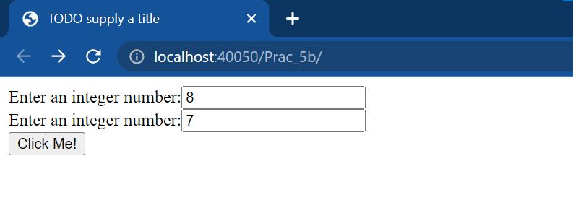

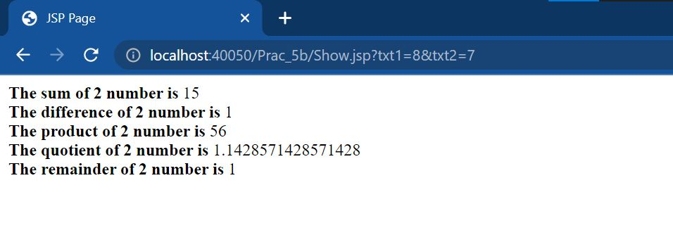

**c.Create a JSP application to demonstrate the use of JSTL.**

**CODE:**

index.html

<html>

<head>

<title>TODO supply a title</title>

<meta charset="UTF-8">

<meta name="viewport" content="width=device-width, initial-scale=1.0">

</head>

<body>

<a href="setDemo.jsp"> SetDemo</a>

<a href="Maxif.html"> Maxif</a>

<a href="forEachDemo.jsp"> ForEachDemo</a>

<a href="outDemo.jsp"> OutDemo</a>

<a href="URLDemo.jsp"> URLDemo</a>

<a href="choose_when_otherwise.jsp"> choose_when_otherwise</a>

</body>

</html>

setDemo .jsp

<%@page contentType="text/html" pageEncoding="UTF-8"%>

<!DOCTYPE html>

<html>

<head>

<meta http-equiv="Content-Type" content="text/html; charset=UTF-8">

<title>JSP Page</title>

</head>

<body>

<%@taglib prefix="c" uri="http://java.sun.com/jstl/core" %>

<c:set var="pageTitle" scope="application" value="hello hello hello" />

${pageTitle}

</body>

</html>

Maxif.html

<html>

<head>

<title>TODO supply a title</title>

<meta charset="UTF-8">

<meta name="viewport" content="width=device-width, initial-scale=1.0">

</head>

<body>

<form action ="IFDemo.jsp">

x=<input type="text" name="x" /><br>

y=<input type="text" name="y" /><br>

<input type="submit" value="Check Max" />

</form>

</body>

</html>

forEachDemo.jsp

<%@page contentType="text/html" pageEncoding="UTF-8"%>

<!DOCTYPE html>

<html>

<head>

<meta http-equiv="Content-Type" content="text/html; charset=UTF-8">

<title>JSP Page</title>

</head>

<body>

<%@taglib prefix="c" uri="http://java.sun.com/jsp/jstl/core" %>

<c:forEach begin="1" end="10" var="i">

The Square of <c:out value=" ${i}=${i*i}"/><br>

</c:forEach>

</body>

</html>

outDemo.jsp

<%@page contentType="text/html" pageEncoding="UTF-8"%>

<!DOCTYPE html>

<html>

<head>

<meta http-equiv="Content-Type" content="text/html; charset=UTF-8">

<title>JSP Page</title>

</head>

<body>

<%@taglib prefix="c" uri="http://java.sun.com/jsp/jstl/core" %>

<c:set var="name" value="Mohika"/>

My name is: <c:out value= "${name}" />

</body>

</html>

URLDemo.jsp

<%@page contentType="text/html" pageEncoding="UTF-8"%>

<!DOCTYPE html>

<html>

<head>

<meta http-equiv="Content-Type" content="text/html; charset=UTF-8">

<title>JSP Page</title>

</head>

<body>

<%@taglib prefix="c" uri="http://java.sun.com/jsp/jstl/core" %>

<c:url value="https://vpmrzshahcollege.edu.in/"/>

</body>

</html>

choose_when_Demo.jsp

<%@page contentType="text/html" pageEncoding="UTF-8"%>

<!DOCTYPE html>

<html>

<head>

<meta http-equiv="Content-Type" content="text/html; charset=UTF-8">

<title>JSP Page</title>

</head>

<body>

<%@taglib prefix="c" uri="http://java.sun.com/jsp/jstl/core" %>

<c:set var="income" value="${4000*8}"/> Your Income is: <c:out value="${income}"/>

<c:choose>

<c:when test="${income <=1000}">

Income is not good

</c:when>

<c:when test="${income > 10000}"> Income is Very Good

</c:when>

<c:otherwise>

Income is undetermined

</c:otherwise>

</c:choose>

</body>

</html>

IFDemo.jsp

<%@page contentType="text/html" pageEncoding="UTF-8"%>

<!DOCTYPE html>

<html>

<head>

<meta http-equiv="Content-Type" content="text/html; charset=UTF-8">

<title>JSP Page</title>

</head>

<body>

<%@taglib prefix="c" uri="http://java.sun.com/jsp/jstl/core" %>

<c:set var="x" value="${param.x}"/>

<c:set var="y" value="${param.y}"/>

<c:if test="${x>y}">

<font color="blue"><h2>The Ans is:</h2></font>

<c:out value="${x} is greater than ${y}"/>

</c:if>

</body>

</html>

**OUTPUT:**

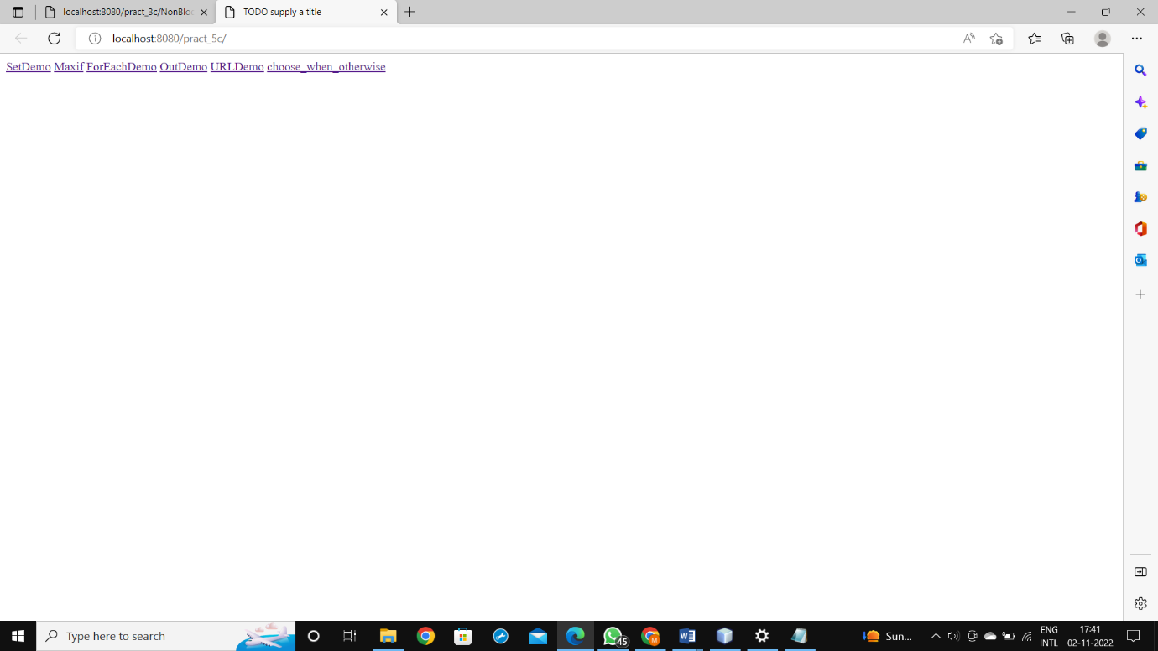

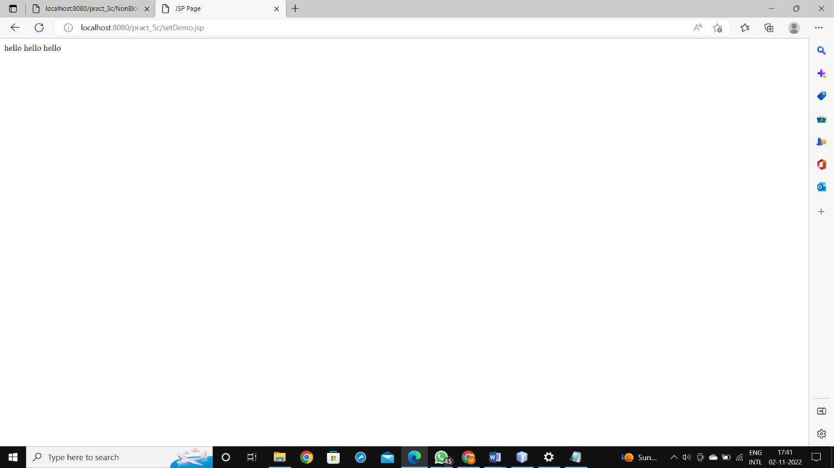

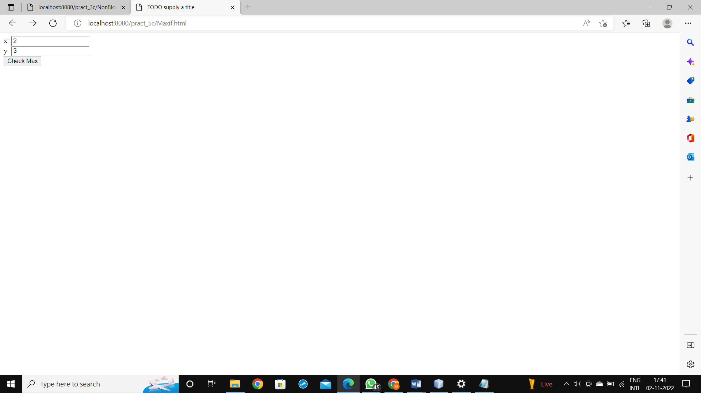

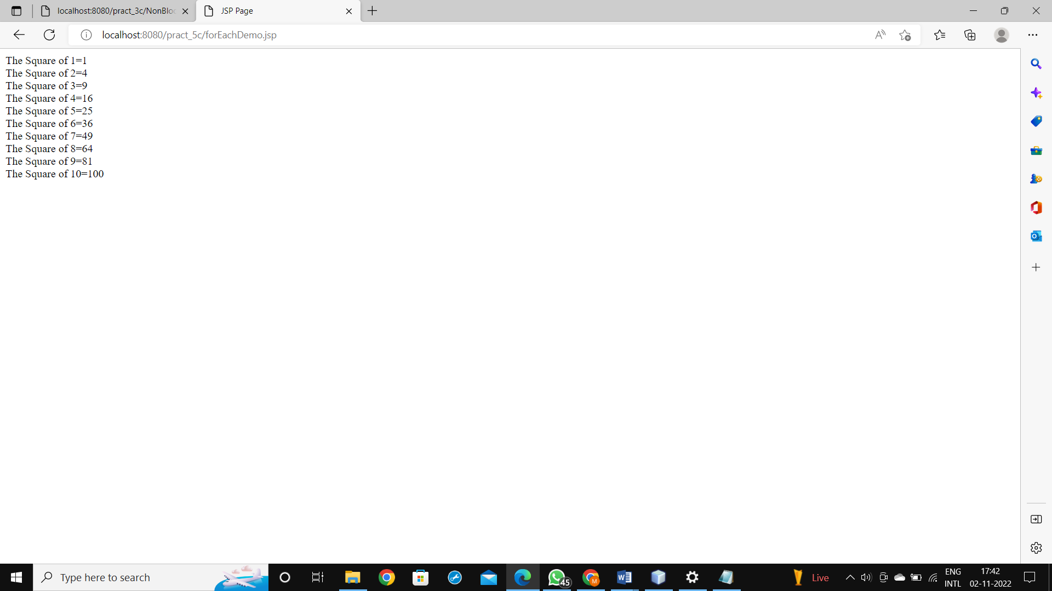

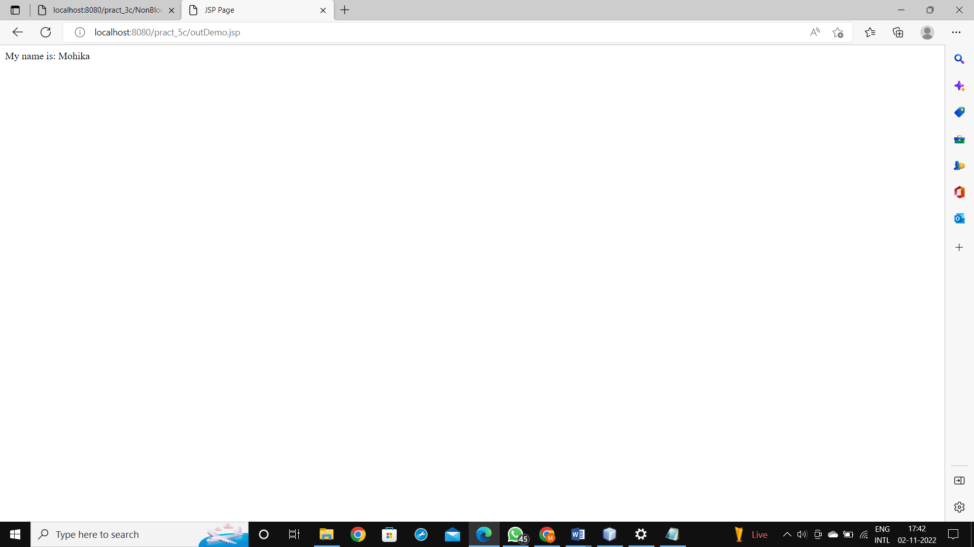

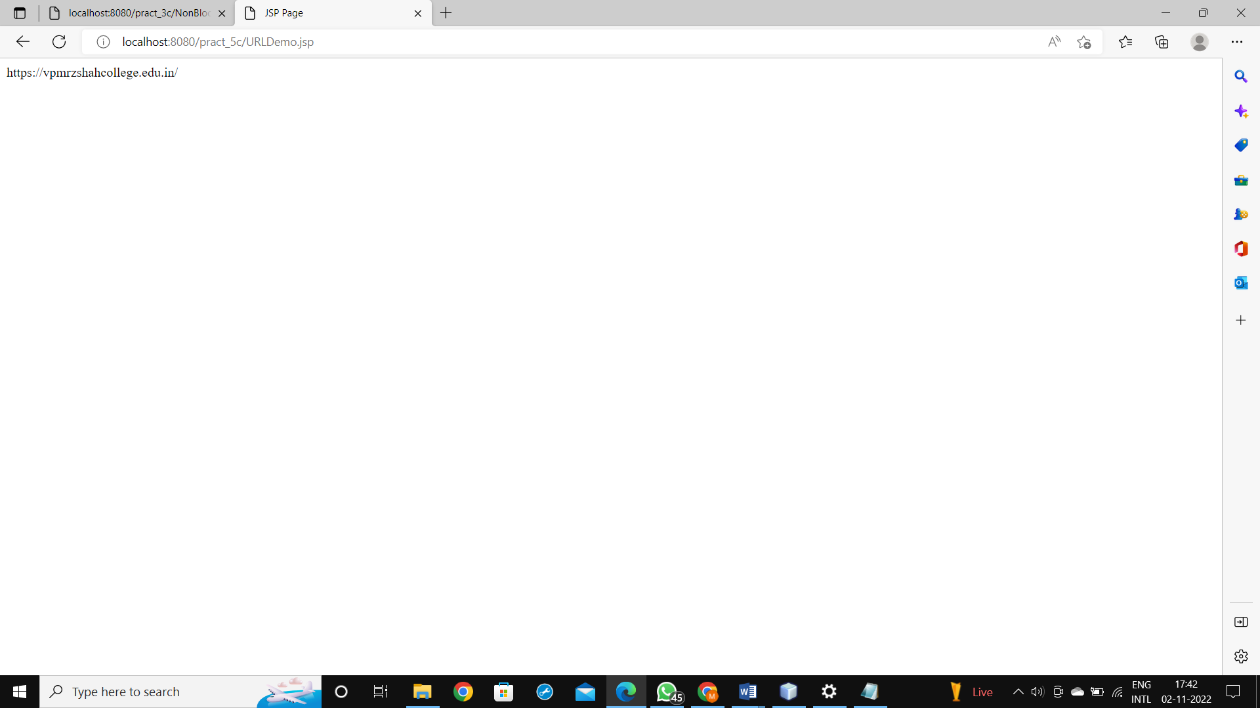

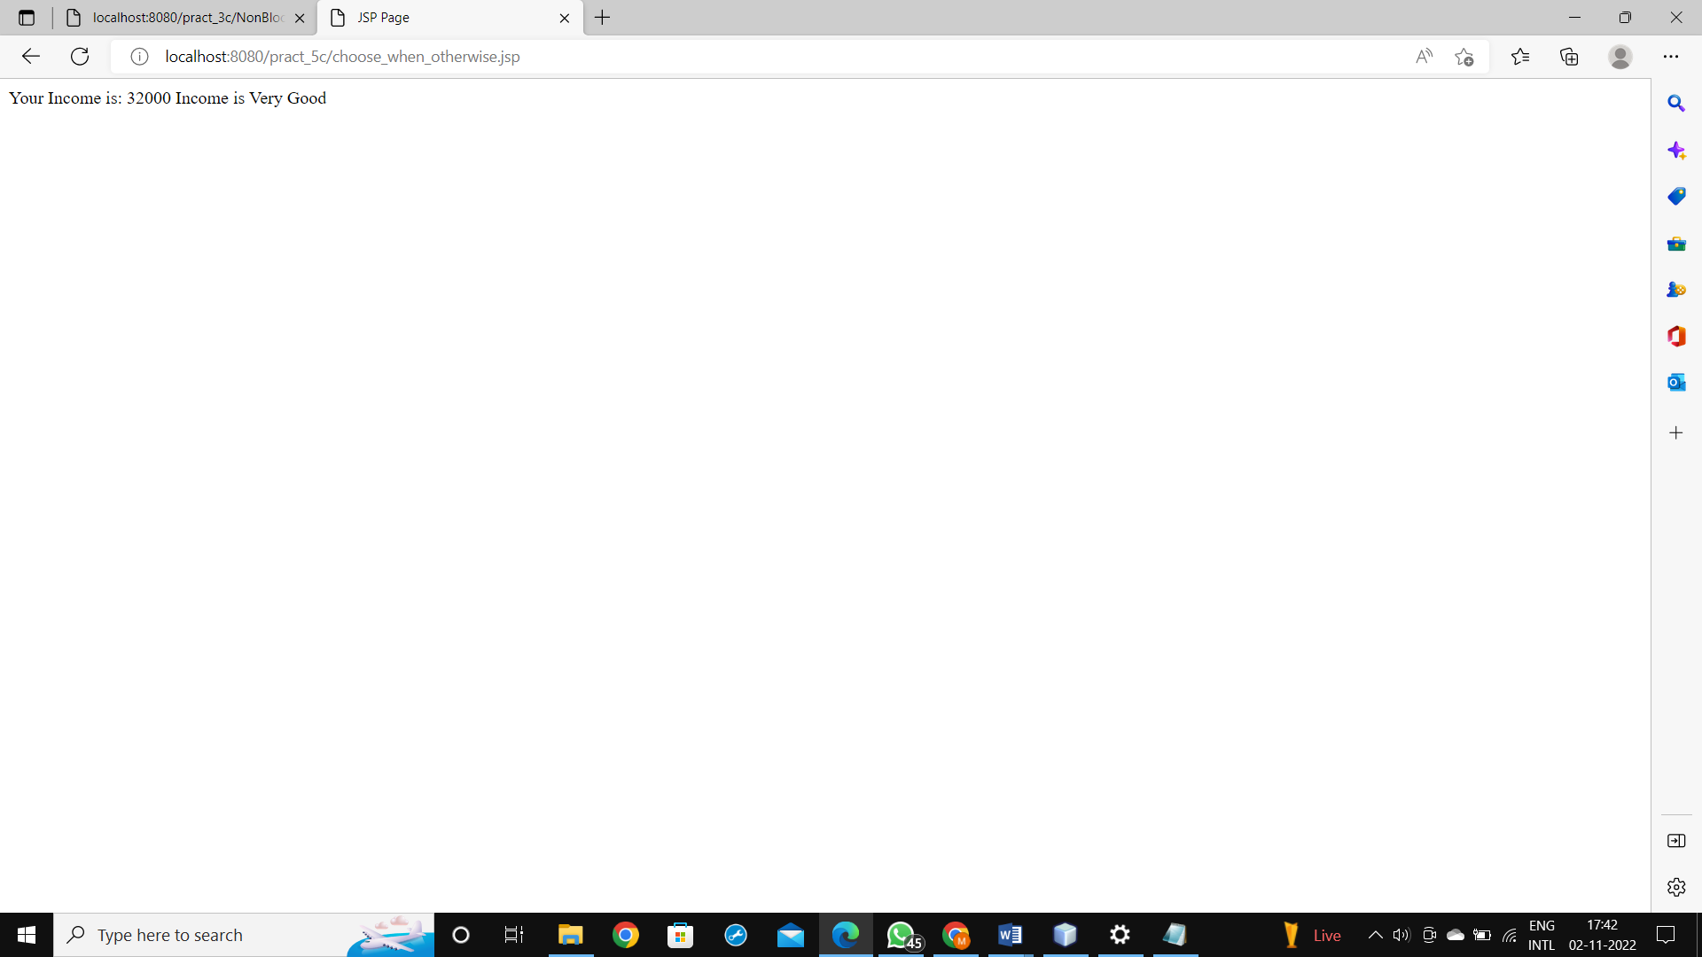

**PRACTICAL 6 Implement the following EJB Applications.**

**a.Create a Currency Converter application using EJB.**

**CODE:**

index.html

<html>

<head>

<title>TODO supply a title</title>

<meta charset="UTF-8">

<meta name="viewport" content="width=device-width, initial-scale=1.0">

</head>

<body>

<form method="post" action="Converter" >

Enter Amount <input type="text" name="amt"><br>

Select Conversion Type

<input type="radio" name="type" value="r2d" checked>Rupees to Dollar

<input type="radio" name="type" value="d2r" >Dollar to Rupees<br>

<input type="reset" ><input type="submit" value="CONVERT" >

</form>

</body>

</html>

Converter.java

package pack2;

import java.io.*;

import javax.servlet.ServletException;

import javax.servlet.http.*;

import javax.ejb.*;

import pack1.ConverterSessionBeanLocal;

public class Converter extends HttpServlet {

@EJB

ConverterSessionBeanLocal c;

@Override

protected void doPost(HttpServletRequest request, HttpServletResponse response)

throws ServletException, IOException {

response.setContentType("text/html;charset=UTF-8");

PrintWriter out = response.getWriter();

Double amt=Double.parseDouble(request.getParameter("amt"));

String t=request.getParameter("type");

if(t.equals("r2d"))

out.println("<h2> Rupees "+amt+" in Dollar is "+c.Rupees_To_Dollar(amt));

if(t.equals("d2r"))

out.println("<h2> Dollar "+amt+" in Rupees is "+c.Dollar_To_Rupees(amt));

}

}

ConverterSessionBean.java

package pack1;

import javax.ejb.Stateless;

@Stateless

public class ConverterSessionBean implements ConverterSessionBeanLocal

{

@Override

public double Rupees_To_Dollar(double amt) {

return (amt/82.54);

}

@Override

public double Dollar_To_Rupees(double dollar) {

return (dollar*82.54);

}

}

ConverterSessionBeanLocal.java

/*

* To change this license header, choose License Headers in Project Properties.

* To change this template file, choose Tools | Templates

* and open the template in the editor.

*/

package pack1;

import javax.ejb.Local;

/**

*

* @author mohik

*/

@Local

public interface ConverterSessionBeanLocal {

double Rupees_To_Dollar(double amt);

double Dollar_To_Rupees(double dollar);

}

OUTPUT:

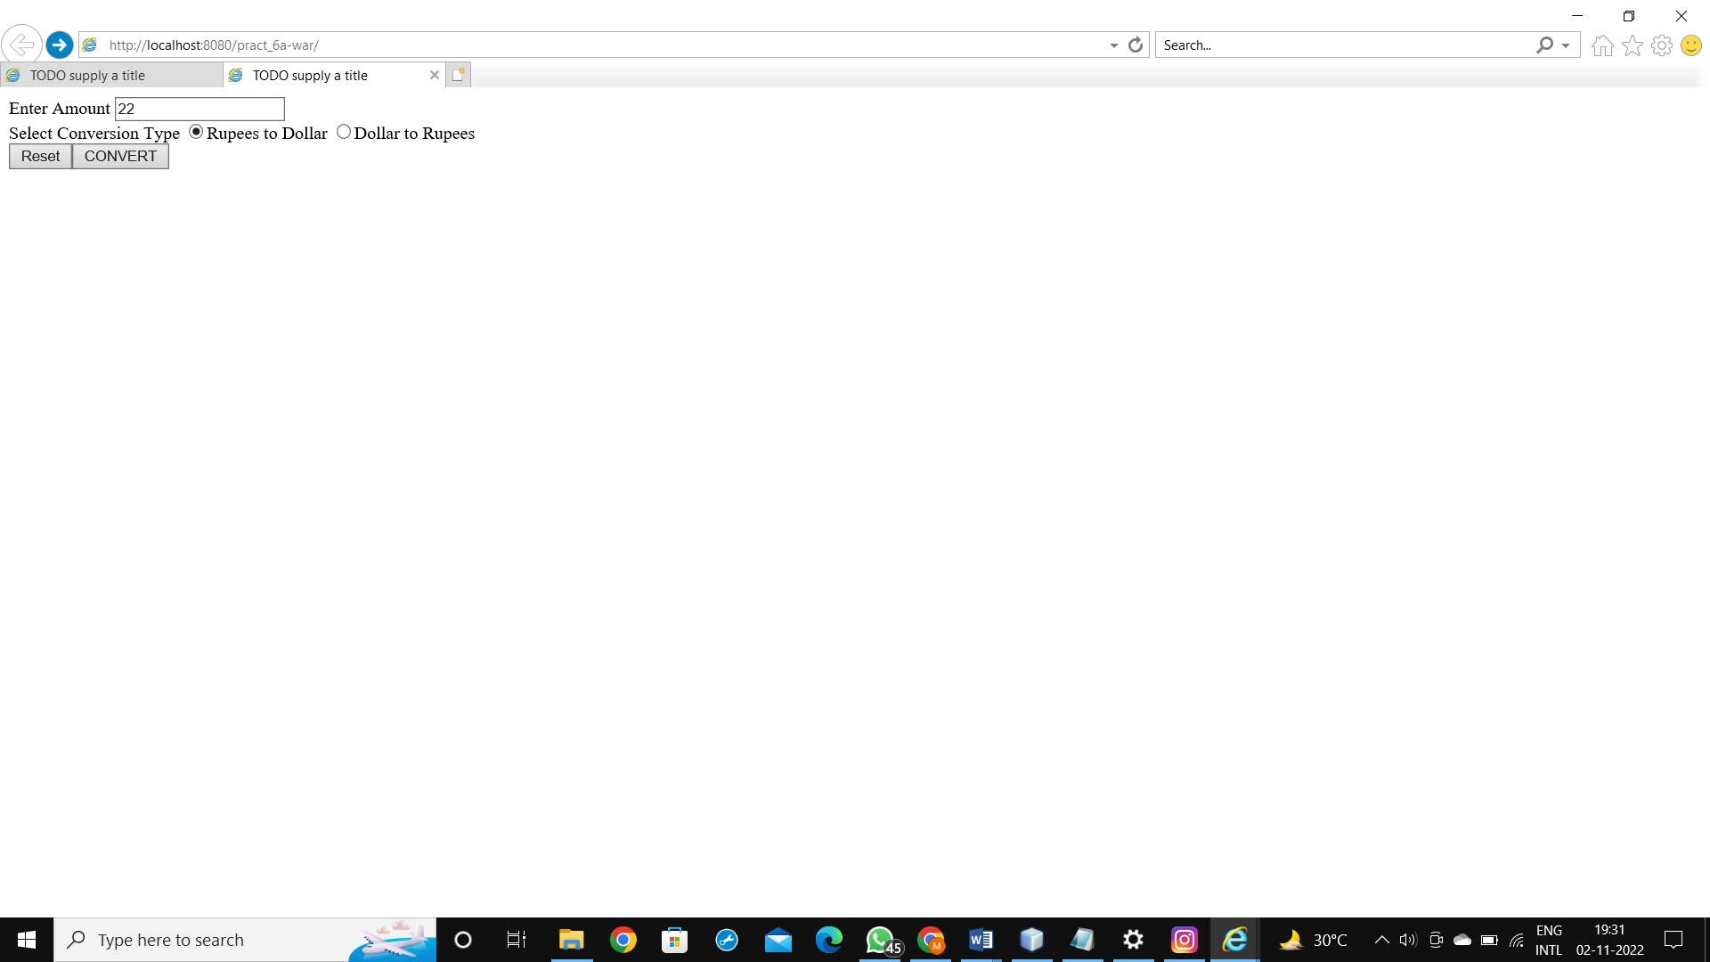

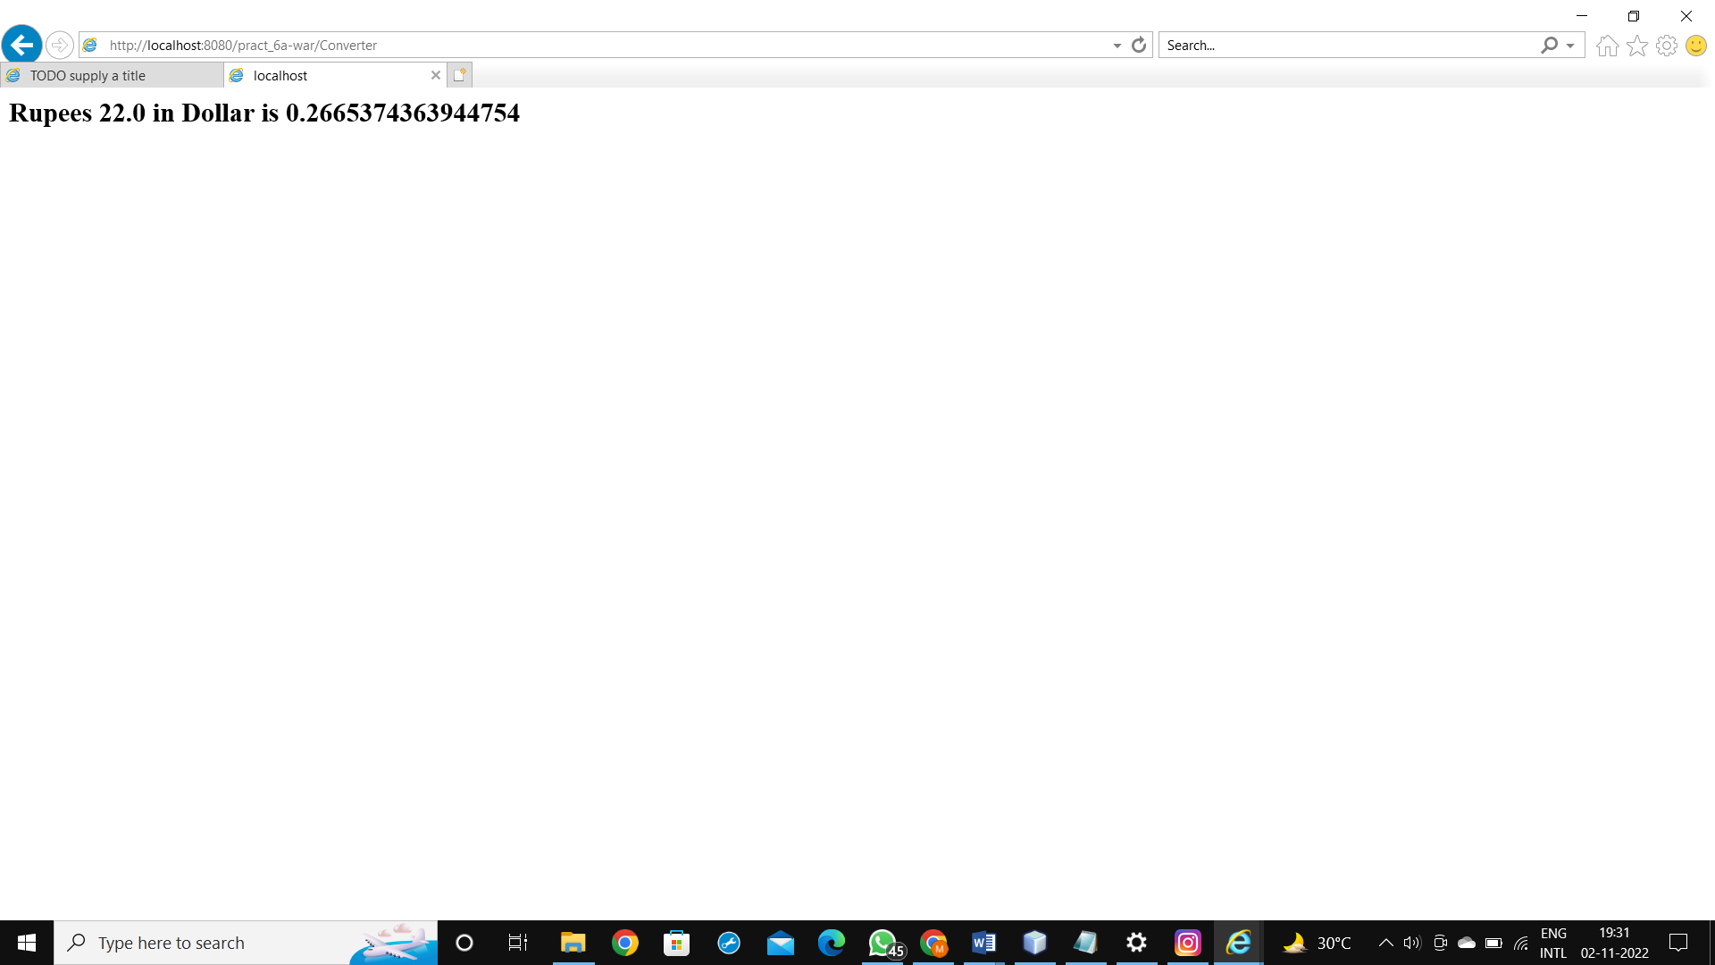

**b.Develop a Simple Room Reservation System Application Using EJB.**

**CODE:**

index.html

<html>

<head>

<title>TODO supply a title</title>

<meta charset="UTF-8">

<meta name="viewport" content="width=device-width, initial-scale=1.0">

</head>

<body>

<p>Enter Details for room reservation</p>

<form method="post" action="Reservation">

<table border="1" width="100">

<tr>

<td>Customer name:</td>

<td><input type="text" name="cname" value="" size="50"/></td>

</tr>

<tr>

<td>Address:</td>

<td><input type="text" name="cadd" value="" size="50"/></td>

</tr>

<tr>

<td>Phone number:</td>

<td><input type="text" name="cph" value="" size="50"/></td>

</tr>

<tr>

<td>Room type:</td>

<td>

<select name="roomtype">

<option id="g">General</option>

<option id="s">Suite</option>

</select>

</td>

</tr>

<tr>

<td>Check in date:</td>

<td><input type="text" name="checkindate" value="" size="12"/></td>

</tr>

<tr>

<td>Check out date:</td>

<td><input type="text" name="checkoutdate" value="" size="12"/></td>

</tr>

<tr>

<td>No of Days:</td>

<td><input type="text" name="days" value="" size="12"/></td>

</tr>

<tr>

<td>Payment mode:</td>

<td>

<select name="paymode">

<option id="cash">CASH</option>

<option id="card">CREDIT/DEBIT CARD</option>

</select>

</td>

</tr>

<tr>

<td colspan="2">

<input type="submit" name="cmdsubmit" value="Submit" />

</td>

</tr>

</table>

</form>

</body>

</html>

Reservation.java

package pack1;

import java.io.*;

import java.util.ArrayList;

import javax.servlet.ServletException;

import javax.servlet.http.*;

import javax.ejb.EJB;

import pack.RoomBeanLocal;

public class Reservation extends HttpServlet

{

@EJB

RoomBeanLocal r;

@Override

protected void doPost(HttpServletRequest request, HttpServletResponse response)

throws ServletException, IOException

{

response.setContentType("text/html;charset=UTF-8");

PrintWriter out = response.getWriter();

int i;

try

{

String cname=request.getParameter("cname");

String add=request.getParameter("cadd");

String ph=request.getParameter("cph");

String roomtype=request.getParameter("roomtype");

String chkin=request.getParameter("checkindate");

String chkout=request.getParameter("checkoutdate");

int d=Integer.parseInt(request.getParameter("days"));

String paymode=request.getParameter("paymode");

ArrayList <String> list1=r.reserve(cname, add, ph, chkin, chkout, roomtype, paymode);

int n=list1.size();

out.println("<h1>"+r.Welcome(cname)+"</h1>") ;

out.println("<h1>"+r.roomType(roomtype)+"</h1>") ;

out.println("<h1>"+r.payment(roomtype, d)+"</h1>") ;

out.println("<b>Your Details are as follows</b><br/>");

out.println("<table border='1'>");

out.println("<tr><th>Name</th><th>Address</th><th>Phone</th><th> Check In date</th>");

out.println("<th>Check Out Date</th><th>Room</th><th>Payment Mode</th></tr><tr>");

for(i=0;i<n;i++)

{

out.println("<td> "+list1.get(i)+"</td>");

}

out.println("</tr></table>");

}

catch(Exception e)

{

out.println(e);

}

}

}

RoomBean.java

package pack;

import java.util.ArrayList;

import javax.ejb.Stateless;

@Stateless

public class RoomBean implements RoomBeanLocal

{

@Override

public String Welcome(String c)

{

return "Hello "+c.toUpperCase();

}

@Override

public String roomType(String rtype)

{

return "You have selected "+" "+rtype.toUpperCase()+" "+"Room";

}

@Override

public String payment(String rtype, int days)

{

System.out.println(rtype);

int amount_paid=0;

if(rtype.equalsIgnoreCase("SUITE"))

{

amount_paid=4000*days;

return "You have to pay Rs. "+amount_paid;

}

else

{

amount_paid=2000*days;

return "You have to pay Rs. "+amount_paid;

}

}

@Override

public ArrayList<String> reserve(String customer,

String address,String phone,String checkin,String checkout,

String roomtype,String payment)

{

ArrayList<String> a=new ArrayList();

a.add(customer);

a.add(address);

a.add(phone);

a.add(checkin);

a.add(checkout);

a.add(roomtype);

a.add(payment);

return a;

}

}

RoomBeanLocal.java

/*

* To change this license header, choose License Headers in Project Properties.

* To change this template file, choose Tools | Templates

* and open the template in the editor.

*/

package pack;

import java.util.ArrayList;

import javax.ejb.Local;

@Local

public interface RoomBeanLocal

{

String Welcome(String c);

String roomType(String rtype);

String payment(String rtype, int days);

public ArrayList<String> reserve(String customer,

String address,String phone,String checkin,String checkout,

String roomtype,String payment);

}

**OUTPUT:**

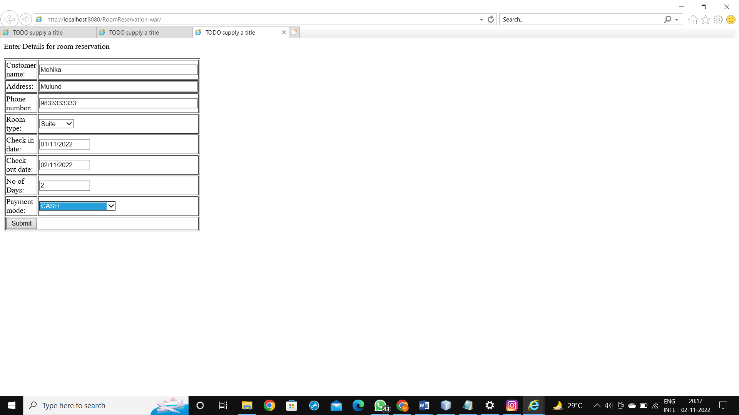

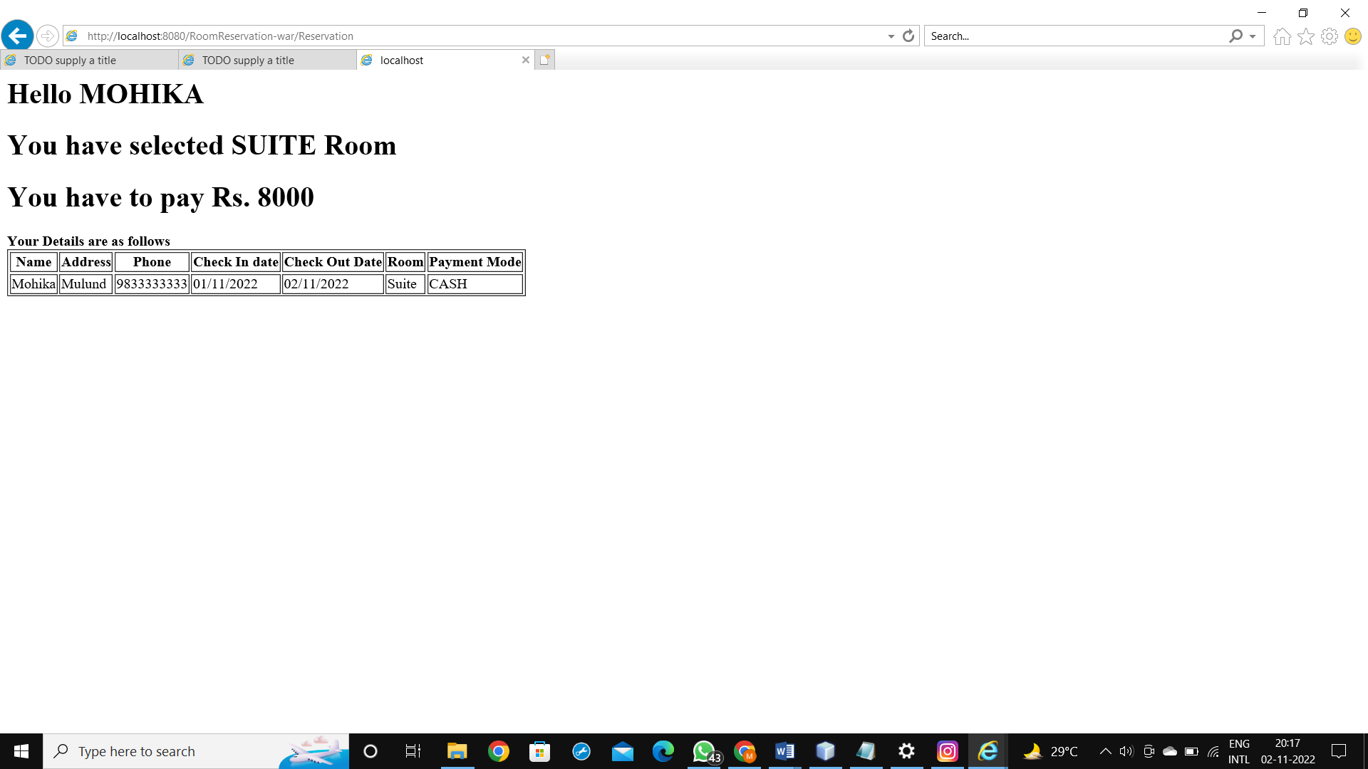

**c.Develop simple shopping cart application using EJB [Stateful Session Bean].**

**CODE:**

index.html

<html>

<head>

<title>TODO supply a title</title>

<meta charset="UTF-8">

<meta name="viewport" content="width=device-width, initial-scale=1.0">

</head>

<body>

<form action="Cart" method="post">

Enter bookname you want to add<input type="text" name="txt1"/><br/>

<input type="submit"/>

</form>

</body>

</html>

Cart.java

package pack;

import java.io.*;

import javax.servlet.ServletException;

import javax.servlet.http.*;

import cart.CartSessionBeanLocal;

import javax.ejb.*;

import java.util.*;

public class Cart extends HttpServlet

{

@EJB

CartSessionBeanLocal c;

@Override

protected void doPost(HttpServletRequest request, HttpServletResponse response)

throws ServletException, IOException

{

response.setContentType("text/html;charset=UTF-8");

PrintWriter out = response.getWriter();

try

{

c.initialize("ABC", "123");

}

catch(Exception e){}

c.addBook("Java 8 Cookbook");

c.addBook("Enterprise Java 7 ");

c.addBook("Java for Dummies");

c.addBook("Learn Java 8");

String str=request.getParameter("txt1");

c.addBook(str);

try

{

List<String> books = c.getContents();

for( String s : books)

out.println(s +"<br />");

}

catch(Exception e)

{

}

}

}

CartSessionBean.java

package cart;

import java.util.*;

import javax.ejb.*;

@Stateful

public class CartSessionBean implements CartSessionBeanLocal

{

String customerName;

String customerId;

List<String> contents;

@Override

public void initialize(String person, String id)throws Exception

{

if (person == null)

{

throw new Exception("Null person not allowed.");

}

else

{

customerName = person;

}

if ( person=="ABC" && id=="123")

{

customerId = id;

}

else

{

throw new Exception("Invalid id: " + id);

}

contents = new ArrayList<String>();

}

@Override

public void addBook(String title)

{

contents.add(title);

}

@Override

public void removeBook(String title) throws Exception

{

boolean result = contents.remove(title);

if (result == false)

{

throw new Exception(title + " not in cart.");

}

}

@Override

public List<String> getContents()

{

return contents;

}

@Remove

public void remove()

{

contents = null;

}

}

CartSessionBeanLocal.java

package cart;

import java.util.List;

import javax.ejb.Local;

@Local

public interface CartSessionBeanLocal

{

void initialize(String person, String id)throws Exception;

void addBook(String title);

void removeBook(String title) throws Exception ;

public List<String> getContents();

public void remove();

}

OUTPUT:

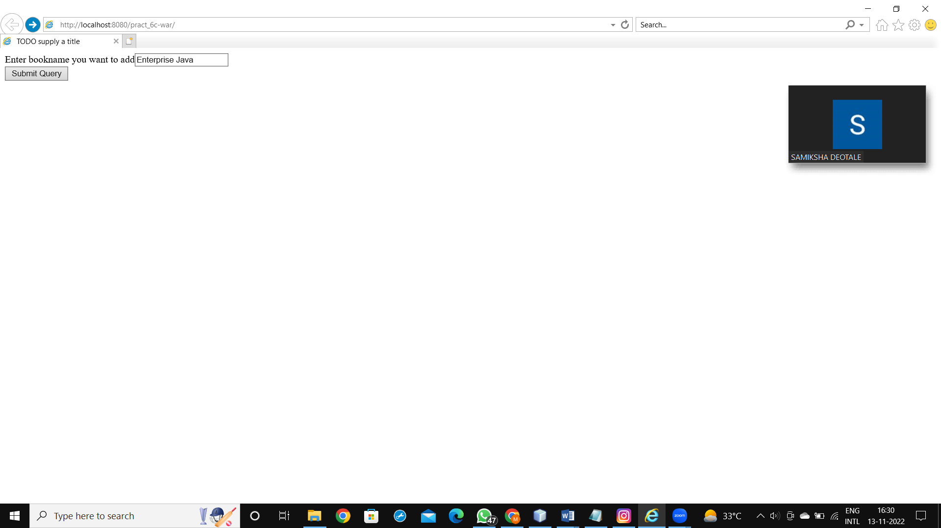

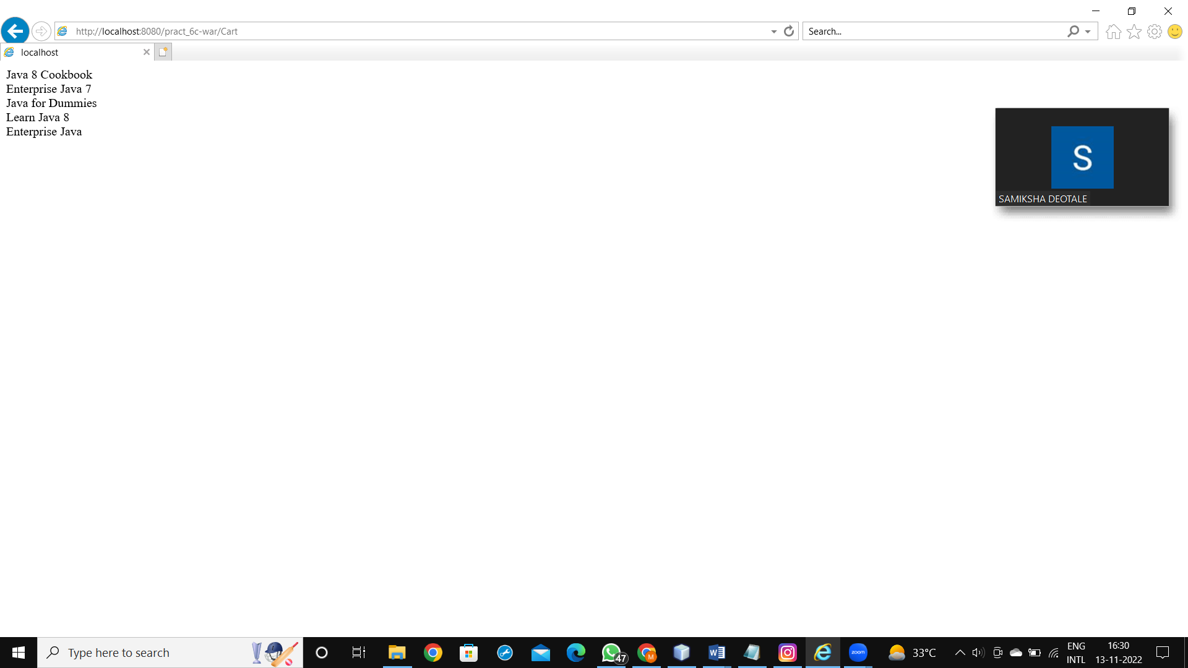

**PRACTICAL 7 Implement the following EJB applications with different types of Beans.**

**a.Develop simple EJB application to demonstrate Servlet Hit count using Singleton Session Beans.**

**CODE:**

ServletClient.java

package servlet;

import ejb.CountServletHitsBean;

import java.io.*;

import javax.ejb.EJB;

import javax.servlet.ServletException;

import javax.servlet.annotation.WebServlet;

import javax.servlet.http.*;

@WebServlet(name = "ServletClient", urlPatterns = {"/ServletClient"})

public class ServletClient extends HttpServlet

{

@EJB CountServletHitsBean obj;

@Override

protected void service (HttpServletRequest req, HttpServletResponse res)

throws ServletException, IOException

{

res.setContentType("text/html"); PrintWriter out=res.getWriter();

out.print("<b>Number of times this Servlet is accessed </b>: "+obj.getCount());

}

}

CountServletHitsBean.java

package ejb;

import javax.ejb.Singleton;

@Singleton

public class CountServletHitsBean

{

private int hitCount;

public synchronized int getCount()

{

return hitCount++;

}

}

**OUTPUT:**

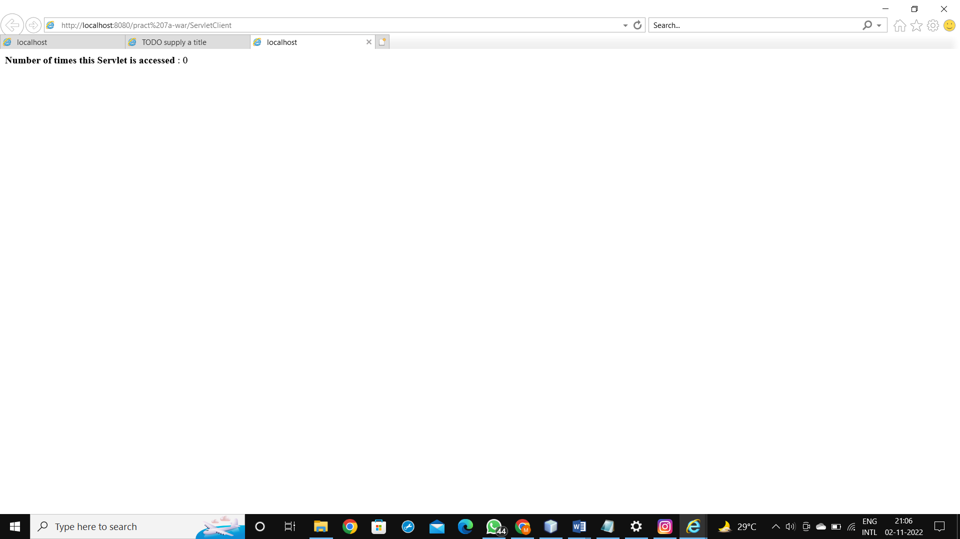

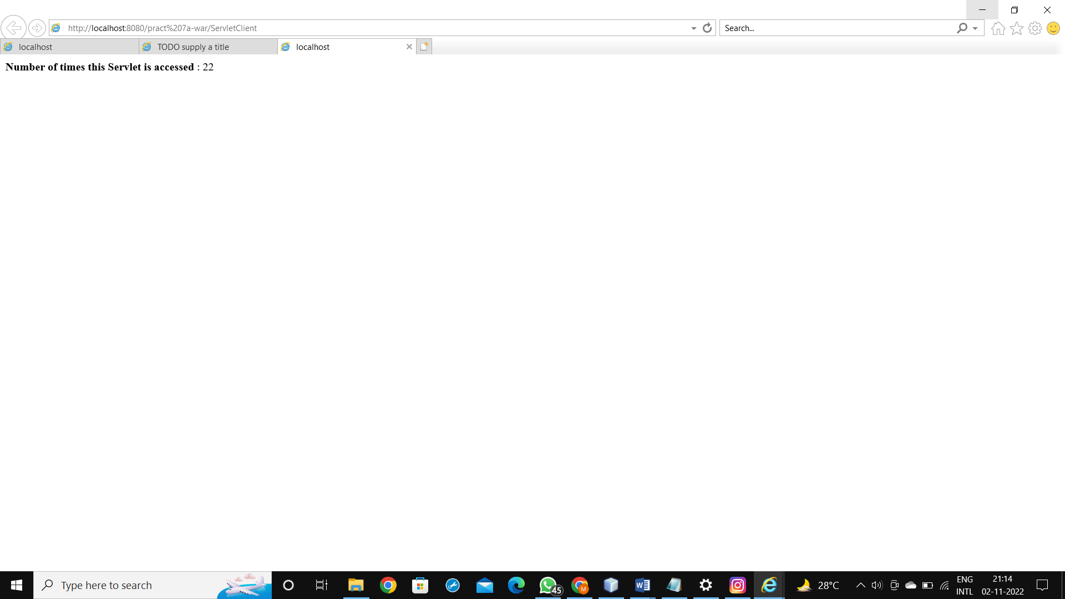

**b.Develop simple visitor Statistics application using Message Driven Bean [Stateless Session Bean].**

**CODE:**

TestingServletForMDB.java

package com.test;

import java.io.*;

import javax.annotation.Resource;

import javax.inject.Inject;

import javax.jms.JMSConnectionFactory;

import javax.jms.JMSContext;

import javax.jms.Queue;

import javax.servlet.ServletException;

import javax.servlet.annotation.WebServlet;

import javax.servlet.http.*;

public class TestingServletForMDB extends HttpServlet

{

@Resource(mappedName = "jms/MyDestination")

private Queue myDestination;

@Inject

@JMSConnectionFactory("java:comp/DefaultJMSConnectionFactory")

private JMSContext context;

protected void processRequest(HttpServletRequest request, HttpServletResponse response)

throws ServletException, IOException {

response.setContentType("text/html;charset=UTF-8");

try (PrintWriter out = response.getWriter()) {

/* TODO output your page here. You may use following sample code. */

out.println("<!DOCTYPE html>");

out.println("<html>");

out.println("<head>");

out.println("<title>Servlet TestingServletForMDB</title>");

out.println("</head>");

out.println("<body>");

out.println("<h1>Servlet TestingServletForMDB at " + request.getContextPath() + "</h1>");

try

{

for(int i=1;i<=4;i++)

{

String message="Sending "+i+" Visitor ";

context.createProducer().send(myDestination, message);

}

out.println("All messages are sent");

}

catch(Exception e)

{

out.println(e.getMessage());

}

out.println("</body>");

out.println("</html>");

}

}

private void sendJMSMessageToMyDestination(String messageData) {

context.createProducer().send(myDestination, messageData);

}

}

TestingMessageBean.java

package com.test;

import javax.ejb.ActivationConfigProperty;

import javax.ejb.MessageDriven;

import javax.jms.Message;

import javax.jms.MessageListener;

import javax.jms.TextMessage;

@MessageDriven(activationConfig =

{

@ActivationConfigProperty(propertyName = "destinationLookup", propertyValue = "jms/MyDestination")

,

@ActivationConfigProperty(propertyName = "destinationType", propertyValue = "javax.jms.Queue")

}

)

public class TestingMessageBean implements MessageListener {

public TestingMessageBean() {

}

@Override

public void onMessage(Message message)

{

TextMessage tm=(TextMessage)message;

try

{

System.out.println("Received Message "+tm.getText());

}

catch(Exception e)

{

System.out.println("Error: "+e.getMessage());

}

}

}

**OUTPUT:**

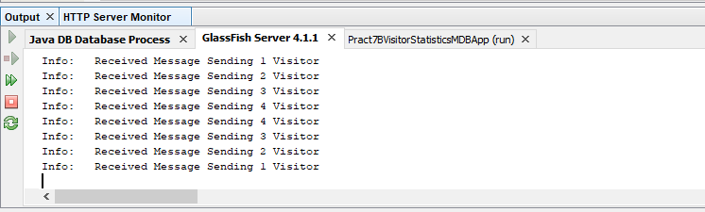

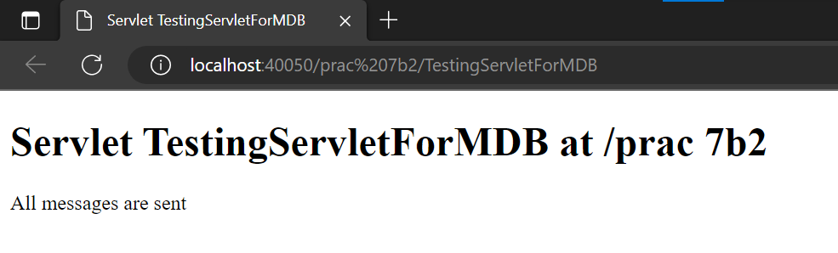

**c.Develop simple Marks Entry Application to demonstrate accessing Database using EJB**

**CODE:**

index.html

<html>

<head>

<title>TODO supply a title</title>

<meta charset="UTF-8">

<meta name="viewport" content="width=device-width, initial-scale=1.0">

</head>

<body>

<form method="post" action="insert.jsp">

<center>

<table border="1">

<tr>

<td>RollNo</td><td><input type="text" name="txtRollno"/></td>

</tr>

<tr>

<td>Name</td><td><input type="text" name="txtName"/></td>

</tr>

<tr>

<td>Java Marks</td><td><input type="text" name="txtJava"/></td>

</tr>

<tr>

<td>Linux Marks</td><td><input type="text" name="txtLinux"/></td>

</tr>

<tr>

<td>AWP Marks</td><td><input type="text" name="txtAWP"/></td>

</tr>

<tr><td colspan="2"><center><input type="submit" value="Click Me!"/></center></td></tr>

</table>

</center>

</form>

</body>

</html>

insert.jsp

<%@page contentType="text/html" pageEncoding="UTF-8"%>

<%@page import="com.test.DatabaseOperations" %>

<!DOCTYPE html>

<html>

<head>

<meta http-equiv="Content-Type" content="text/html; charset=UTF-8">

<title>JSP Page</title>

</head>

<body>

<%

try

{

int r=Integer.parseInt(request.getParameter("txtRollno"));

String name=request.getParameter("txtName");

int java=Integer.parseInt(request.getParameter("txtJava"));

int linux=Integer.parseInt(request.getParameter("txtLinux"));

int AWP=Integer.parseInt(request.getParameter("txtAWP"));

DatabaseOperations d=new DatabaseOperations();

d.addMarks(r, name, java, linux, AWP);

out.println("<h2>Records are added successfully</h2>");

}

catch(Exception e)

{

}

%>

</body>

</html>

DatabaseOperations.java

package com.test;

import javax.ejb.Stateless;

import java.sql.*;

@Stateless

public class DatabaseOperations implements DatabaseOperationsLocal

{

Connection con;

ResultSet rs;

ResultSetMetaData rsmd;

PreparedStatement pst;

Statement st;

@Override

public void addMarks(int RollNo, String SName, int Java, int Linux, int AWP)

{

try

{

Class.forName("com.microsoft.sqlserver.jdbc.SQLServerDriver");

}

catch(ClassNotFoundException e)

{

}

try

{

String url="jdbc:sqlserver://localhost:1433;databaseName=db1";

con=DriverManager.getConnection(url,"sa","123456");

String str="insert into Student_Marks values(?,?,?,?,?)";

pst=con.prepareStatement(str);

pst.setInt(1,RollNo);

pst.setString(2,SName);

pst.setInt(3,Java);

pst.setInt(4,Linux);

pst.setInt(5,AWP);

pst.executeUpdate();

}

catch(SQLException e)

{

}

}

}

**OUTPUT:**

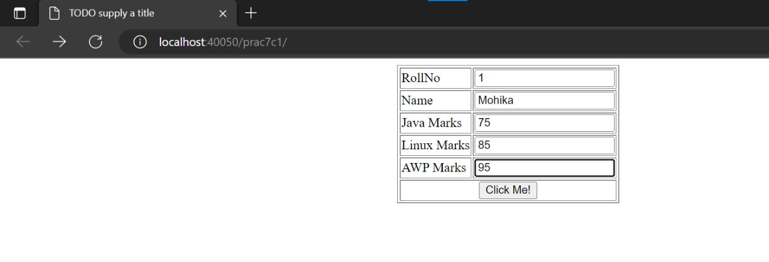

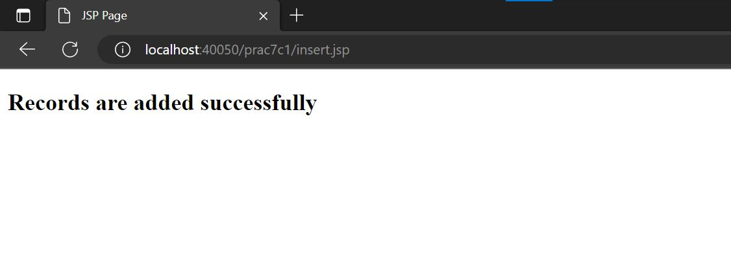

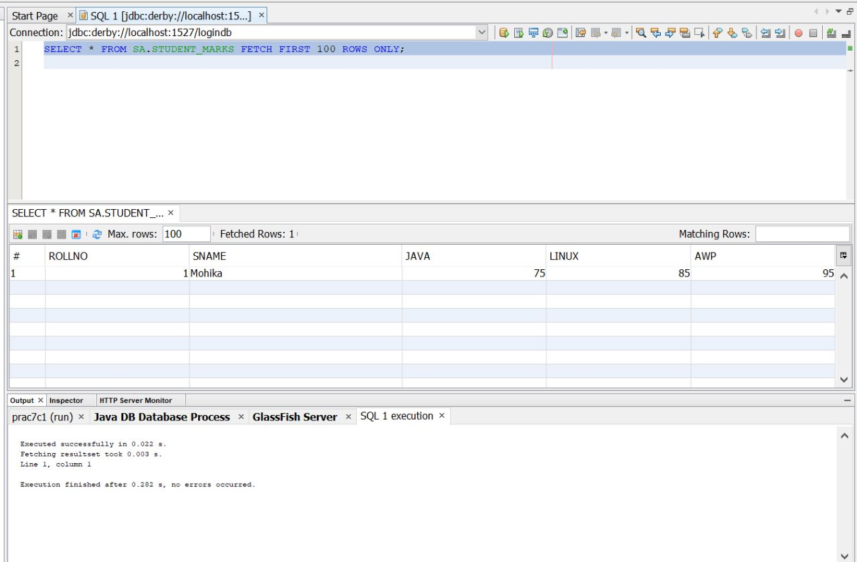

**PRACTICAL 9 Implement the following JPA applications with ORM and Hibernate**

**a.Develop a JPA Application to demonstrate use of ORM associations.**

**CODE:**

index.html

<html>

<head>

<title>TODO supply a title</title>

<meta charset="UTF-8">

<meta name="viewport" content="width=device-width, initial-scale=1.0">

</head>

<body>

User Details <hr><br><br>

<form action="userview.jsp" >

Name <input type="text" name="uname" maxlength="20"><br> User Type <input type="text" name="utype" maxlength="20">

<br><input type="submit" value="submit">

</form>

</body>

</html>

userview.jsp

<%@page import="java.util.List"%>

<%@page import="java.util.Iterator"%>

<%@page import="hibernate.User"%>

<%!

SessionFactory sf; org.hibernate.Session ss; List<hibernate.User> User;

%>

<%

sf = new Configuration().configure().buildSessionFactory();

ss= sf.openSession();

Transaction tx=null;

User ur=new User();

try

{

tx=ss.beginTransaction();

String uname=request.getParameter("uname");

String utype=request.getParameter("utype");

ur.setUname(uname);

ur.setUtype(utype);

ss.save(ur);

tx.commit();

}

catch(Exception e)

{

out.println("Error"+e.getMessage());

}

try

{

ss.beginTransaction();

User=ss.createQuery("from User").list();

}

catch(Exception e)

{

}

%>

<html>

<head>

<title>Guest View</title>

</head>

<body> Guest View

Click here to go <a href="index.html"> BACK </a>

<br><br>

<%

Iterator it=User.iterator();

while(it.hasNext())

{

User eachrecord=(User)it.next(); out.print(eachrecord.getUid()+" "); out.print(eachrecord.getUname()+"<br>"); out.print(eachrecord.getUtype()+"<br><hr>");

}

%>

</body>

</html>

hibernate.revenge.xml

<hibernate-reverse-engineering>

<schema-selection match-catalog="userdb"/>

<table-filter match-name="user"/>

</hibernate-reverse-engineering>

hibernate.cfg.xml

<hibernate-configuration>

<session-factory>

<property name="hibernate.dialect">org.hibernate.dialect.MySQLDialect</property>

<property name="hibernate.dialect">org.hibernate.dialect.MySQLDialect</property>

<property name="hibernate.connection.url">jdbc:mysql://localhost:3306/userdb?zeroDateTimeBehavior=conve rtToNull</property>

<property name="hibernate.connection.username">root</property>

<property name="hibernate.connection.password">tiger</property>

</session-factory>

</hibernate-configuration>

User.hbm.xml

<hibernate-mapping>

<class optimistic-lock="version" catalog="userdb" table="user" name="hibernate.User">

<id name="uid" type="java.lang.Integer">

<column name="uid"/>

<generator class="identity"/>

</id>

<property name="uname" type="string">

<column name="uname" length="20"/>

</property>

<property name="utype" type="string">

<column name="utype" length="100"/>

</property>

</class>

</hibernate-mapping>

User.java

package hibernate;

public class User implements java.io.Serializable { private Integer uid;

private String uname; private String utype; public User() { }

public User(String uname, String utype) { this.uname = uname;

this.utype = utype;

}

public Integer getUid() { return this.uid;

}

public void setUid(Integer uid) { this.uid = uid;

}

public String getUname()

{

return this.uname;

}

public void setUname(String uname)

{

this.uname = uname;

}

public String getUtype()

{

return this.utype;

}

public void setUtype(String utype)

{

this.utype = utype;

}

}

**OUTPUT:**

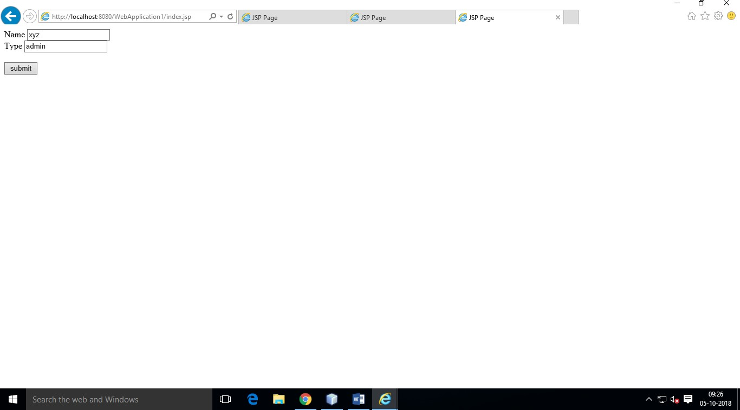

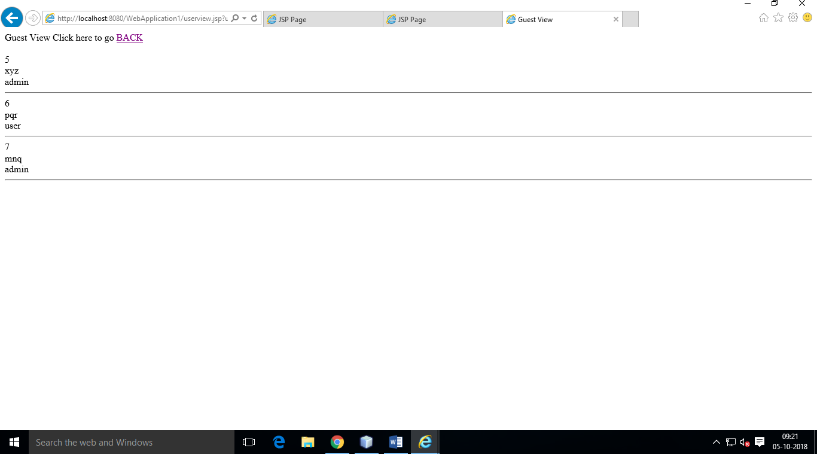

**b.Develop a Hibernate application to store Feedback of Website Visitor in MySQL Database.**

**CODE:**

Step 1: MySql Command:-

Select Services -> right click on database -> connect -> password -> ok ->again right click on database -> create database -> db -> ok.

Expand db -> Select and right click table -> click on Execute command ->

Create table guestbook (no int primary key auto_increment, name varchar(20), msg varchar(100), dt varchar(40));

Step 2: Create a Hibernate Project :-

File -> New Project -> Java Web -> Web application - > Next -> give the project name -> browse the location as required -> select the checkbox – “dedicated folder for storing libraries” -> Next

Select glassfish server -> next

Select frame work - hibernate -> select the respective database connection -> finish.

Step 3: Adding Reverse Engineering File :-

Right click on Project -> new -> other -> select Hibernate -> Hibernate Reverse Engineering wizard file type -> next -> file name (hibernate.reveng) , folder -> click on browse and select src->java -> next -> select guestbook table name from the available tables option -> click add ( select the checkbox – include related files) -> finish.

Step 4: Adding Hibernate mapping files and POJOs from Database file type:-

Right click on Project -> new -> other -> select Hibernate -> Hibernate mapping files and POJOs from Database file type) -> next -> keep the default configuration file name file name (hibernate.cfg) and Hibernate Reverse Engineering File (hibernate.reveng) -> type the package name (hibernate) -> finish.

Step 5: Creating JSP File :-

Right click on project -> new -> JSP -> filename -> guestbookview -> select radiobutton -> JSP file (Standard syntax) -> Finish.

Guestbook.java

package hibernate;

public class Guestbook implements java.io.Serializable

{

private Integer no;

private String name;

private String msg;

private String dt;

public Guestbook()

{

}

public Guestbook(String name, String msg, String dt) { this.name = name;

this.msg = msg; this.dt = dt;

}

public Integer getNo() { return this.no;

}

public void setNo(Integer no) { this.no = no;

}

public String getName() { return this.name;

}

public void setName(String name)

{

this.name = name;

}

public String getMsg()

{

return this.msg;

}

public void setMsg(String msg)

{

this.msg = msg;

}

public String getDt()

{

return this.dt;

}

public void setDt(String dt)

{

this.dt = dt;

}

}

hibernate.cfg.xml

<hibernate-configuration>

<session-factory>

<property name="hibernate.dialect">org.hibernate.dialect.MySQLDialect</property>

<property name="hibernate.connection.driver_class">com.mysql.jdbc.Driver</property>

<property name="hibernate.connection.url">jdbc:mysql://localhost:3306/db</property>

<property name="hibernate.connection.username">root</property>

<property name="hibernate.connection.password">tiger</property>

<mapping resource="hibernate/Guestbook.hbm.xml"/>

</session-factory>

</hibernate-configuration>

Guestbook.hbm.xml

<hibernate-mapping>

<class name="hibernate.Guestbook" table="guestbook" catalog="db">

<id name="no" type="java.lang.Integer">

<column name="no" />

<generator class="identity" />

</id>

<property name="name" type="string">

<column name="name" length="20" />

</property>

<property name="msg" type="string">

<column name="msg" length="100" />

</property>

<property name="dt" type="string">

<column name="dt" length="40" />

</property>

</class>

</hibernate-mapping>

index.jsp

<html>

<head>

<title>Guest Book</title>

</head>

<body>

Guest Book <hr><br><br>

<form action="guestbookview.jsp" >

Name <input type="text" name="name" maxlength="20"><br>

Message <textarea rows="5" cols="40" maxlength="100" name="msg"></textarea>

<br><input type="submit" value="submit">

</form>

</body>

</html>

guestbookview.jsp

<%@page import="org.hibernate.SessionFactory"%>

<%@page import="org.hibernate.Session"%>

<%@page import="org.hibernate.cfg.Configuration"%>

<%@page import="org.hibernate.Transaction"%>

<%@page import="java.util.List"%>

<%@page import="java.util.Iterator"%>

<%@page import="hibernate.Guestbook"%

<%!

SessionFactory sf; org.hibernate.Session ss; List<hibernate.Guestbook> gbook;

%>

<%

sf = new Configuration().configure().buildSessionFactory(); ss= sf.openSession();

Transaction tx=null;

Guestbook gb=new Guestbook(); try

{

tx=ss.beginTransaction();

String name=request.getParameter("name"); String msg=request.getParameter("msg"); String dt=new java.util.Date().toString(); gb.setName(name);

gb.setMsg(msg); gb.setDt(dt);

ss.save(gb);

tx.commit();

}

catch(Exception e){ out.println("Error"+e.getMessage());

}

try

{

ss.beginTransaction(); gbook=ss.createQuery("from Guestbook").list();

}

catch(Exception e)

{

}

%>

<html>

<head>

<title>Guest View</title>

</head>

<body>

Guest View

Click here to go <a href="index.jsp"> BACK </a>

<br><br>

<%

Iterator it=gbook.iterator(); while(it.hasNext())

{

Guestbook eachrecord=(Guestbook)it.next();

out.print(eachrecord.getDt()+" ");

out.print(eachrecord.getName()+"<br>");

out.print(eachrecord.getMsg()+"<br><hr>");

}

%>

</body>

</html>

**OUTPUT:**

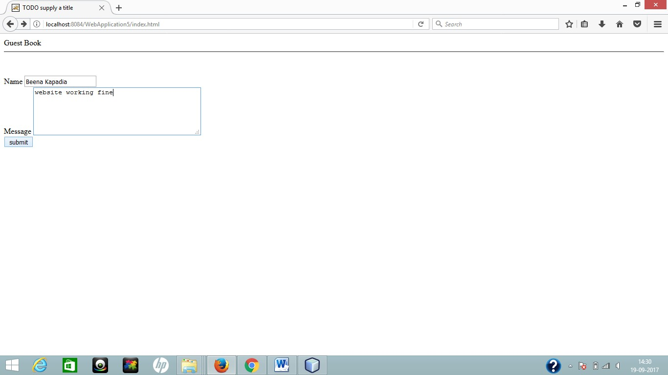

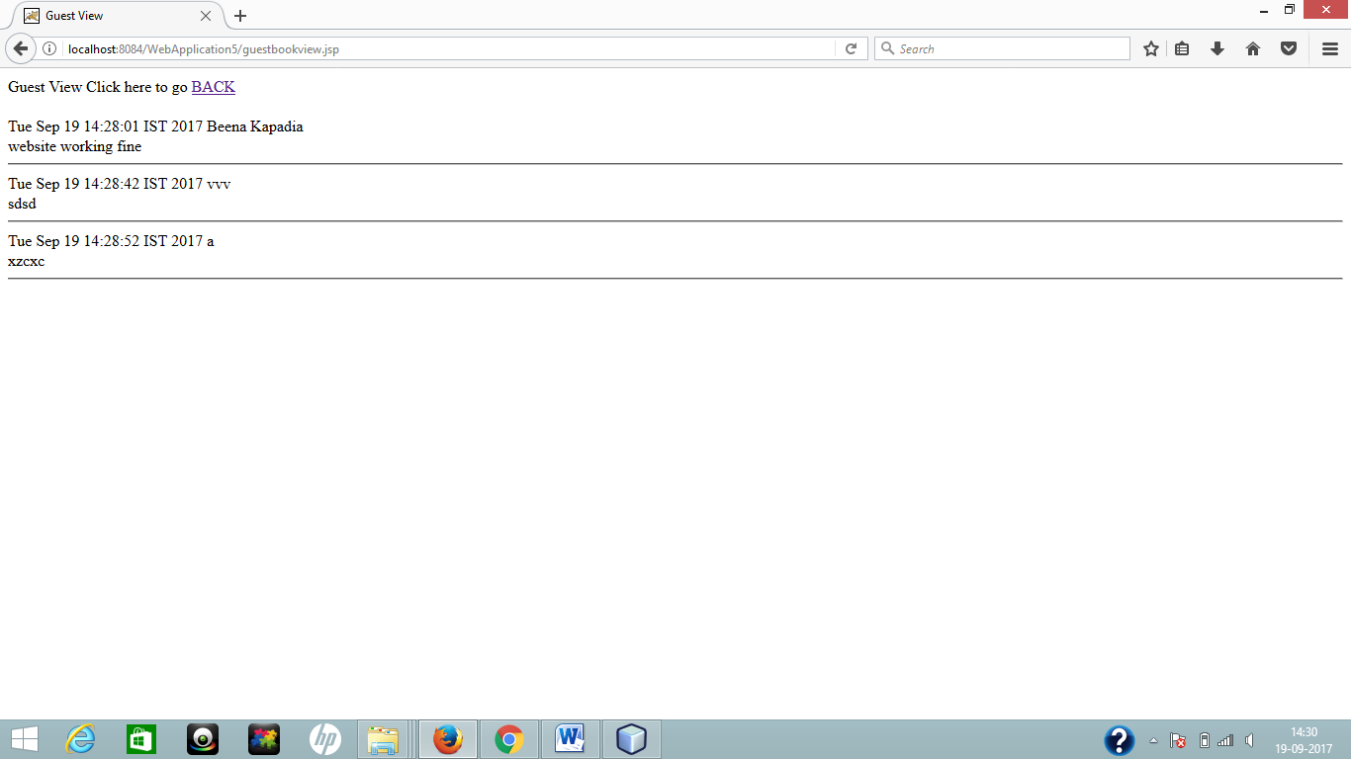

**c.Develop a Hibernate application to store and retrieve employee details in MySQL Database.**

**CODE:**

index.html

<html>

<head>

<title>Employee Details</title>

</head>

<body>

Employee Details <hr><br><br>

<form action="empview.jsp" >

Name <input type="text" name="name" maxlength="20"><br> Salary <input type="text" name="salary" maxlength="20"><br>

Designation <input type="text" name="designation" maxlength="20">

<br><input type="submit" value="submit">

</form>

</body>

</html>

empview.jsp

<%@page import="org.hibernate.SessionFactory"%>

<%@page import="org.hibernate.Session"%>

<%@page import="org.hibernate.cfg.Configuration"%>

<%@page import="org.hibernate.Transaction"%>

<%@page import="java.util.List"%>

<%@page import="java.util.Iterator"%>

<%@page import="hibernate.Emp"%>

<%!

SessionFactory sf; org.hibernate.Session ss; List<hibernate.Emp> Emplist;

%>

<%

sf = new Configuration().configure().buildSessionFactory();

ss= sf.openSession(); Transaction tx=null; Emp em=new Emp(); try

{

tx=ss.beginTransaction();

String Name=request.getParameter("name"); String Salary=request.getParameter("salary");

String Designation=request.getParameter("designation"); System.out.print("Name "+Name+" "+Salary+" "+Designation);

em.setName(Name);

em.setSalary(Salary); em.setDesignation(Designation); System.out.print("set done ");

ss.save(em);

System.out.print("save done ");

tx.commit();

System.out.print("commit done ");

}

catch(Exception e){ out.println("Error"+e.getMessage()); } try

{

ss.beginTransaction(); Emplist=ss.createQuery("from Emp").list();

}

catch(Exception e)

{

}

%>

<html>

<head>

<title>Employee View</title>

</head>

<body>

Employee View

Click here to go <a href="index.html"> BACK </a>

<br><br>

<%

Iterator it=Emplist.iterator(); while(it.hasNext())

{

Emp eachrecord=(Emp)it.next(); out.print(eachrecord.getName()+"<br>"); out.print(eachrecord.getSalary()+"<br><hr>"); out.print(eachrecord.getDesignation()+"<br><hr>");

}

%>

hibernate.revenge.xml

<hibernate-reverse-engineering>

<schema-selection match-catalog="employeedb"/>

<table-filter match-name="emp"/>

</hibernate-reverse-engineering>

hibernate1.cfg.xml

<hibernate-configuration>

<session-factory>

<property name="hibernate.dialect">org.hibernate.dialect.MySQLDialect</property>

<property name="hibernate.connection.driver_class">com.mysql.jdbc.Driver</property>

<property name="hibernate.connection.url">jdbc:mysql://localhost:3306/employeedb?zeroDateTimeBehavior=c onvertToNull</property>

<property name="hibernate.connection.username">root</property>

<property name="hibernate.connection.password">tiger</property>

</session-factory>

</hibernate-configuration>

Emp.hbm.xml

<hibernate-mapping>

<class optimistic-lock="version" catalog="employeedb" table="emp" ame="hibernate.Emp">

<id name="id" type="java.lang.Integer">

<column name="id"/>

<generator class="identity"/>

</id>

<property name="name" type="string">

<column name="name" length="20"/>

</property>

<property name="salary" type="string">

<column name="salary" length="20"/>

</property>

<property name="designation" type="string">

<column name="designation" length="20"/>

</property>

</class>

</hibernate-mapping>

Emp.java

package hibernate;

public class Emp implements java.io.Serializable { private Integer id;

private String name; private String salary; private String designation; public Emp() { }

public Emp(String name, String salary, String designation) {

this.name = name;

this.salary = salary; this.designation = designation;

}

public Integer getId() { return this.id;

}

public void setId(Integer id)

{

this.id = id;

}

public String getName() { return this.name;

}

public void setName(String name) { this.name = name;

}

public String getSalary() { return this.salary;

}

public void setSalary(String salary) { this.salary = salary;

}

public String getDesignation() { return this.designation;

}

public void setDesignation(String designation) { this.designation = designation;

}

}

OUTPUT:

